*C.A.N.E.*

*(Computerized Assistive Near Eyesight)*



EEL 4915: Senior Design 2 Final Documentation

Group: 14

Members

Carlos Diego Arevalo - Electrical Engineering

Rebecca Englehart - Computer Engineering

Clement Hall - Computer Engineering

Davis Hilton - Electrical Engineering

# **Table of Contents**

**1. Executive Summary** **5**

**2. Project Description** **5**

**2.1. Motivations** **6**

**2.2. Goals** **6**

**2.4. House of Quality** **9**

**3. Design Constraints & Standards** **11**

**3.1. Design Constraints** **11**

**3.1.1. Economic Constraints** **11**

**3.1.2. Time Constraints** **12**

**3.1.3. Environmental Constraints** **12**

**3.1.4. Social Constraints** **13**

**3.1.5. Political Constraints** **13**

**3.1.6. Ethical Constraints** **14**

**3.1.7. Health and Safety Constraints** **15**

**3.1.8. Manufacturability Constraints** **16**

**3.1.6. Sustainability Constraints** **16**

**3.2. Standards** **16**

**3.2.1. Power Standards** **17**

**3.2.2. Battery Standards** **17**

**3.2.3. PCB Standards** **18**

**3.2.4. Soldering Standards** **19**

**3.2.6. Ultrasonic Standards** **21**

**4. Project Research** **22**

**4.1. Existing Products & Technology** **23**

**4.1.1. Considerations for Future Technology** **26**

**4.2. Hardware Design Research** **26**

**4.2.1. Laser Sensors** **27**

**4.2.1.1 Considerations for Laser Range Finding Sensors** **28**

**4.2.1.2. I2C Protocol** **29**

**4.2.2. Ultrasonic Sensors** **30**

**4.2.2.1 Considerations for Ultrasonic Sensors** **31**

**4.2.3. Optical Sensors** **32**

**4.2.3.1. Motivations** **32**

**4.2.3.2. Considerations for Optical Sensors** **32**

**4.2.3.3. Optical Sensor Functionality** **33**

**4.2.3.5. Time of Flight** **37**

**4.2.3.6. Review of Optical Sensor** **38**

**4.2.4. Vibration Motors** **38**

**4.2.4.1. ERM and LRA** **39**

**4.2.4.2. Component Specifications** **41**

**4.2.4.3. Pulse Width Modulation** **42**

**4.2.6. Camera Part Selection** **45**

**4.2.7 Power System Research** **46**

**4.3. Software Design Research** **48**

**4.3.2.1. HSV Color-Space** **50**

**4.3.2.2. Grayscale Color-Space** **51**

**4.3.2.3. Canny Algorithm** **52**

**4.3.2.5. Hough Transform** **55**

**4.3.2.6. Camera Calibration** **57**

**4.3.2.7. Comparison of Different Sobel Methodologies** **60**

**4.3.3. Neural Networks** **60**

**4.3.3.1. Motivations** **60**

**4.3.3.2. Neural Network Functionality** **61**

**4.3.3.3. Architecture Variations** **62**

**4.3.3.4. CNNs for Object Detection** **63**

**4.3.3.5. Review of Available Tools** **64**

**5. Project Design** **65**

**5.1. Hardware Design** **65**

**5.1.1. Power Design** **65**

**5.1.1.1. Power Draw from Components** **65**

**5.1.1.2. Battery Design and Housing** **68**

**5.1.1.3 Voltage Regulator Design** **71**

**5.1.1.4 Battery Charging** **72**

**5.1.1.5 PCB Design** **75**

**5.1.2. MCU Design** **76**

**5.1.2.1. MSP430** **77**

**5.1.2.2. Raspberry Pi** **77**

**5.2 Software Design** **78**

**5.2.1. Design Methodology** **78**

**5.2.2. Version Control** **79**

**5.2.3. Integrated Development Environment** **80**

**5.2.4. Ultrasonic Sensor Algorithm** **82**

**5.2.4.1. Overlap Ultrasonic Sensor Algorithm** **83**

**5.2.5. Optical Sensor Algorithm** **84**

**5.2.5.1. Sidewalk Detection Algorithm** **84**

**5.2.5.2. Doorway Detection Algorithm** **86**

**5.2.5.3. Stairway Detection Algorithm** **88**

**5.2.6. Vibration Motor Controller** **90**

**5.3. User Interface** **92**

**5.3.1. User Input** **92**

**5.3.1. Product Output** **92**

**5.4. Placement of Ultrasonic Sensors** **94**

**5.4.1. Secondary Placement** **95**

**5.5. Placement of Vibrating Motors** **96**

**5.5.1. Shoulder Placement** **97**

**5.5.2. Belt Placement** **99**

**5.7. Placement of Optical Sensors** **101**

**6. Testing** **102**

**6.1. Hardware Testing** **102**

**6.1.1. Microcontroller** **103**

**6.1.2. Sensors** **103**

**6.1.2.1. Ultrasonic sensor** **103**

**6.1.2.2. Optical Sensor** **104**

**6.1.2.2.1. Care Prior to Testing** **104**

**6.1.2.2.2. Testing Protocol** **104**

**6.1.2.2.3. Testing Location** **105**

**6.1.2.2.4. Testing Techniques** **106**

**6.1.3. Power Systems** **108**

**6.1.4. Computer Vision Subsystem** **110**

**6.1.5. Audio Output Testing** **110**

**6.2. Software Testing** **111**

**6.2.1. Software Test Environment** **111**

**6.2.2. Ultrasonic with Air Temperature Testing** **112**

**6.2.5. PWM Testing** **113**

**6.2.6. Computer Vision Testing** **114**

**6.2.7 Blind Spot Testing** **116**

**6.2.8 Vibrators** **117**

**6.2.9. Overall Desired Testing Results** **118**

**7. Administrative** **121**

**7.1. Budget** **121**

**7.2. Milestones** **123**

# **1. Executive Summary**

Technology has advanced greatly in the last century, and people are working tirelessly to apply these new inventions to problems faced by consumers and industry alike. Though we as engineers have done quite well to help develop new ideas for enjoyment, there is a noticeable lack of work in the area for the visually impaired. People with this condition have a hard time operating in our modern world of rapid change. The visually impaired have used the iconic “White Cane” since 1931 [1], and the use of canes predates this for centuries. In today’s world, we are long overdue for a device that can help the visually impaired operate with much more ease than they are accustomed to through the aid of technology. The aim of our project is to develop a prototype that will assist the visually impaired in such a way that they can replace their current pathfinding techniques, and improve on their overall experience to get more out of their other senses.

This document describes the research and development for the *C.A.N.E.* system, as well as the goals and requirements for the system. The standards and constraints this system follows are also outlined and detailed below. The major components will be discussed, as well as their functionality in regards to the system. Finally, proper testing conditions will be laid out so the *C.A.N.E. System* can be verified as working.

# **2. Project Description**

The Computer Assisted Near Eyesight (C.A.N.E.) System is a synthesis of sensors, controllers and software to assist visually impaired individuals with navigating the world. It gathers information about the environment with the use of its sensors, and interprets the data to look for obstacles and landmarks in the world. It will then alert the user to these obstacles based on priority and proximity. Vibrating motors along with audio feedback are used to alert the user and direct them to safety. Multiple sensor technologies are utilized to ensure reliable and safe readings of the environment. Computer Vision technologies will further detect and classify obstructions and additional surroundings. Audio feedback is used to alert the user to changes in the environment or high alert messages.

# **2.1. Motivations**

According to the World Health Organization there are thirty-nine million people globally who are visually impaired **(**World Health Organization, 2010). Being visually impaired is a serious handicap and can have an hindrance on this persons’ way of life, from trying to find their way around a street to trying to get from one classroom to another. Overcoming these challenges have been manageable with such aids such as a seeing eye dog and a walking stick. However, seeing eye dogs need to be fed and taken care of and walking sticks might hinder nearby people or be a nuisance to the people they are trying to help. As years go by, technology is improving the lives of everyone and should be used to benefit the visually impaired as well. A modern replacement for the service animal or walking stick is long overdue. With the aid of a range of sensors, a device could be designed to “see” for the visually impaired.

In 2017, a senior design group created a similar project, which they named the Batpack. The Batpack also aimed to provide visual aid for the visually impaired using sensors and providing feedback with vibrations. They stored their hardware in a backpack and put their cameras and sensors on a pair of goggles. They also provided a belt which vibrated to alert the user of objects. We hope to improve on this idea by requiring less and/or smaller hardware. We hope to fit all sensors and hardware on the glasses, with a hat as a backup plan if additional space is needed. We also plan to provide additional wearable pieces such as anklets, and bracelets on top of the belt, which will allow additional feedback for the user on the height of the obstructions in front. We also plan to introduce an audio feedback aspect, which will provide the user with more detailed information when necessary. The audio will be able to guide the user through doorways, up and down staircases, and provide additional assistance in other scenarios in which vibrations alone might not be enough. Finally, we hope to improve on the Batpack design by providing a full 180 degree view in front of the user.

# **2.2. Goals**

The C.A.N.E. system was designed with the intentions to replace (or at least supplement) the white cane that is commonly used by visually impaired persons today. The cane is cumbersome, requires the use of the user’s dominant hand at all times, and is long overdue for a technological upgrade. Our main goal with the C.A.N.E. is to meet the needs of a visually impaired person without the inconvenient nature of the canes; and to therefore improve our user’s quality of life.

When completed, our goal is that our device will be capable of detecting obstructions in front of and in close proximity to the user. We would like to achieve a 180° range of detection in front of the user. The user should be informed of upcoming obstructions via wristband vibrations so that they are able to correct their path to avoid them. The wristband vibrations should be intuitive and easy to decipher. The C.A.N.E. device should also be able to detect the presence of sidewalks, stairs, and doorways. The device should notify the user of the detected obstacle, as well as details about it such as the type of obstruction, the distance from the user, and the elevation of the obstruction. This will be accomplished through a combination of vibrations and audio feedback. Through the combination of this information, our hopes are that the user will be able to successfully navigate any crowded or cluttered area with nearly the same ease as a person with perfect vision.

Some additional goals of ours include achieving the smallest possible size of the C.A.N.E. device. Our initial goal is to fit all of our hardware onto a pair of glasses, which would come with accompanying wristbands to receive vibrations. However, we are willing to use a hat instead if this will improve the comfort, wearability, and sleek design.

An additional goal of ours is to create some sort of housing for our hardware that will allow the C.A.N.E. device to be worn in inclement weather situations such as rain, snow, etc. We would like to 3D print our own customized housing to fit easily on the glasses (or hat). We would like to use a lightweight polymer to accomplish this, in order to keep the overall product weight as light as possible.

While less feasible given our time and budget constraints, we have some stretch goals concerning the battery usage and power of our device. Ideally, we would like to explore the possibility of a movement-powered rechargeable battery. While this is unlikely to generate enough power for our device, it could be implemented as a supplement to improve battery life. If the hat approach is used, we would consider miniature solar panels that would feed the device power throughout the day. Failing this, any means to extend the battery life of the C.A.N.E. will be considered. Ideally, our device will have enough battery power to make it through a sixteen hour day, which is approximately the amount of time the average adult spends awake each day [2].

Above all other technical and aesthetic goals, our most important goal for this project is to improve the quality of life for our users. Any strides we are able to make, including improved comfort, portability, and confidence in movement are of the utmost importance to our group.

**2.3. Specifications & Requirements**

The components and specifications we anticipate requiring for this project are below.

* Various sensors
  + We will use ultrasonic & optical sensors under $10 (each).
  + Sensors will have a minimum sensing distance of 4 meters.
* Feedback
  + Haptic Feedback Pads
    - Buzz when an object is nearby and will increase in intensity as the object gets closer.
  + Audio Feedback
    - Will utilize tones to alert user of potential objects in path
* Headphones  
  + Capable of receiving and playing audio from MCU
* Wristband, anklets, belt, vest  
  + Housing for vibration feedback to the user.
    - Will require research/testing to determine the most efficient and user friendly experience.
* Power supply  
  + Rechargeable batteries
  + Min 2000mAh
  + Maximum 10W
* Micro-Controller  
  + I/O protocols
    - I2C and SPI protocols required and satisfied by MSP430 board
  + Power requirement
    - Texas Instruments MSP430G2553
      * Recommended Operating Conditions [3]
        + Vcc - Supply Voltage {1.8, 3.6}V
        + TA- Free-Air Temperature {-40, 85}℃
* Housing
  + Ideally on glasses/wristband only
  + Dimensions: To fit on glasses or hat
  + Weight: Less than 2lbs

# **2.4. House of Quality**

The House of Quality is a visual, product planning tool to demonstrate and classify both engineering and customer requirements and determine their correlation to each other. The House of Quality is designed to identify and take into consideration the voice of the consumer, which is often overlooked. It contains both Technical and Competitive Benchmarking to determine how a product can best fulfill the needs of the developers and consumers.

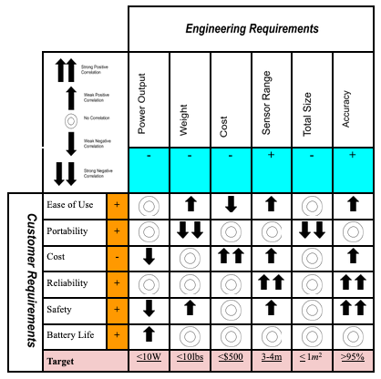

Figure 1: House of Quality

As can be seen in our House of Quality visual, we are considering customer requirements, which are listed on the left panel of the diagram. Factors such as increased ease of use and battery life as well as lower cost are important to users who would consider purchasing our device. Engineering requirements that will be considered are on the top, and include the need for accuracy and high sensor ranges, while maintaining low weight and cost.

# **3. Design Constraints & Standards**

The C.A.N.E. device will be a wearable medical device that is capable of recording and analyzing our user’s surroundings. Its nature as a medical device alone is enough to make it subject to a myriad of constraints. The presence of an on-board computer and camera module present even more. All anticipated constraints and how our team plans to handle them are detailed in the subsections below.  
  
Also important to our project are the standards that our team will follow. The use of standards will improve the reliability of our project, keep consistency throughout, and allow our device to meet criteria set by engineers with more experience and testing time. The standards that our team plans to use are described in detail in the following subsections.

# **3.1. Design Constraints**

The design of this project is influenced by both hardware and software constraints, which need to be accounted for when building the system. There are numerous other constraints detailed below that have directed the path in development.

# **3.1.1. Economic Constraints**

Our team's biggest economical constraint will be our funding. We are limited to the UCF budget of $500 unless we find sponsors or outside donations. This financial constraint puts the team in a situation where doing due diligence on the components being used is very necessary. We do not have the current funds to order multiple components to test different specifications. We will be limited to just what we need to build our system. If we had extra funds or a sponsor we would be able to order multiple various components to test out and verify our requirements are met and also if we are able to expand on our idea and make it better and possibly more accurate.

From the perspective of our users, cost would continue to be a constraint. If we create this system that is too expensive then not everyone who needs it will have access to it. Another reason for trying to create this product as efficiently but as cheap as possible would be to allow a wider selection of users to be able to afford the system. The more affordable the design as a whole is the better for all.

# **3.1.2. Time Constraints**

The biggest concern for our team may be the time constraint. We are all in other classes and working jobs outside of class as well. The team must adjust their hours accordingly so that enough time can be devoted to research and design of the project before the given deadlines come up. We have created a milestones chart that shows us when different sections are due so that we do not miss important dates.

The team must also take into account that we are taking Senior Design 1 over the summer. The summer semester is about four weeks shorter than spring or fall semester. This takes away a whole month of researching that is out of our hands. We will need to find extra time in our days to devote to research and development since we will be missing out on this extra time.

When ordering parts we must also take into consideration that there may be some sort of backlog or delay in how long the components will get to us due to the pandemic as well. Although these backlogs are out of our hands we will take this into account and try to order our components as soon as possible. Certain situations are out of our control, for example COVID-19, that could lead to unknown other variables and obstacles but by taking this into account early we will be better prepared to proceed with the project.

The team must make up for that time by working efficiently so that by the end of the semester, there is a complete and working prototype.

# **3.1.3. Environmental Constraints**

Some constraints that we will have to consider include the disposal or recycling of the batteries that are used. Lithium batteries are considered hazardous waste and need to be handled accordingly. The lithium batteries may be potentially reactive if not discharged and handled appropriately. Other types of rechargeable batteries, Nickel-Cadmium or Nickel Metal Hydride, when disposed of correctly may be used to make new products. If any of the batteries begin to leak or show signs of corrosion then placing them in plastic bags and disposing in the recycling bin or taking them to battery disposal locations throughout the city.

Our team is residing out of Orlando, Florida, which is known for its heat and high humidity. Our team does not currently anticipate any issues in our sensors or other components that would be caused by extreme weather, but additional testing will be required to be sure.

Weather is a slight constraint dependent upon how drastic the weather is due to the fact that the speed of sound will also vary between the temperature of the environment that is in. With the use of an ultrasonic sensor many are able to operate in all sorts of weather that a human is able to withstand.

# **3.1.4. Social Constraints**

Our team's C.A.N.E. system is designed to help the blind and sight impaired community but it does not exclude users who are sight-abled. The C.A.N.E. system was designed with the intent to help people, whether it be someone who needs a lot of help or just a little, our system will benefit all. The size and weight of the C.A.N.E. system should allow for anyone to use it as well.

We have also taken into account financial constraints from the perspective of our potential users. We are trying to make our system as affordable as possible so that more people have easier access to it. The less expensive we are able to create the system, the more people will be able to benefit from our work. Additionally, we hope that access to our product would never be limited to a wealthier demographic. In an ideal world, our goal is that anyone with a need for it would have access to the C.A.N.E. system.

# **3.1.5. Political Constraints**

Our team has identified a series of political constraints with our project as well. The use of the Raspberry Pi camera module and associated camera module poses questions about the security of the device. Even though we are not planning to store any video footage of snapshots past the amount of time needed to process the images and search for obstructions, the very existence of a camera aboard our device poses several issues. For example, an employee in a classified or government job might raise questions about the camera recording and storing sensitive information. A student may have similar issues when faced with testing or any other form of work where cheating is possible. Even though we are not storing any of this information, what will it take for employers or teachers to understand and accept this as reality? Our team believes that any device with a camera attached will be unwelcome in environments such as the ones described. In fact, they could be so shunned that our users could potentially be denied opportunities due to the fact that they have a camera on them at all times. Our team has yet to come up with a viable solution to this, since the aforementioned camera will be an essential part of our computer vision algorithms.

An additional concern regarding the camera module is the possibility that it could be hacked. Even though we are not storing any information about the users surroundings does not mean it is inaccessible to hackers. In fact, our plans to use bluetooth to communicate to the vibration motors that our users will wear as wristbands further implicates hacking as a potential issue. Bluetooth is known for being relatively simple to hack into, and our team sees no way around its use to communicate with the wristbands. How much information could a hacker potentially gather from the information passed to the wristbands alone? Most likely nothing too important. However, how much of a stretch is it to go from hacking our bluetooth systems to realizing we are utilizing live camera footage and hacking our video stream? We are not entirely sure. Even hacking the bluetooth systems alone could be enough to be considered a violation of HIPPA for our users. The Health and Privacy act guarantees anonymity and safety to our users, but even that seems susceptible to hacking from outside sources.

Given time, our team plans to do additional research on additional security measures that could be utilized to keep our systems and our user’s information safe. Barring that, extra precautions will be needed to ensure that our users’ information is kept safe and private.

# **3.1.6. Ethical Constraints**

An ethical constraint our team encountered was in choosing between saving money on componentes to fit our budget of $500 or to spend a bit more to make sure each component is safe so as to not harm the user. There are lithium-ion batteries that have caught fire or even exploded in the past. These situations normally occur when the battery is punctured, pierced, or is in extreme temperatures. The safer alternative to the lithium-ion battery is its close relative, the Lithium-Ion-Polymer (LiPO) battery. The LiPO is not as cheap as the lithium-ion battery but the team believes that safety is paramount. The team's original goal for this project was to help the visually imjpaired and we want to continue that idea from every angle in the design process. So we decided it was more than fine to spend more to make sure our components were safer so as to minimize any chance of harm. Our goal with this project is not to profit financially. Our goal is to help and make the lives of the visually impaired better in any way we can.

# **3.1.7. Health and Safety Constraints**

As a wearable medical device, there are many potential health and safety risks associated with our project. In an ideal world, the C.A.N.E. device would completely replace the existing walking cane currently used by people who are visually impaired. However, there are many factors that must be considered in order to ensure safety for our users.

When selecting parts to be used for the C.A.N.E. device, our team gave preference to lighter and smaller alternatives when possible. Since the plan is for the user to wear the device on their face as a pair of glasses, we had to be careful about component selection. An important consideration when choosing parts is to make sure the user is comfortable. When looking for parts the weight shall be a factor. This means parts that are chosen should be light, sleek, and not bulky. We will also carefully consider the placement of our electrical components. For example, parts that require higher voltage will be kept as far from the user’s face as possible.

An additional consideration for the safety of our users is the potential issue with the use of a headphone to receive audio feedback. Hearing everything in their surroundings is very important to people who are visually impaired, and often serves as the sense they rely on most to get them through day to day life. Having users wear even one headphone might impede on their ability to hear their surroundings. This could potentially be an issue even at times when there is no information and no noise coming through the headphones. The existence of the headphone itself could block some amount of noise, which is definitely not ideal. Our team did consider utilizing the Raspberry Pi 4’s on board speaker instead, but that raises the concern that any information provided to the user could be heard by everyone around them. That raises concerns that information read aloud could violate the privacy of our users. Additionally, information read aloud could be distracting to people around, which could also become a safety hazard. Our team has decided that further research and testing will be required to determine the best course of action regarding audio feedback, and which option will prove less hazardous in the long run.

Our final and most important consideration in regards to health and safety is the liability that could come with our device. Since our users will be partially if not completely visually impaired, it is important for our sensors and cameras to record correct information and present it to the user quickly and efficiently. Failure to do so could result in the injury of our users. Even more importantly, our algorithms cannot miss objects or fail to classify obstructions correctly. A mistake in our sensors could cause a user to run into an obstruction. A mistake in our computer vision algorithms could cause a user to fall down the stairs or walk into traffic. As with all medical devices, there is little to no room for error, as the health and safety of our users and even people nearby could potentially be at risk.

# **3.1.8. Manufacturability Constraints**

There will be certain manufacturing constraints that we have taken into account for our project. The biggest constraint and concern is the unknown future of COVID-19 and its continued impact on the economy and our daily life. We have seen there have been many sectors in the industry that have had to slow down certain processes to protect their employees. This means for us when ordering products that we have to make sure whoever creates our products that we need that they are still operational. We also have to take into account the time they have shipped before and how that time may be affected now. We have decided its best to play it safe and assume each order could take an extra week or two. Along these, we will also have to verify that the components being ordered are still available. Many companies are now backlogged due to Covid-19. Our considerations for how long the component will take to reach us will hopefully cover this issue.

# **3.1.6. Sustainability Constraints**

Despite the constant technological advances of today’s society, there is no perfect machine. No technology is immune from eventual deterioration. That being said, our team will take into consideration any components that are proven to have longer lifetimes. We will also be utilizing components such as rechargeable batteries in an effort to extend the longevity of the C.A.N.E. device.

# **3.2. Standards**

We will be following engineering standards for our project. Following the standards set in place will help the team in creating a safe and reliable product. These standards give us guidelines to abide by that are critical in the design process. They will help in the development process by guiding us through lenses that will allow us to design our product faster, more safely, and without damaging expensive components in the design process.

# **3.2.1. Power Standards**

The system we are trying to implement will be used away from a permanent outlet or power supply, so we must take great care to ensure the batteries used will be sufficient and long-lasting to give the user an optimal experience. Following the correct standards will be very important to make sure our components have the longest possible lifetime of use.

CUI Inc. is a company that designs and produces various electronic equipment for industry and consumer applications. They have developed their own Power Supply Safety Standards, which will be used to deploy proper safety protocols for our own use.

The Power Supply Safety Standards from CUI Inc. contains the following requirements a circuit must meet in order to be called a Safety Extra-Low Voltage (SELV) Circuit:

* If a single fault occurs, the circuit cannot exceed 42.4Vac peak or 60Vdc for greater than 200ms.
* Cannot reach above voltage (hazardous) under normal operating conditions
* Absolute limit of 71Vac or 120Vdc must not be exceeded.
* At least two layers of separation from hazardous voltages.
  + Ex: A double layer of insulation or basic insulation and an earthed conductive barrier.

SELV Circuits are considered safe for operator access and do not require extensive safety testing or clearance evaluations[4]. Since our system will not exceed these rated voltages, we can consider our system to be impervious to hazardous shock since the voltage will not approach the target of 42.4Vac or 60Vdc, even in the event of a single fault.

# **3.2.2. Battery Standards**

The battery standards at first glance seem overwhelming. There are many different agencies and organizations globally with their own set of standards many of which seem very similar. Their core though is to work towards a safer battery industry standard. Agencies like The American National Standards Institute (ANSI) have standards for portable rechargeable cells and batteries under their ANSI C18.2M and also for portable Lithium Primary cells and batteries under ANSI C18.3M. These documents are general battery specifications as well as safety. The United Nations (UN) and Department of Transportation(DOT) also have their own battery standards as laid out in UN/DOT 38.3. This document covers the transportation safety guidelines for all lithium ion and metal cells and batteries. For Underwriters Laboratories (UL), an independent organization which focuses on product safety and testing, they have a few documents for batteries as well. They include UL 1642, which is standards for lithium battery testing. There is UL 2054, that is for cell level lithium battery testing. And finally the UL 2580, is the standards for electric vehicle batteries. Then there is the International Electrotechnical Commission (IEC) a non-profit organization that writes standards. Some of their standards include IEC 62133 that is for secondary cells and battery safety. IEC 60086-4 is for the safety guidelines of the primary batteries. They also wrote their own standards for the safety during transportation of primary and secondary batteries in IEC 62281. Lastly, the Institute of Electrical and Electronics Engineers (IEEE) an international non-profit lays out two important documents. The IEEE 1725 that is for safety standards of rechargeable batteries for cell phones. And then there's IEEE 1625 that is another safety document guideline for rechargeable multi-cell batteries.[5]

# **3.2.3. PCB Standards**

The Printed Circuit Board standards we will be following will be coming from the Institute for Printed Circuits (IPC). The IPC is an association that was created by six different printed circuit board manufacturers with the goal to help standardize and regulate design and implementation of printed circuit boards for the industry. [6]

Important documents we will be following will help us follow the standard in the industry for printed circuit board specifications, design, inspection and safety. A few of the documents the IPC have that will help us in our project include: IPC-2615, IPC-D-325, IPC-2612, IPC-2221.

The IPC-2615 is the document for printed board dimension and tolerances. The IPC-2221 is a generic standard on printed board design documents. Both of these will be followed closely in our design of our board. We will not be creating the board ourselves though, we will be out sourcing this part of the project to a printed circuit board manufacturer. But we need to make sure that the company we are using follows the industry standards as well. They may be using documents like the IPC-D-325 which is the documentation requirements for printed boards. And also IPC-2612 which is that standard documentation for schematic and logic drawings of the board.

When we design our board we will be using EAGLE software as it's a very powerful electronic design automation software. Following the standards provided by the IPC will allow for the team to create and design a very reliable and safer printed circuit board for the project.

Precautions will be taken into account from the IPC standards and will help the team create a stronger, safer, and more reliable product.

# **3.2.4. Soldering Standards**

In regards to soldering, we will have to make sure we are compliant with the standards set before us to make sure our connections are adequate and done correctly to avoid any loose wires or pins. NASA has a free soldering standard document, NASA-STD-8739.3, titled “Soldered Electrical Connections”. This Technical Standard describes the requirements they have specified to establish reliable soldered electrical connections [7].

The document goes on to explain how to maintain a clean and orderly work station. It details that the work station should be used only for work and activities such as eating, drinking, or even smoking by the workstation are prohibited.

The Technical Standard also shows ideal environmental conditions for soldering. It states that an ideal room temperature between the ranges of about 20 degrees C to 26 degrees C with humidity between 30-70 %RH is best suited for soldering. It is also recommended that the area you are working in is in compliance with Occupational Safety and Health Administration (OSHA) requirements so that proper ventilation is allowed to prevent from being exposed to harmful fumes. Another safety measurement to abide by is having proper lighting. NASA-STD-8739.3 recommends being in a properly lit room with a minimum of 1077 lumens per square meter.

NASA-STD-8739.3 also gives us proper soldering preparation where they request that the tools are checked daily to make sure they are operation ready, their condition is well, and the performance is up to standard. After verifying the tools are appropriate the soldering procedure may begin. The document then outlines different conditions for soldering and how to approach each one. We will be dealing with soldering onto a Printed Circuit Board (PCB). Where we will be soldering our components and sensors we must make sure to solder properly. NASA states when soldering the components to the board there must be no movement allowed and that they do not interfere with other positioned parts. Stress relief is to be applied at any time possible and making sure that during the soldering that markings labeling components are not hidden.  
  
  **3.2.5. High Level Programming Language Standards**

In order for the project to run properly, several members in this group will be required to program respective hardware. The following guidelines will be used so that when reviewing the code to ensure consistency throughout the project. The use of standards will also ensure that others who might need to analyze the code are able to understand it.

* All code will have a header, which will include the name of the person working on it and the certain function of the code
* Headers shall include the following information:   
  + Author
  + Title
  + Date last modified
* A brief comment shall follow the header in the code that will be required to describe the code’s functionality
* All classes will name will be named with single words and the first letter is to be capitalized
* All variables and functions names will follow the camel casing naming convention
* All variable names will pertain to its functionality within the code
* No line shall be more than 100 characters in length
* The beginning of any curly bracket will be started on a new line and the following lines within the code will be indented (specifically for C code)
* Four spaces will be used in place of tabs to ensure the code will be transferable between different machines (specifically for Python code)

# **3.2.6. Ultrasonic Standards**

This project relies on several sensor technologies, and ultrasonic is the most numerous type of sensor incorporated in the design. Ultrasonic sensors emit ultrasonic sound waves to detect the range of objects by calculating the return time from the initial wave to the object. To verify and preserve the integrity of our ultrasonic sensors, we will adhere to special standards for ultrasonic sensors.

ASTM (American Society for Testing and Materials) is a group that produces standards for testing [32]. Several key standards relating to our research and design in ultrasonic technology are available through ASTM. These are outlined briefly below.

First, we looked at ASTM E2373 / E2373M - 19, Standard Practice for Use of the Ultrasonic Time of Flight Diffraction (TOFD) Technique. This standard relates to the Time-of-Flight-Diffraction usage by ultrasonic sensors and is relevant to our project. Another related standard is the ASTM E2375 - 16, Standard Practice for Ultrasonic Testing of Wrought Products, which discusses the use of ultrasonic detection on wrought products. Wrought products are any product that has been machined into a standard form, and this standard can therefore be applied to wall detection. ASTM E494 - 15, Standard Practice for Measuring Ultrasonic Velocity in Materials, is useful to understand how to measure ultrasonic sound waves in various materials. Our project concerns itself with air as the only means of propagation for the ultrasonic wave, but if this project was implemented on a wider scale, would most likely need to also concern itself with propagation through water as well (to include the possibility of rain as a limiting factor in wave detection). If this project was a consumer product, it should work in rain just as well as sunshine.

The implementation of the standards above will help our team safely test and operate our ultrasonic sensors. By following these standards, devices will be protected and safe from easily avoidable damage and can help our team better understand how different testing methods can be validated or invalidated by the many conditions our sensors might be tested under.

# **4. Project Research**

Our product should allow visually impaired users to navigate in the world with ease and unobstructed by the usual companions known to them, such as a physical cane or seeing eye dogs. We will use a combination of eyeglasses and earbuds/headphones as well as sensors and vibrating motors attached to wristbands and leg straps to detect and alert the user to the environment.

The eyeglasses will serve as a good position to mount our sensors and our MCUs if safety allows for it. Visually impaired people often wear dark glasses to cover their eyes so this is also non-intrusive to people who traditionally have eyesight problems. By attaching sensors to the eyeglasses, we have a good idea what the maximum height of the user is and can allow for more accurate data since it will always be in the forward position relative to the user. Use of an optical sensor or camera can allow for a much greater distance than infrared or ultrasonic sensors can provide. The camera will feed data to a computer vision algorithm which can interpret the data and provide output to the user. The camera can also help with surface detection, or differentiating between asphalt and a grassy field and can help orient the user more effectively. The user will no longer have to “feel” around for the grass or sidewalk, but will be able to detect it several feet out in front of them ahead of time, just like a non-impaired person would.

The audio output to a pair of earphones or headphones will allow the user better integration with their environment by directing the user on the correct path away from any walls or obstacles based on feedback from the sensors. This will help guide people away from any danger nearby and work in symbiosis with the haptic feedback. Either a direct warning or a queue by playing tones will be implemented to alert the user to changes in environment or obstacles.

Sensors will be attached to the user by multiple straps, fastened to their wrists. These sensors will tell how far away something is to the MCU, which will then send a corresponding pulse to the vibrating motors also attached to the user to indicate distance. Since wrists are often in motion when a person is walking, we will have to take great care to eliminate any incorrect data when the user is not using the device. This can be accomplished by simply turning off the range finding sensors when not in use.

[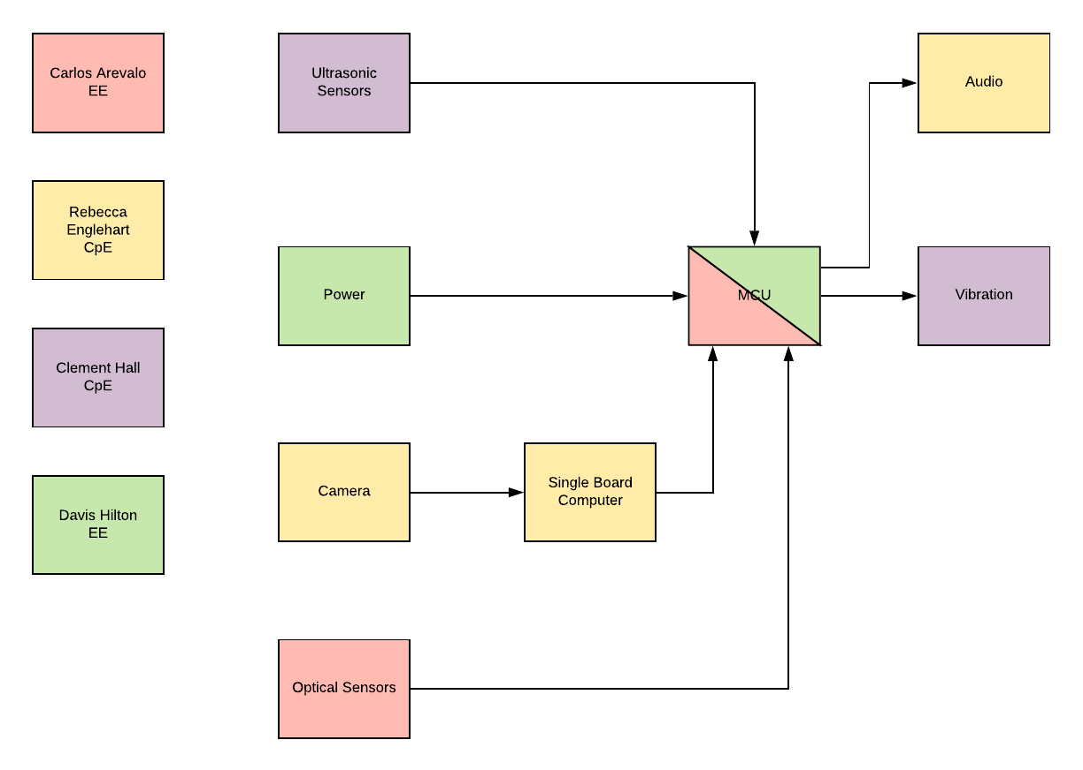](https://app.lucidchart.com/documents/edit/f7e11067-08bc-455d-8169-bb6173f7b326/0?callback=close&name=docs&callback_type=back&v=521&s=612)

*Figure 2: Block Diagram for C.A.N.E. Design*

# **4.1. Existing Products & Technology**

Visually impaired people around the world total more than 285 million, so there is a great demand for devices that can help these people get around in their daily lives. Many inventions have been created to help solve the same problem we are tackling, and a thorough understanding is needed to help make a better system. If we can understand these products’ shortcomings and successes, we can create a better product of our own. Below is a review of several exciting and ambitious existing products that we feel can be complimented or improved on.

***eSight 3:***

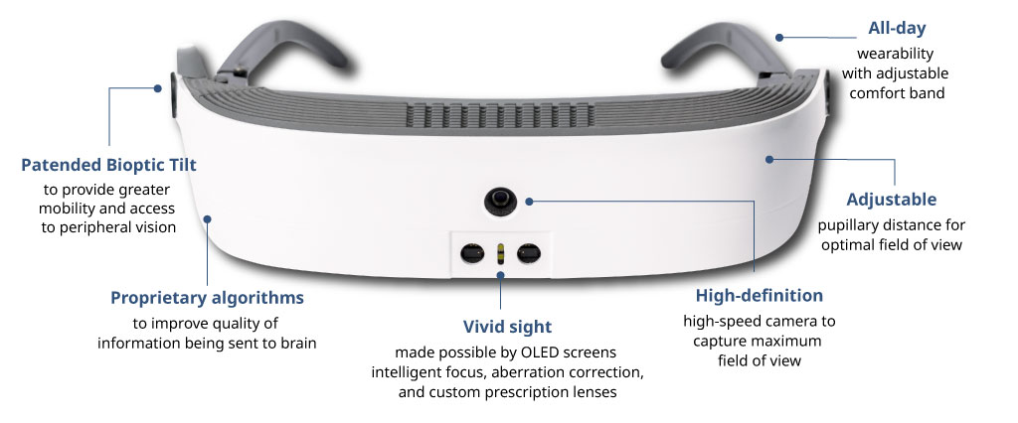

*Figure 3: eSight 3*

This device is used by people with “central vision loss, blurry vision, blind spots and more” [8].The goals of this product are to assist these people view the world around them more clearly with the help of cameras and other sensors and display it to the user on a wearable screen. Both this and our project aim to help people with dulled senses interpret the world around them better, but this product is more for individuals who have partial sight loss (legally blind).

A product like this is more refined and will likely have more powerful cameras and sensors than ours will. It is also Wifi and Bluetooth enabled, with removable SD cards. The combination of the above technologies will be much more taxing on the battery life and may make for a heavier product. Adding strong sensor technology and video output will increase the unit’s overall price to manufacture. This is an interesting solution to people with partial blindness, but our product aims to help every visually impaired person.

***Microsoft Soundscape:***

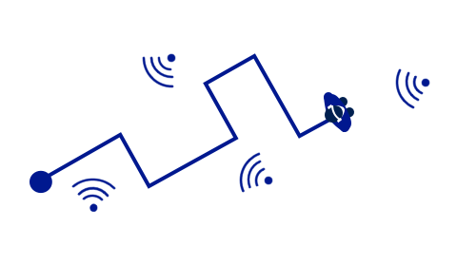

*Figure 4: Microsoft Soundscape*

Microsoft has taken aim at the problem of navigation for the visually impaired as well, and have achieved a similar outcome to the one we want. Soundscape provides “information about your surroundings with synthesized binaural audio, creating the effect of 3D sound”[9].

The user can learn their environment by remembering the sounds they hear and helps them navigate throughout the world easier. Our project is quite similar because we had the idea of echolocation to see, and Microsoft Soundscape mimics this natural instinct for many animals and applies it for humans with impaired vision. We wish to add functionality of sound to our system, so we can tell the user if they are too close to an obstacle.

***BraiBook:***

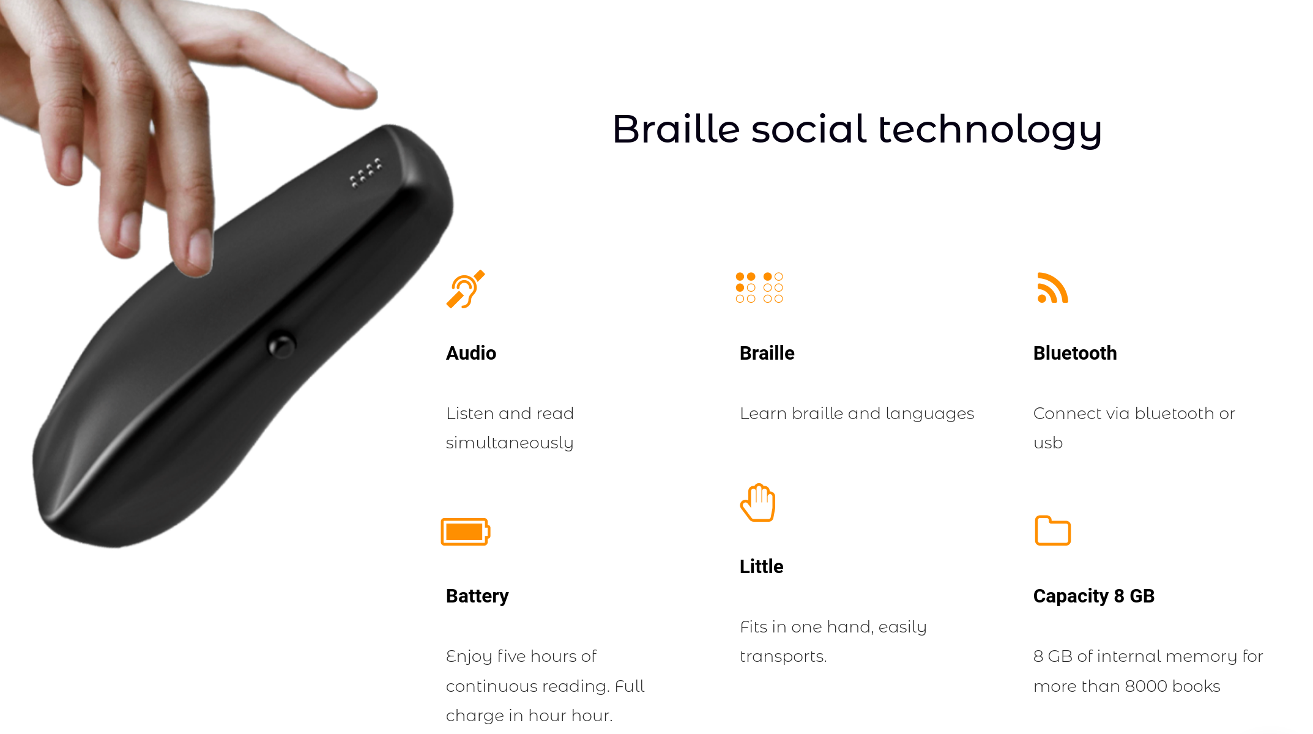

*Figure 5: BraiBook E-Reader*

Braibook is a device that can be used to read electronic books and documents in braille. This can be used to teach common people how to read braille at a slower pace, and includes audio feedback for more ease of use. This device has the benefit of being portable, connected to bluetooth, and helps visually impaired people read again.

***Batpack:***

A project with a very similar aim to ours was a UCF Senior Design project from Fall 2017 called the *Batpack*. This project and ours share many things in common, so we wish to improve on the implementation of their design.

The Batpack is a system for the visually impaired to help them navigate in the world with tactile feedback. This system used several sensor technologies including ultrasonic, LiDAR and cameras to activate a vibrating vest and guide the user through the environment. This was all mounted on a backpack and could be easily recharged. Sensors could tell the user how far they were from something as well as the surface they were walking on.

We wish to improve on this concept by using more powerful sensors, software and technologies to deliver a smaller and more efficient product that accomplishes the same goals with better execution. We do not wish to limit the physical housing to a backpack and instead wish to pursue other wearable possibilities for better user integration into their daily lives.

# **4.1.1. Considerations for Future Technology**

In the future, miniaturization of technology will continue. Because of this, we can be sure our system could be produced in a smaller and more efficient package. Ideally, we would see a device that has the same functionality as ours, or better, with a smaller package. The device could be shrunk down to fit on your wrist entirely, or could be made to fit inside a physical cane used by the visually impaired. You could get alerts to your ear via a bluetooth-ready device that tells you where you need to go or avoid. Sensor technology will have improved, allowing more accurate readings and further distances to be fed back to the user. Better battery technologies will allow for smaller and longer lasting devices before needing a recharge. The combination of these factors will give the ability to produce a better product than we have the ability to make right now.

* Sleeker design
* More intuitive user interface
* Ability to give more accurate results
* Further range of sensors and camera
* Longer battery life
* Smaller physical package
* Easily integrated into other technologies
* Cheaper production costs

# **4.2. Hardware Design Research**

In this section of the project, we will discuss all hardware research. We will discuss range finders, vibration motors, glasses, power supply, and camera selection. We will be compliant with all standards while selecting and researching the hardware necessary for our final project.

# **4.2.1. Laser Sensors**

Laser Range Finding sensors are one of many ways that are able for hardware to be able to detect objects at a distance. This is done by the mechanism releasing a laser that then travels a distance at a certain speed to hit an object. Once the object is struck by the beam of the laser , the beam will then be reflected back to the mechanism. At the moment the beam is reflected the mechanism will raise a signal that it has detected an object. To be able to determine to distance of said object the mechanism will then be able to tell the distance of how far the object is by running the equation:

$$Distance = (Speed) \frac{(Travel Time)}{2}$$

The manufacturer of the specific laser range finder will determine the speed at which the laser is being emitted. And the sensor of the laser range finder will start a timer from when the laser is being emitted and will stop when the sensor detects the laser returning, this will give the travel time. By using these numbers and the equation above the distance can be found between the mechanism and the detected object.

The Laser Range Finder Sensor is acceptable to use when detecting and determining the distance of an object. The key benefits of using a Laser Range Finder are the speed at which the laser is emitted which means that the updated distance will come quicker, this is also dependent upon manufacturer hardware. The disadvantages when using a laser range finder is that it works well only when the object that is being detected is in a known position. This is due to the nature of a laser how it is a single beam of light see Figure 6 below. This would not be able to detect an object that was closer and out of the line of laser.

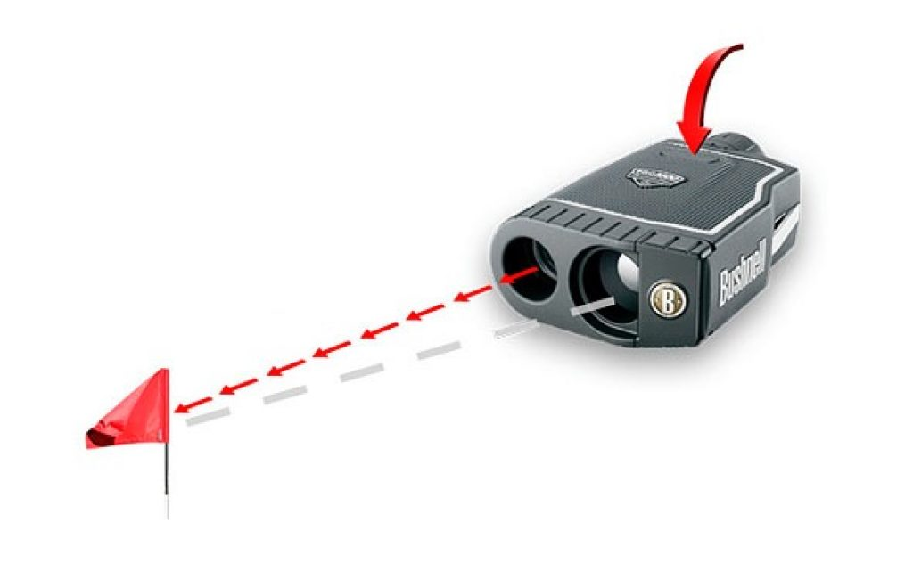

*Figure 6: Laser Range Finder*

This however can be overcome by using Light Detection and Ranging(LiDAR). Lidar has the same functionality as the aforementioned Laser Range Finder of how it is used and how it collects data. The key difference is rather than a single beam of light it sends pulses of light to scan a target. This allows to measure certain distances and such of a wider range instead of single target to multiple targets by moving the angle of the laser and so that it is able to scan the area. By using the angle at which the laser is being pointed and the distance from the objects. The data can be recorded and show the distance between multiple objects.

Because many devices were considered for obtaining the distance between the user and several other objects, these types of devices were not used in the project due to the redundancy of gathering data that other devices could do this was not used.

# **4.2.1.1 Considerations for Laser Range Finding Sensors**

There are many laser range finding sensors in the market but for the purpose of the project choosing the correct sensor will be based upon these factors:

* Size: the size must be small enough to fit on a wearable object such as a hat or glasses.
* Weight: the sensor may not be too heavy so that object is not bothering the user.

* Accuracy: the sensor should be able to detect objects accurately and often.
* Range: The sensor should be able to detect objects that are far and close as specified in the goals.
* Power consumption: the sensor should not consume high amounts of voltage
* Cost: The cost of the sensor should be at a fair price.

# **4.2.1.2. I2C Protocol**

I2C (Inter-integrated Circuit Protocol) is a very popular communication protocol due to its simplicity, needs only two wires to connect a theoretically limitless number of devices, and only the upper bus speed needs to be defined, and can be used on slower MCUs with GPIO pins since only Start/Stop and Read/Write functions are needed [10].

Because of this, we can use it to transmit data to and from the MCU with great efficiency and it will work well with our distance sensors then another communication protocol such as SPI or PWM.

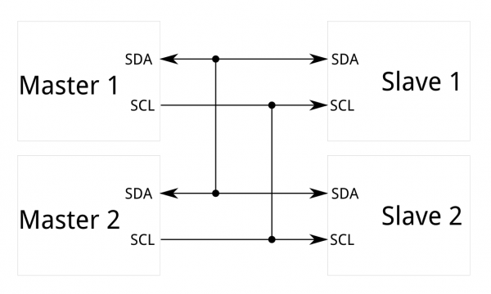  
*Figure 7: Typical I2C Setup*

I2C communication protocol requires only two wires, serial clock (SCL) and serial data (SDA), to communicate, and is able to handle multiple “Masters” at the same time. 8+1 (1 bit forACK/NACK) bits are sent with a frequency between 100-400 kHz. The SCL wire is managed by the master, and allows synchronization across every device.

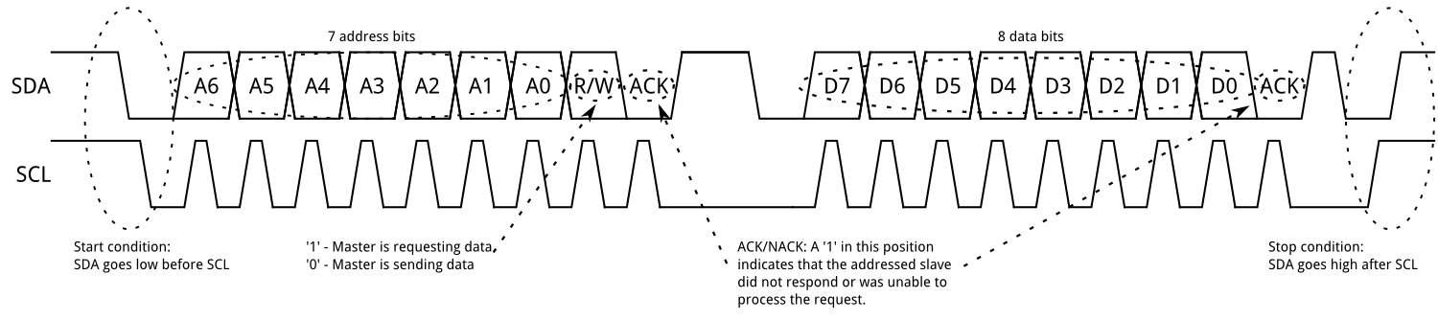  
*Figure 8: I2C Data and Clock Transmission*

There are two types of frames in which messages are transmitted: an address frame to indicate where data is being stored, and one or more data frames to send to the address previously specified. The falling edge of the SCL signal tells the slave that data is now on the SDA line and the transmission of data will stop and data is sampled when SCL has a rising edge and can be seen in the figure above.

# **4.2.2. Ultrasonic Sensors**

Ultrasonic Range Finding sensors are mechanisms that detect objects using ultrasonic waves. These types of devices also compute the range between the object and the sensor. This is done by using an emitter and receiver on the device. The emitter will emit a sound wave at a very high that will travel at a distance to the object. The sound wave will then reflect off the target object and return back to the receiver and detect the object. The distance of an object can also be computed by using the equation:

$$Distance = (Speed) \frac{(Travel Time)}{2}$$

The speed for the above equation, is the speed of the sound wave which will be known and given by the manufacturer of the sensor. To compute the travel time a timer will be started when the emitter emits the sound wave. Then after a while when the sounds wave returns back to the receiver once it reflects off the target the timer will then stop. The time at which it stops is the Travel time. The travel time must be divided by two so that the distance after the sound wave returning back to the receiver is not calculated.

The key advantages of using an ultrasonic sensor for the detection of objects is its ability to be able to scan a wide area for multiple objects due to it emitting a sound wave. For example, see figure 9.

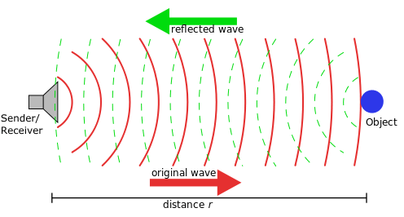

Figure 9: Ultrasonic Wave Detector

The ultrasonic sound wave travels at around 343 m/s (Source) which is relatively fast. In the case of detecting an object at close ranges this would be useful but if it were more than a couple kilometers it would be relatively slow. A disadvantage when using the sensor is sensing surfaces that absorb sounds like foam or other products the sound wave would travel and then hit the sound absorbing wall. The sound wave would not reflect back to the receiver thus never detecting an object.

# **4.2.2.1 Considerations for Ultrasonic Sensors**

There are many ultrasonic sensors in the market but for the purpose of the project choosing the correct sensor will be based upon these factors:

* Size: the size must be small enough to fit on a wearable object such as a hat or glasses.
* Weight: the sensor may not be too heavy so that object is not bothering the user.

* Accuracy: the sensor should be able to detect objects accurately and often.
* Range: The sensor should be able to detect objects that are far and close as specified in the goals.
* Angle of Sensing: The sensor should not have any detection that is too wide for there will be multiple sensors that are relatively in the same direction in order to have more precise detection of objects .
* Power consumption: the sensor should not consume high amounts of voltage
* Cost: The cost of the sensor should be at a fair price.

# **4.2.3. Optical Sensors**

Optical sensors will be a vital part of the C.A.N.E. device. The research on specific components and functionality are detailed in the subsections below.

# **4.2.3.1. Motivations**

For our C.A.N.E. project it is empirical that we create a system that is safe, reliable, and accurate for the benefit of our future user base. Because of this, we are using multiple sensors, one of which is the Optical Sensor. We need it to accurately measure the distance of objects that may appear in front of our user quickly and reliably.

# **4.2.3.2. Considerations for Optical Sensors**

There are several optical sensors in the market but for the purpose of the project choosing the correct sensor will be based upon these factors:

* Size: The size for the optical sensor must be small enough to fit securely

on the glasses.

* Weight: The optical sensor must be light enough so that it does not add too much weight to the overall project. It must be light enough so that the sensor does not bother the user.
* Accuracy: The optical sensor should be able to detect objects accurately from different distances.
* Range: The optical sensor should be able to detect far objects that are up to 10m away and as close as 1 meter away.
* Angle of Sensing: The optical sensors should be placed in such a way to give optimal line of sight for best overall use.
* Power consumption: The optical sensor should require low power consumption
* Cost: The cost of the sensor should be reasonable and ideally under fifty dollars.

# **4.2.3.3. Optical Sensor Functionality**

Optical sensors are devices that measure light in the visible & near visible electromagnetic spectrum. They do this by emitting a beam of light from the device's transmitter and It then waits for an interruption in the signal or for the receiver to trigger to start the recording. These beams of light on most optical sensors will be emitted by pulse-modulation method. This method will have the emitter transmitting a beam which is pulsed at set intervals. This helps detect any interference by being able to calculate the differences in between the emitted pulses. The unmodulated method will have a beam that is constantly emitting and when and if the beam is interrupted, this will trigger for a recording. Though, these types of unmodulated beams tend to be seen more with fiber optic sensors. Yet typically, these sensors are able to measure the light signal in a few ways described below.

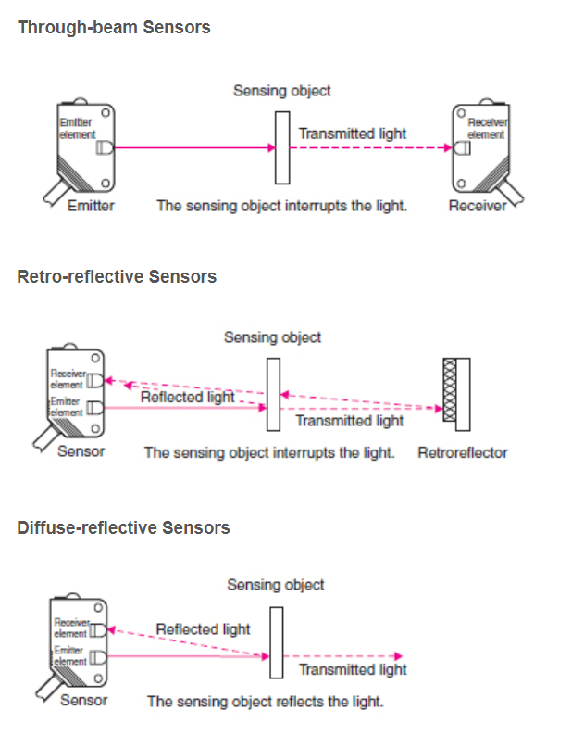

*Figure 10: Types of Optical sensing techniques*

Through-Beam Sensors are a two-piece system that consists of a transmitter and a receiver. The components are placed across from each other and signal is emitted from the transmitter to receiver. This signal will hold a steady state until an object interrupts the signal. This in turn triggers the receiver to record the break. The great thing about the through-beam sensor is their high accuracy and ability to record signals across large distances. But for our project we need the sensor to house both the transmitter and receiver. The Retro-Reflective and Diffuse Reflection sensors both house the transmitter and receiver in the same unit but measure the signal slightly differently. [36]

The Retro-Reflective Sensor houses both the transmitter and receiver but this sensor also requires an additional component to work properly. The Reflective sensor requires the installment of a reflective piece of material located opposite the emitter. When the light hits the object, it will reduce the amount of output light. This is then reflected back to the receiver that uses this measurement to calculate the total distance. But like the through-beam, this will not work for our project because of the impractical nature in adding reflective surfaces everywhere. We may have use for this kind of beam for testing though.

The Final type is the Diffuse-reflective Sensor. This sensor perfectly houses both the receiver and transmitter in one unit. This class of optical sensor works by emitting light from the transmitter. This light is then sent out until it hits a object and is reflected. When reflected light is received by the receiver, the intensity of the light will increase, and this will be used to measure and find the object. This type of optical sensor will be ideal for our project as it will be able to accurately detect objects in front of the user while still being small enough and practical enough to fit on the glasses themselves.

|  |  |  |  |  |  |
| --- | --- | --- | --- | --- | --- |
|  | **Accuracy** | **Sensing Distance** | **Reliability** | **Cost** | **Install Points** |
| **Through Beam** | Most Accurate | Longest | Very | Costly | Two |
| **Reflective** | Slightly less Accurate | Less than T.B. sensor | Very | Costly | Two |
| **Diffuse** | Least Accurate | Less than Reflective | Very | Less than T.B. & Ref. | One |

**4.2.3.4. Optical Sensors Variations**

The optical sensor has many other variations while still using a light beam as an instrument to be measured. The other classifications of optical sensors can be broken down into 3 categories. They would be structure, beam source, and output circuit.   
  
Structure is classified based on its built in elements. For example, the amplifier is built in or separated, is the power supply built in. For our project we need to reduce the amount of extra components as much as possible so having both the power supply and amplifier built in would be ideal. The optical sensor can also be classified based on its beam source. Whether the beam is, colored, red, blue, green, or if the beam is infrared. And the last classification used for optical sensors is the output circuit. There are two main sub categories here that are ON/OFF output and analog output. While these classifications help in organizing all the kinds of optical sensors, for our project we need to make sure we get the most accurate and dependable readings from our sensors.

|  |  |  |  |
| --- | --- | --- | --- |
| **Device** | Classification | Sub-Class | **Method** |
| **Optical Sensors** | Structure | **Amplifier Built-in** | |
| **Power supply Built-in** | |
| **Amplifier separated** | |
| **Fiber Optic** | |
| Sensing Mode | Through-Beam | **General Purpose** |
| **U-Shaped** |
| **Area** |
| Retro-Reflective | **General Purpose** |
| **With Polarizing Filters** |
| **Transparent Object Detection** |
| Reflective | **Diffuse** |
| **Narrow-View Reflective** |
| **Convergent Reflective** |
| **Adjustable Range** |
| **Mark Sensing** |
| Beam Source | **Infrared Beam** | |
| **Red Beam** | |
| **Green Beam** | |
| **Blue Beam** | |
| **Three Color Beam (Red, Blue, Green)** | |
| Output Circuit | ON/OFF Output | **NPN Open-Collector Transistor** |
| **PNP Open-Collector Transistor** |
| **DC 2-wire** |
| **NPN Transistor Universal** |
| **Relay Contact** |
| Analog Output | **Analog Voltage** |

*Figure 11: Classifications of different Optical Sensors*

# **4.2.3.5. Time of Flight**

Time of flight principle is a method for measuring the distance between a sensor and the object being detected. This is based on the time difference between the emitted beam and the return beam to the sensor. Time of flight applications may include LiDAR imagine, motion sensing, 3D imaging, and object detection for machine vision. These applications are great and would do well for our project. The object detection and 3D imaging will help us in getting accurate and reliable measurements that we can cross check and verify with our other sensor, ultrasonic sensor. In the diagram below, it shows the different ways that the beam measurements happen.

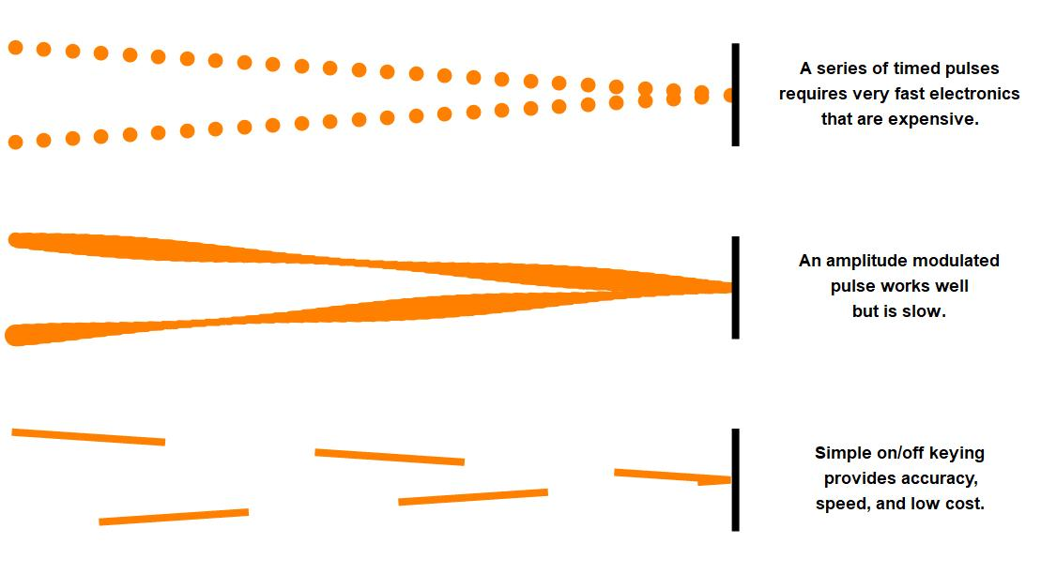

*Figure 12: Different ways travel time is used to measure distance*

The top figure shows the pulse-modulation method. The middle shows the modulation of light and the phase shift would be recorded to be used to measure the difference. And the bottom and last image shows the beam being transmitted at a 50% duty cycle square-wave that would then be recorded at the receiver and the amount of light recovered would create the measurement.[37]

The current optical sensor we are looking at to use for our module, the AFBR-S50MV85G, has a Time of Flight module built in. Thankfully this specific optical sensor was built to explicitly focus on accuracy at medium distance, and as well as to focus on providing the highest speed while being housed in a small device. This was achieved with the added benefit of also consuming very low power. This sensor's Time of Flight Module has the ability to be configured by us to either focus on 3D mapping applications or for the sensor to improve its setting to focus on 1D mapping for better distance measurements and reading. This is the settings the team will most likely focus on.

# **4.2.3.6. Review of Optical Sensor**

The optical sensor being used is the Broadcom AFBR-S50MV85G. A dynamic module able to be used in a variety of different applications including but not limited to distance measurement, robotics, automation, security, and augmented reality applications. The AFBR-S50MV85G is devoted to optimize in distance measuring. With its Time-of-Flight built in module and its top notch ambient light suppression technology, it allows for fantastic use in outside environments where there will be bright direct sunlight. The ambient light suppression technology creates a sort of filter that helps in eliminating possible interference that is helpful especially when reflecting off reflective or black material and objects. This is ideal of our project where the sensors will be used outside a lot and the need to be able to detect objects of all colors and reflectivity is key. The AFBR-S50MV85G is also ideal for our project because we want to measure accurately shorter distances versus longer distances objects. And per the AFBR-S50MV85G specifications sheet, we are informed that the closer the object is, the precision will scale accordingly. So when we measure objects nearby our error accuracy will be lower compared to if we measure objects further away, our error will scale up [28].

# **4.2.4. Vibration Motors**

In order for the user to be able to detect the sense of where they will be walking to avoid objects haptic feedback will be used. Vibration motors will be used to fulfill this role. By sending electrical signals to the vibrating motors the device will vibrate to let the user know that there is an object in front of them. The motors should also be able to vibrate at different sensitivities so that when an object is detected from a far distance it will vibrate softly. When an object is close by the motor will vibrate strongly.

# **4.2.4.1. ERM and LRA**

There are two ways in which to achieve the feat of making vibration motors vibrate. The first way is the Eccentric Rotating Mass (ERM). In this way the motor of the vibrating motor connects to a rod that connects to a mass that is distributed on half of the rod which is as seen in Figure 13.

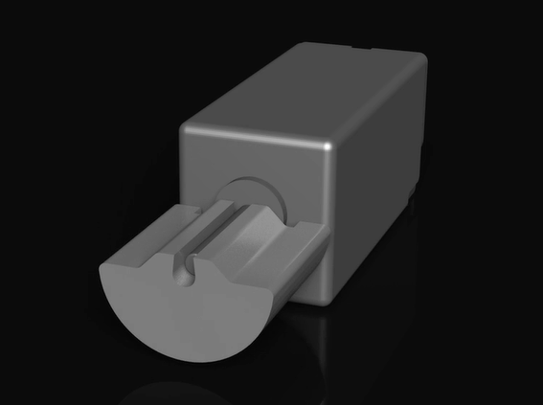

*Figure 13: Vibrating Motor Rod*

The ERM causes the effect of vibrations because as the mass is rotating a it creates a centripetal force. Since the mass is connected to the stationary motor the constant change in direction of the force causes the device to move which gives the sensation of vibration. [62]

The project requires that the vibration motor be able to change its intensity to represent how close an object is. So by using ERM to change the intensity of the vibration the force that the mass and motor produce must be altered. This done by using the equation below:

$Force = m r ω^{2}$

Where *m* is the mass that is being rotated , *r* which is the radius of the rotated mass, and the angular velocity , ⍵, of the mass the force that can be calculated. So to make the intensity of the vibration feel greater any of the variables must be increased. This is only effective depending on the size of the Vibration motor and the device that is using the vibration motor. If the object is big like a table the vibration would barely be felt but is compared to the vibration motor being set in a gaming controller the vibration would be felt with more intensity. Due to our project the vibration motor should be small enough to fit the casing but also big enough so that vibrations can be felt.

The second method which produces the sensation of vibration are Linear Resonant Actuators(LRA). In this way a magnetic plate is connected to a spring. Electrical signals then cause the magnetic plate to up and down to produce the force.[61] This can be seen in the figure 14:

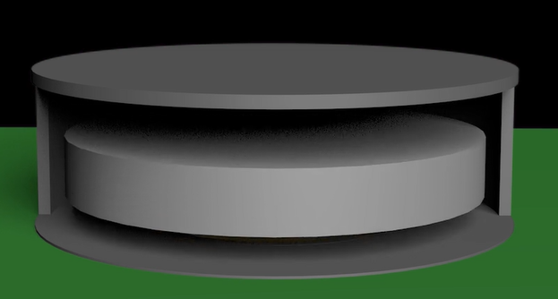

*Figure 14: Magnetic Plate for LRA*

Due to the plate only being able to move on one axis the to be able to produce a force the plate has to oscillate using spring. Due to that concern the electrical signal that is being sent to move the plate up and down must be turned on and off constantly. The electrical source to cause that effect would have to be an alternating current source. If the source being used was a direct current source the electrical signal would be constant. With the constant electrical signal the spring and the magnetic push will reject each other and cause an equilibrium effect, so that the plate would never move up or down. Because there is no movement there would be no force produced, which in turn means that no vibration would be created.

To change the intensity of the vibration the amplitude of the input signal is not as important as the frequency. This is because the LRAs operate best at its resonant frequency.

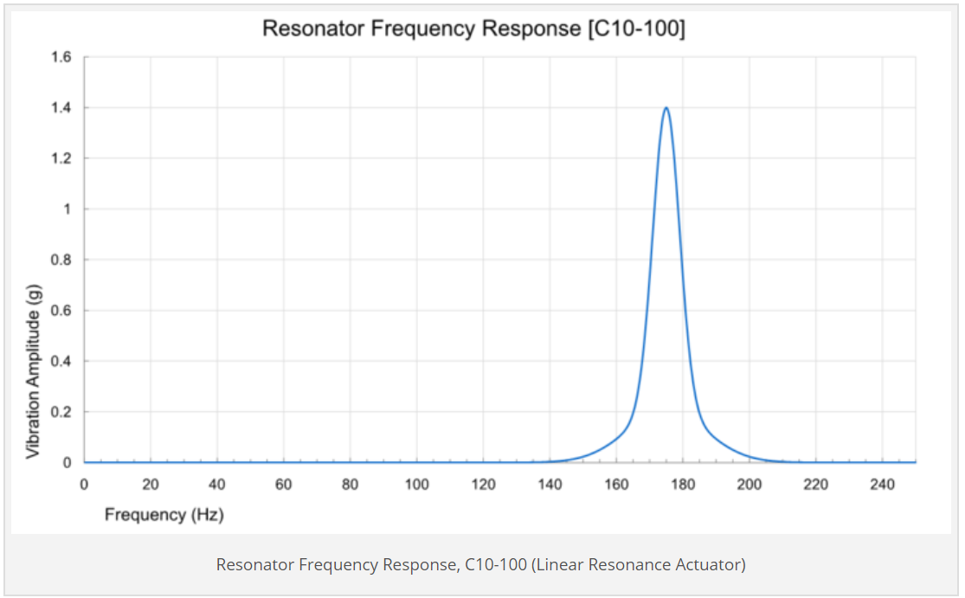

*Figure 15: Resonator Frequency Response*

As can be seen for the plot above for C10-100 LRA the maximum intensity of the vibration will happen at around 175 hz. So to be able to change the intensity the input signal needs to have a frequency either greater or lower so that the vibration amplitude will be lowered.

# **4.2.4.2. Component Specifications**

While Both ERM vibrating motor and LRA vibrating motor both have the same functionality for the purpose of the project which is to vibrate there are times to use one rather than the other. In terms of size the ERM motors although can come in various sizes require dc motors which make the shape of the housing that they are in in a more rectangular form. In comparison LRA vibrations are typically flat which is great to fit in objects that are also flat and can be kept in a more confined space. In this purpose of the project, to sense the direction of the object the user will be using a wearable device. A sub goal of the project is for the wearable device to be comfortable meaning for it to not be bulky. In this sense something flat would be used as the wearable device so a good choice in vibration methods would be to use the LRA.

# **4.2.4.3. Pulse Width Modulation**

When using vibration motors one must worry about the need of powering the device and its electrical signaling to operate the device. The DC power supply would cause this vibration motor to constantly be on and vibrate with the same intensity which for our project would not be helpful in the detection of how close the object that is being detected is. A microcontroller is good to use when trying to overcome this because it will send quick pulses of electrical signal to tell the device when to be on and off, such as for the figure below.

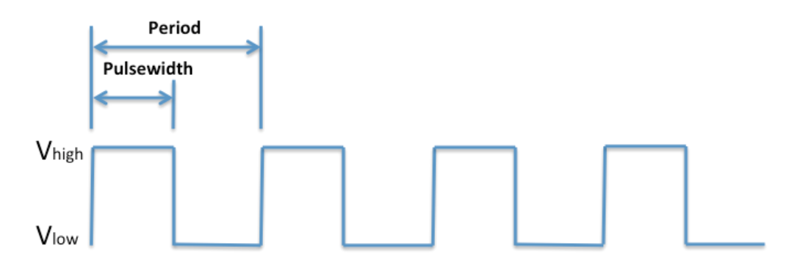

*Figure 16: Pulse WIdth Modulation*

This is just the basics which do not help when trying to change the intensity of the vibrations. To help with that pulse width modulation is used to aid in this. By changing the duty cycles, which is the percentage of time that a cycle is at V high in the given period, the intensity can be changed because the amount of voltage given to the vibration motor is related to the intensity of the vibration.[63]

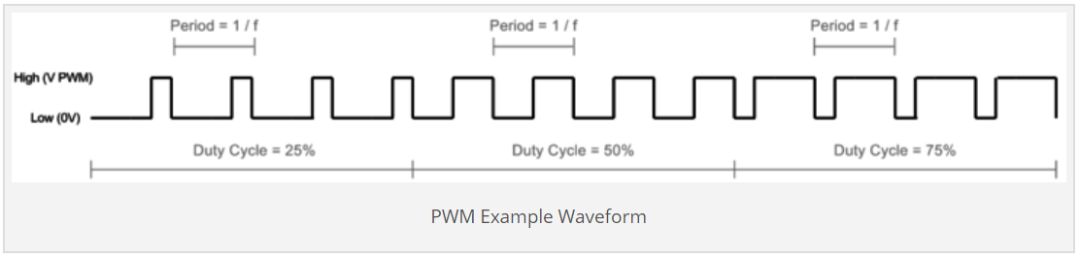

*Figure 17: PWM Example Waveform*

As seen from the figure above the duty cycle and how long the pulse is at the high voltage can be seen and as said before the intensity is directly affected by the amount of voltage given. In order to manipulate this the following equation is used to affect the intensity of the vibration.

$Vout = duty cycle * Vhigh$

It can then be seen that the higher the duty the greater the output voltage to the Vibration motor will be which in turn cause the intensity of the vibration to be greater.

*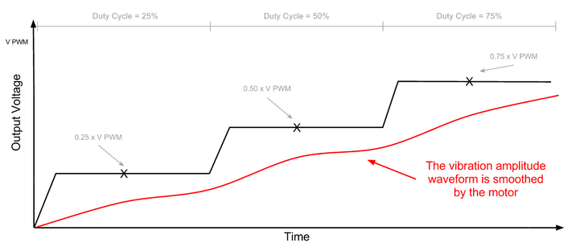  
Figure 18: Duty Cycle and Output Voltage*

**4.2.5. Microcontrollers**

A microcontroller is a miniaturized, efficient computing system that differs from modern PCs in size, power consumption, IO pins, processing speed and data storage. MCUs are used in dedicated applications unlike general purpose computing, and are particularly attractive for applications that do not require complex processing, large battery life, and have no need for a front-end operating system. They are also referred to as embedded systems because they are often hidden inside of consumer products and act as the “brain [11]”.

Our selection for microcontrollers for this project includes the MSP430G2553 microcontroller, as well as the Raspberry Pi 4.

Texas Instruments’ MSP430 is a good choice for our project because it is low-power while still providing excellent clock speeds, and has multiple power-saving settings for inactivity. The MSP430 is an excellent option for a job that requires repetitive, specialized computing and is suitable for few distinct tasks.

The Raspberry Pi 4 is another good option because although it has a higher power draw (5V supply and recommends 3A of current), it can power multiple peripherals and handle their operation and the transmission of this data for calculation. It has a much faster clock speed than the MSP430, at 1.5GHz and 40 IO pins, and will probably be handling our calculations.

The synthesis of these two MCUs will allow our project to be powered and handled appropriately by two sufficient boards.

|  |  |  |  |
| --- | --- | --- | --- |
| **PARAMETER** | **ARDUINO UNO R3** | **MSP430G2553** | **RASPBERRY PI 4** |
| **CLOCK SPEED** | 16MHZ | 8MHz | 1.5GHz |
| **DIGITAL I/0 PINS** | 14 | 16 | 40 |
| **FLASH** | 32KB | 16 KB | 512KB |
| **INPUT VOLTAGE** | 7-12V | 3.3V | 5V |
| **MIN POWER** | 42mA | 1.8V | 2.5A |
| **PROCESSOR** | ATMega 328 | ARM Cortex M4 | ARM Cortex-A72 |
| **SRAM** | 2KB | 512B | 16GB |
| **SIZE** | 68.6mm x 53.4mm | 229 mm² 24.33 x 9.4 | 85.6mm x 56.5mm |
| **WEIGHT** | 25g | 136.078g | 46g |

*Figure 19: Microcontroller Data*

# **4.2.6. Camera Part Selection**

There are several requirements that will be necessary in the camera component that will be used for the C.A.N.E. project. This camera will need to be as small as possible so that it can be placed on glasses without hindering usage. The camera will also need to be very accurate with the largest possible range. Finally, and most importantly, the camera will need to be compatible with computer vision systems.

After considering several different computers compatible with computer vision technology (and specifically Raspberry Pi), our team has decided to go with the Raspberry Pi Camera Module (v2). There are many factors that went into this decision, including size of the camera, power requirements, compatibility with the Raspberry Pi board, speed, and image quality. The Raspberry Pi Camera Module is just 25mm x 23 mm and weighs just under three grams [12], which makes it perfect for our needs. It has no additional power requirements aside from that of the Raspberry Pi single board computer. It utilizes the Sony IMX219PQ image sensor, and is capable of supporting a 1080p stream of HD video footage [13]. Additionally, the camera module automatically filters out unnecessary noise and has built in exposure control, white balance, and exposure luminance detection. It’s size, compatibility with the Raspberry Pi module, and automatic image correction make this camera a good fit for the C.A.N.E. system.

# **4.2.7 Power System Research**

The use of sensors, control units and other peripherals must be powered constantly and sufficiently in order to provide reliable support for the visually impaired. Considerations for the power supply to this device has included several key elements including:

* Weight
* Dimensions
* Reliability
* Output Power

The power system used in this project must deliver enough power to the required components at all times. The critical components needing power are the microcontrollers used as the “brains” of our device. We will be using a MSP430G2553 MCU and a Raspberry Pi 4 to control our systems. The MSP430 requires a supply voltage within the range of 1.8-3.6V and in “Active Mode” uses ~230μA at 2.2V[14]. Our Raspberry Pi requires 5V and 3A to operate[15]. The peripherals we intend to use for our project includes optical sensors, ultrasonic sensors, vibrating motors, a Raspberry Pi camera module, and sound output. The recommended maximum total USB current draw from peripherals attached to the Raspberry Pi 4 is 1.2A, so we must keep our usage below this threshold.

If our battery supply outputs 5V, this would be highly convenient since that is the voltage required by the Raspberry Pi and no voltage regulation would be needed. However, the MSP430 needs a lower input voltage so we would adjust the supply voltage with a step-down voltage converter for that case. The peripherals will be handled by both MCUs and will only increase the current draw, so power requirements should be satisfied if we chose a battery pack with an output voltage of 5V, and current output of 3A, but would be suggested to go higher for more breathing room in the design.

Another peripheral likely to require lower voltage (typically between 1.5-3.7V) are the various vibrating motors. There are many excellent options for voltage regulators and converters and a package similar to this may be used to ensure a longer lifetime for each peripherals.

**4.2.7 Audio Output Research**

The Raspberry Pi 4 has a built in 3.5mm 4-pole composite video and audio jack. This is sufficient to drive the sound output we require to the user via headphones. Alternatively, there is on-board Bluetooth capability, which could also be used to output audio to the user. The Raspberry Pi 4 also contains an on-board speaker, which is another valid option to deliver audio feedback.

At this time, our team plans to utilize the audio jack for audio feedback. There are several advantages that we believe will come with this decision. Firstly, the use of the audio jack will not require our headphones to maintain their own charge. The use of bluetooth headphones could be a hindrance to the users, who would need to ensure that the C.A.N.E. device and their headphones were properly charged at any time. The failure of either of these things would of course cause the C.A.N.E. device to malfunction, so our team has decided that this is an unnecessary risk.

The use of an out-loud speaker system poses its own issues. The speaker system could be considered a violation of privacy or even become a distraction to people around the user. These issues are discussed in more detail in the social constraints section of our paper.

We will use the data from sensors on our device to alert the user to changes in environment and obstacles in their vicinity. This feature will allow for greater safety and advanced notification to the user.

**4.2.8. Glasses Research**

When considering what glasses to use as the base for our device, there are a few factors to consider. These include the size of the glasses; a larger of which will allow us to attach more components. We are also considering the comfort of the glasses, as this is important for our users. Finally, we will consider the price of the glasses. Since they are only a base for our hardware, and don’t need to have prescription lenses (or even decent lenses), preference will be given to glasses with a lower cost. This is especially true since there is still a possibility that our team will shift to a hat as the base for our design, if more space is needed for storing components.

When considering the weight of the glasses, our team also took into account the total possible weight of our C.A.N.E. project which would sit on the glasses frame themselves. The lighter the frame the better but we also must acknowledge the durability of the frames. If we choose a lighter frame, it may benefit the project in reducing the overall weight. But a negative aspect of this would be the possibility that it can break easily. The frame of the glasses must be able to sustain a decent amount of handling without breaking. The user will be putting the C.A.N.E. on daily and should not have to worry if their frame (the base of the product) is too flimsy. This brings an interesting situation for our team to handle. We must have a durable, strong, yet lightweight frame to be able to hold all the required components.

In the case that our team decides to use a hat as the base for our project, we will consider many of the same factors.

**4.2.9. Voltage Regulator Research**

The voltage regulator is a component that is used to help in maintaining a constant output level voltage and thus keeps from causing damage to different parts of the design. The voltage regulator works by keeping a steady output while input may vary using different BJTs and MOSFETs. It is an exceptionally important component for all designs in keeping the product safe and components from frying up. There are two main types of voltage regulators. The more popular one at the moment is the Switching Regulator and the other one is the Linear Regulator. [16]

While both provide the same purpose, their design and performances do vary. The Linear regulator works by using a feedback loop that senses the output voltage and adjusts the current to meet the required allowed output voltage. This difference between the input voltage and output voltage is called the drop out voltage. An advantage of the linear regulators is its ability to have a clean output that does not have much noise associated with it.

The Switching Regulator works by taking the input voltage and moving the filtered output voltage back into and through the circuit that controls the power switch, switching it on and off. By switching it on and off, it governs the output voltage to remain at a constant level. Some advantages of the switching regulator include higher overall efficiency, large output power capability, and ability to buck and boost voltage. Some downside to the switching regulator in relation the linear regulator would be the design complexity. Switching regulators have a more complex circuitry with higher part count. The price for a switching regulator is also higher. [17]

# **4.3. Software Design Research**

Software Design is a very large portion of the C.A.N.E. project. In our project, software design will be used for computer vision purposes, as well as to determine what information to pass to the user and at what times it should be conveyed. As a vital part of our project, careful consideration and research will go into all software design, algorithms, dependencies, and libraries used. **4.3.1. Operating System**The Raspberry Pi 4 single board computer will be used for the Computer Vision and optical algorithm portions of the C.A.N.E. project. As a single board computer, the Raspberry Pi runs with the Linux Operating System. This will allow us the freedom to use any programming languages, libraries, and dependencies we choose.

For the computer vision portion of this project, Python will be used in conjunction with the open source computer vision and machine learning software library, *OpenCV*.

**4.3.2. Optical Algorithm**  
As mentioned earlier, our weapon of choice for approaching the computer vision and optical algorithms in this project is Python’s open source computer vision library, *OpenCV.* As a library of Python bindings that are specifically designed with computer vision in mind, OpenCV is a very powerful tool. We selected OpenCV due to its popularity and compatibility with the Raspberry Pi 4, and since there is an abundance of information and documentation about its many features easily available to us. OpenCV is also built for real-time use, and allows testing to occur using both static images and real-time camera feed. [18]

Another important software element that will be used in our project is the NumPy package built into Python. NumPy is built for scientific computing and provides, among other things, a multidimensional array object that will prove to be very useful in handling computer vision. Instead of storing a large video stream in the Pi and attempting object detection on still-moving images, we will utilize NumPy to store a collection of periodic snapshots, which will be easier to analyze \ from a programming standpoint as well as prove to be less stressful on the Raspberry Pi’s CPU [19].

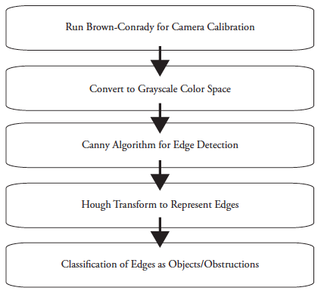  
*Figure 20: Planned Optical Algorithm*

Optical algorithms involving computer vision will be used to identify obstacles that cannot be located or properly identified by our array of sensors, including sidewalks, doorways, and stairs. Figure 20 is a visual representation of the algorithms that will be used. Each algorithm will be discussed in more detail below.

# **4.3.2.1. HSV Color-Space**

The HSV (Hue, Saturation, Value) Color-Space is an image manipulation tool used to aid in computer vision object detection. It is a common tool in computer vision when trying to detect objects/obstructions that are similar in color. The HSV color-space could prove useful in the detection of stairs, sidewalks, and doorways since in most cases, they are a consistent color throughout. An example of the HSV color-space is below.

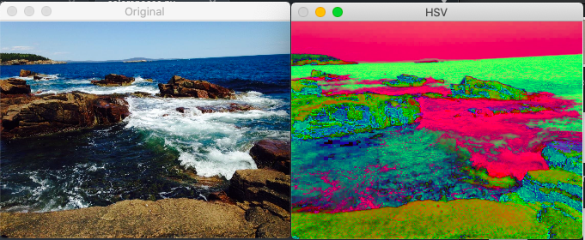

*Figure 21: The HSV Color-Space*

Examining the figure 21 above, it can be seen that even before any edge detection algorithms are run, the HSV color-space is a powerful tool. Compared to the original image, even the human eye can see edges as well as slight variations in color more clearly than in the RGB counterpart of this image.

# **4.3.2.2. Grayscale Color-Space**

The Grayscale Color-Space is also a commonly used image manipulation tool. It is an alternative to the HSV Color-Space, and can also be very useful when converted immediately before edge detection. Unlike the RGB or HSV Color-Space, Grayscale requires only one parameter be stored for each pixel: the intensity. This is stored in an 8-bit unsigned integer, and can therefore have a value between 0 and 255 inclusive. [20]

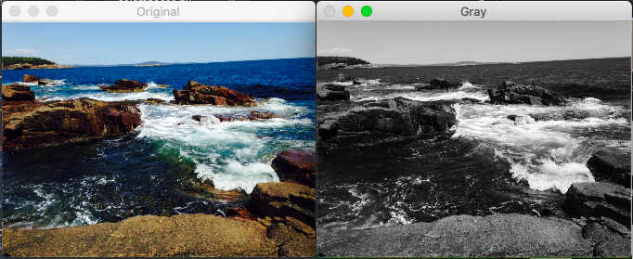

*Figure 22: Grayscale Color-Space*

Assigning each pixel a single intensity value is very effective at improving edge detection algorithms as well. Instead of checking for differences in colors, the edge detector now only needs to search for neighboring pixels with large differences in their intensity.

After carefully considering the differences and strengths of the HSV Color-Space as compared to the Grayscale Color-Space, our team has decided to utilize the Grayscale color-space going forward. The Canny Algorithm was run on several different images in each color space, and the results have conclusively shown that grayscale is more effective for our purposes. All future algorithms going forward shall be preceded with a conversion to the Grayscale color-space.

# **4.3.2.3. Canny Algorithm**

The Canny Algorithm is a multiple step, edge detection algorithm commonly used in computer vision. It is built into the OpenCV library in Python.   
   
The Canny algorithm begins with applying a Gaussian filter with the purpose of blurring the image to remove unnecessary noise. This includes textures and finer details that will not be necessary in the edge detection process but could cause the Canny algorithm to pick up extra, unnecessary details. The Gaussian blur requires the input of a Gaussian kernel, which is essentially the parameter that defines how blurry the image will become. This kernel, also called the *convolution kernel,* defines the size of the window that will be used to blur each individual pixel. A 5 x 5 kernel will adjust the pixel at the center of this matrix to have the average color value of the pixels in the surrounding matrix. The kernel must be an odd number, so there will be a true center to the matrix. A larger kernel value will produce more blur in the picture, but risk losing detail that might be desired in the edge detection. Smaller kernel values might leave unwanted noise in the image, which could later cause unwanted edges detected by the Canny Algorithm. For this project, a kernel of 7 x 7 will be used. The algorithm for the Gaussian blur is below, where σ represents the kernel size of an image of size m x n.

,   
where

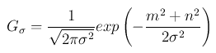

The second step in the Canny Algorithm is the computation of the gradient intensity representation of the image. This will be accomplished using the Sobel kernel in the horizontal (gm) and vertical (gn) directions. Since the edges in an image could point in many different directions, the Sobel edge detection operator returns the first derivative in the horizontal and vertical directions, which can be used to determine the edge gradient and direction as below.

,

and



Next, the Canny Algorithm will apply non-maximum suppression to the detected edges. This essentially works with the purpose to thin the detected edges in the image. This is accomplished by checking if each non-zero edge is greater than other edges along its gradient direction. If so, the edge is left unchanged. If not, the edge is eliminated.

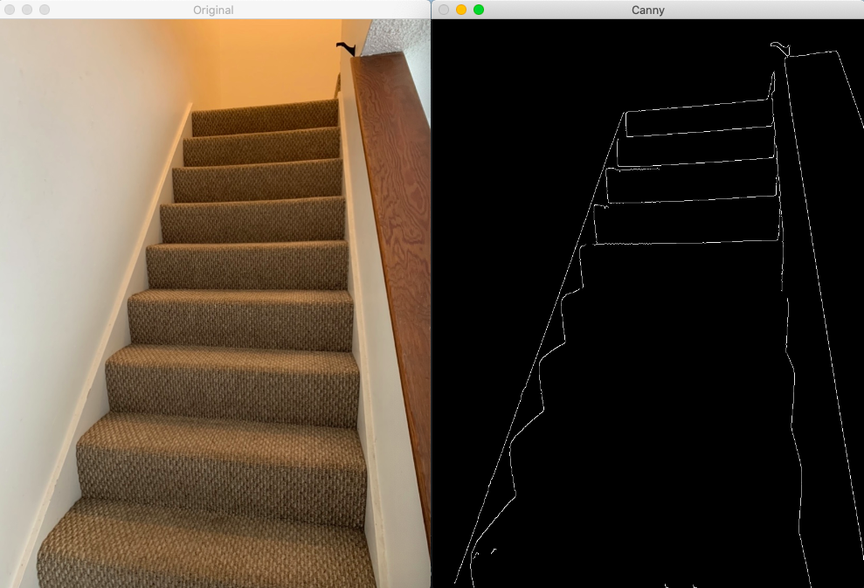

*Figure 23: Canny Algorithm, σ = 11*

The final step in the Canny Edge Detection Algorithm is to track edges using hysteresis thresholding, which will be discussed below.

The Canny Algorithm returns an image containing outlines of the edges found. Figures 23 and 24 show the results of the Canny Algorithm run twice on an image of a staircase, revealing the detected edges. Two different kernel sizes were used in the Gaussian blur, which contributes to the extra edges picked up in Figure 24. Although the higher kernel value produces a clearer image, there are some details missing in the image that could be important in further algorithms. Therefore, the lower Gaussian kernel, σ = 7 will be used for this project. Additional image processing will be required to filter through and remove edges detected by the Canny algorithm that will not be necessary to identify any sidewalks, stairs, or doorways.

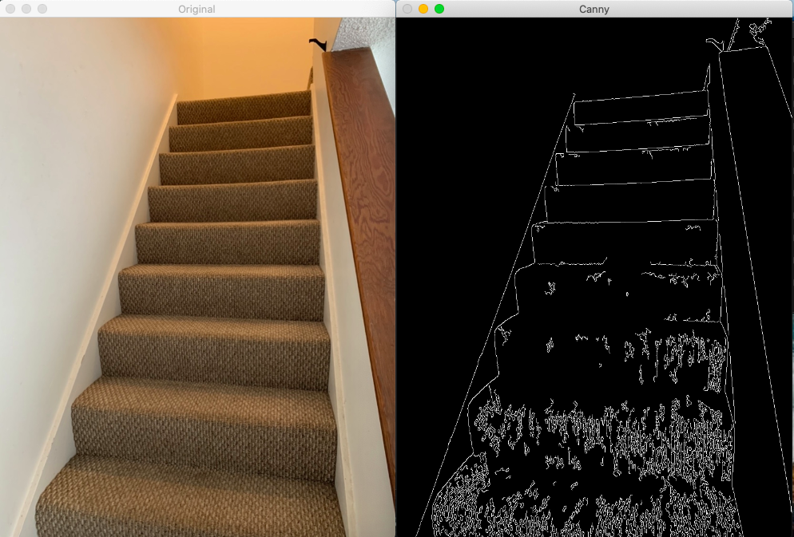

*Figure 24: Canny Algorithm, σ = 7*

Regardless of the extra noise, it is not difficult for the human eye to discern the contents of this image; however a computer will require more help. The image will need to be cleaned up and then examined by further algorithms to classify the contents and determine if they are of interest.

**4.3.2.4. Hysteresis Thresholding**  
After the maximum suppression stage, the Canny Algorithm needs to apply thresholding techniques to achieve the final result. Most thresholds function with a single threshold boundary, which might cause broken lines in edge detection. The Hysteresis thresholding technique is unique in that it works by using lower and upper boundaries to ensure that the edges found are continuous lines, and are not interrupted by fluctuating edge values. These bounds are manually input into OpenCV’s Canny function.

Would like to use Rosebrock’s auto-canny function - contact author. This auto-canny function automatically optimizes the thresholds by computing the median intensity of pixels in the image and utilizing a function to find the upper third and lower third values. These values are multiplied by the calculated median, then compared to the absolute minimum and maximum values (0, 255) to find the optimal values.

# **4.3.2.5. Hough Transform**

The Hough Transform is an image processing technique used to isolate features that match a given shape within an image. While the Canny Algorithm is very effective for detecting edges, the Hough Transform allows us to give these edges a mathematical representation, which is useful in determining the shape and using them to identify contents of an image.

The edges returned by the Canny Algorithm are simply a sequence of pixels. This information alone is difficult to work with, and even more difficult to conclusively determine the contents of an image. Using the Hough transform, each pixel in the image is compared to others in position and their intensity value, which allows the algorithm to determine which edges are the most prominent. These prominent edges are then represented as lines in what is called the *MC Space.* Since any straight line can be represented by a slope and an intercept, the MC Space allows each line to be represented by a single ordered pair based on these characteristics.

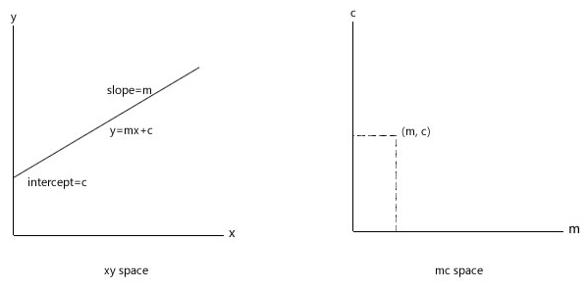

*Figure 25: The MC Space*

Each edge detected by the Canny Algorithm will be represented in the described MC Space. However, this poses an issue for lines that are completely vertical. Since the slope tends to infinity for vertical lines, there is a potential issue with the memory required to store the MC Space. Therefore, the normal form of the lines will be used instead.

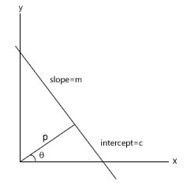

*Figure 26: The Normal Form*

In the normal form, a line is represented by angle θ and length p. Storing all of the information about lines in the image is not an issue in this form. In the normal form, the equation of the line is below.

P = x1cosθ + y1sinθ

The Hough transform will examine each pixel in an edge-detected image and determine whether or not it is an edge. In the case that it is an edge, a line is generated to represent it. A 2D array is generated with the points on the (p, θ) plane. When plotted, brighter points correspond to the parameters of lines in the image. This information, along with the intensity profiles of each edge provide valuable information for classifying the contents of an image.

# **4.3.2.6. Camera Calibration**

**Motivations**

A large part of the C.A.N.E. project relies on the accuracy and clarity of the images we receive from the camera module. Due to the nature of our project as a medical device, there is very little room for error. In order to ensure the best results from our image processing algorithms, we must first verify that the images we pass to it are optimized. Although camera technology has made great strides in recent years, there are still a few things that we must look out for in our captured images. The use of a small pinhole camera, such as the Raspberry Pi Camera Module comes at a cost; there is significant distortion of the images produced.

Distortion is a common issue in all types of photography and videography in which straight lines in the captured image appear to bend. Nearly all cameras experience some type of image distortion; there is no perfect lens in existence today. When processing images for computer vision, our algorithms will often search for straight lines, so distortion is a potential issue that requires research.

**Different Types of Distortion**

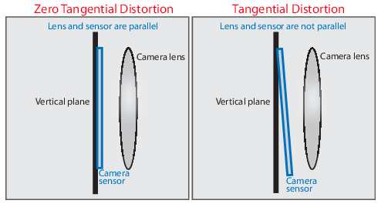

*Figure 27: Tangential Distortion*

There are two main categories to classify image distortion. Tangential distortion occurs when the camera lens is not parallel to the image plane. For image dimensions (x, y) and tangential distortion coefficients p1 and p2, the distorted points x and y can be calculated with the below equations:

*x*distorted = *x* + [2 * *p*1 * *x* * *y* + *p*2 * (*r*2 + 2 * *x*2)]

*y*distorted = *y* + [*p*1 * (*r*2 + 2 \**y*2) + 2 * *p*2 * *x* * *y*],

where

r2 = x2 + y2

Tangential distortions are more difficult to see with the human eye that other types of distortions, but are just as troublesome. If left uncorrected, tangential distortions can cause errors in computer vision algorithms. These might include miscalculations of distance between the camera and the subject, or the distance between two items.

Radial distortion occurs when light bends more near the edges of the lens than it does in the optical center of the lens. This is more common in smaller lenses such as our chosen camera module, so we will focus on it more than tangential distortion.

*x*distorted = *x*(1 + *k*1\**r*2 + *k*2\**r*4 + *k*3\**r*6)

*y*distorted= *y*(1 + *k*1\**r*2 + *k*2\**r*4 + *k*3\**r*6),

where

r2 = x2 + y2

There are several types of radial distortion that could potentially cause issues with our computer vision algorithms. They include Barrel, Pincushion, and Mustache distortion.

Barrel distortion occurs when straight lines appear to bend out towards the edges of the image. It occurs when the magnification of the images decreases as the subject of image gets further away from the lens. It essentially boils down to the perspective of the camera lens in comparison to the object in question. Barrel distortion is a common phenomenon in wide-angle or zoom lenses. It can be fixed using a specific ‘tilt and shift’ lens or by image processing in later stages.

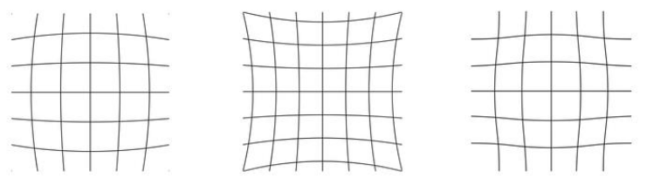

Figure 28: Barrel, Pincushion, and Mustache Distortion

Pincushion distortion is the reverse effect, and is caused by image magnification increasing towards the edges of the frame. It is commonly seen when using longer, telephoto lenses and on occasion, zoom lenses. It can be fixed with image processing after the picture has been taken.

Mustache distortion is considered a combination of the both barrel and pincushion distortion. It is considered more complex than the barrel and pincushion distortion, and is also more difficult to correct. Fortunately, OpenCV has helpful libraries built in to correct the effects of both tangential and radial distortion.  
  
  
**Solution**

The Brown-Conrady model was the first to classify distortion into radial and tangential varieties. It is a widely used and very effective means of removing distortion from images. Lucky, OpenCV provides an implementation of the Brown-Conrady model as a part of it’s Camera Calibration Module.

The Brown-Conrady model uses a multi-step algorithm to determine the distortion matrix and the camera matrix, and is able to correct the image from there. OpenCV’s Camera Calibration module provides a simple solution by determining the distortion coefficients. [20]

Their suggested method involves printing out a chess board image and measuring the squares on the grid. The real-world measurements are compared to OpenCV’s measurements in order to determine the distortion coefficients. Once the coefficients are located, the image is corrected by OpenCV.

# **4.3.2.7. Comparison of Different Sobel Methodologies**

The Canny Algorithm is just one implementation of what are known as Sobel Methodologies. More research will be done to determine the best algorithm or combination of sobel methodologies for our edge detection purposes.

# **4.3.3. Neural Networks**

If you have ever seen the movie *The Incredibles*, you have a good idea of the concept of Machine Learning. The scene in which the villain creates a series of robots designed to learn from every attack used against them was a major contributor to my interest in engineering as well as artificial intelligence as a child. Machine learning is an application of artificial intelligence (AI) that provides machines the ability to learn from experiences without being specifically programmed [21]. Neural networks are an application of machine learning in which a computer learns how to perform a given task based on analyzing training examples [22]. For example, an algorithm that is designed to recognize cars in an image may be given hundreds or even thousands of car images to analyze and find patterns in before the algorithm is ever run.

# **4.3.3.1. Motivations**

As stated in earlier sections, it is extremely important to our project that the computer vision algorithms work. In addition to our optical algorithms described above, the use of neural networks can further aid in our search of images and object identification.

# **4.3.3.2. Neural Network Functionality**

Neural networks is one method of deep learning which is sub level of machine learning. This means that algorithms are used in coding for the machine to learn from a previous encounter with a situation and over come the previous situation by knowing what it did in the last situation. An example of this would be coding a program where machine learning was used to teach an avatar to walk. At first it would move its feet and stumble. After the next iterations the avatar would then be able to walk once obstacles were added the avatar would then stumble into them and after a couple more iterations the avatar would be able to avoid the obstacles with ease as if it was learning[23].

As the word neural is in the term neural networks it is seen that the brain and neurons are heavily factored in its functionality. Neural networks are algorithms that are closely structured from the human brain. A human goes through a process of inputting information through our senses such as touch, taste , or sight. That input of data gets directed to the brain where the sense is processed to say whether the surface is hot or cold or the food tastes sweet. The processing of data then also goes through the memorization of a previous encounter of the event and then outputs a reaction to the input of data. For example if you touch boiling water as an adolescent your body will sense that it was hot and you will feel pain which was processed by the brain and then the brain will say move your hand which is the output. Then when faced again with seeing boiling water the person will not touch the water again which is learning.

Neural networks undergo a similar process:

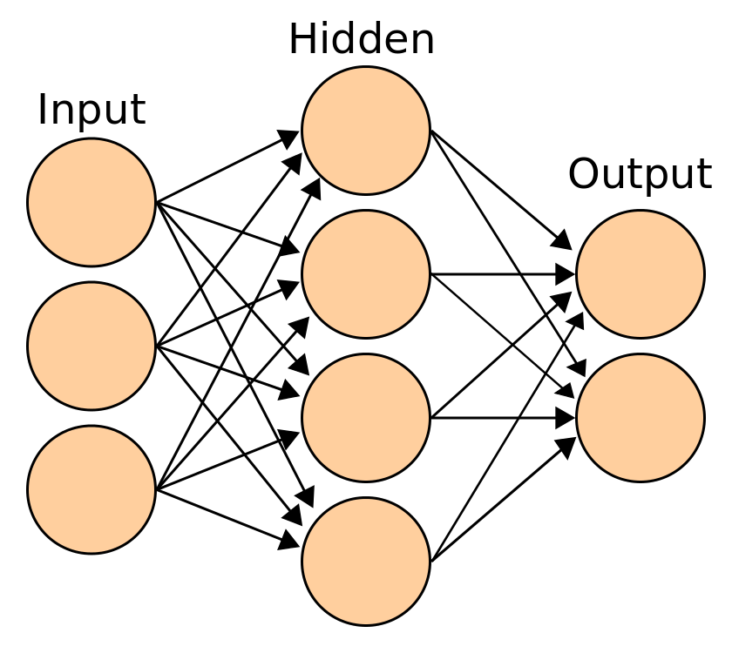

*Figure 29: Neural Networks*

Each circle in the figure above is a neuron which represents data that is flowing through the network. In the beginning the data is then input into the network. From the example above this would be the sensing. The next layer is the hidden layer where the input is then processed. This layer can be several layers deep. The last part in the process is the output which could be success or failure. If the output is failed the process will be repeated but the hidden layer would then be reconfigured so that it does not go to the same failure output.

**Neural Networks and Image Processing**

Wikipedia defines deep learning as part of the broader family of machine learning based on artificial neural networks with representation learning. In other words, deep learning is a powerful tool for neural networks. Combined, they form what is widely considered the most powerful tool for object detection today. We will explore different techniques using deep learning and neural networks that will aid in our detection of any stairs, sidewalks, and doorways.

# **4.3.3.3. Architecture Variations**

**Convolutional Neural Networks**Convolutional Neural Networks (CNN’s) are a type of deep learning neural networks that provided a huge breakthrough in object detection. They are the overwhelming choice when it comes to image detection, and are used in everything from Facebook to self-driving cars. CNN’s are ideal for use in processing 2D images. They work by comparing learned features with the provided image data, and return either a match or a percent probability that the image contains a match for a given object. CNN’s contain several layers for comparisons, including the input layer, output layers, and hidden layers. A convolution operation is applied to the input layer, which then passes information to the next layer and so on. The CNN’s are able to extract elements from the image for comparison. Features are learned through hundreds of hidden layers, each of which is more complex than the last [24].

**Regional Convolution Networks**

Regional Convolution Neural Networks (RCNN) are another way in which to be able to aid object detection, In RCNN when an image is placed several boxes are formed across the image to make sections of the image. The boxes are created by using selection algorithms to determine location and size. Once the sections are divided up CNN operations are then carried out so that a prediction of each different region can be made [25].

# **4.3.3.4. CNNs for Object Detection**

**Image Classification vs. Object Detection**An important distinction in the image processing field is the difference between image classification and object detection. PyImage Search defines image classification as the ability to obtain a label prediction of the contents of an image, as well as a probability that the label description is accurate. {SOURCE}. It defines object detection as image classification, but with the added ability to determine where in an image the object in question is located, and provide a bounding box to identify it. For our purposes in the C.A.N.E. project, object detection will be necessary. Since we plan to inform the user of their distance from the obstruction, it will be important to know its exact location. Some tools to assist in the object detection process include image pyramids, sliding windows, and non-maxima suppression, which will be detailed below.

**Image Pyramids**  
One concern in the image classification is the possibility of false negative results that occur due to the differing size of our reference compared to the detected object. Without this technique, there is a potential that our algorithms would miss objects of interest that do not exactly match the size of the object picked up by the Raspberry Pi’s camera module. The issue can be solved through the use of image pyramids, which essentially store a multi-scale representation of the images or shapes that we are searching for, so that there is no possibility of a miss due to differing scales.

**Sliding Windows**

In the process of determining the location of the object in question, sliding windows are a very powerful tool. Instead of processing the image as a whole, which would return the image classification without any information on location, sliding windows can be utilized. A sliding window is a rectangle that starts at the top left corner of an image, and works its way around the image from left to right and top to bottom, similar to how we would read a page. The image processing algorithms are run at each stop of the sliding window, and information determining whether or not this section of the image is a match for the object/obstruction we are looking for is stored for each stop. With information about which areas of the image contained what we were looking for, a bounding box can be generated using non-maxima suppression.

**Non-Maxima Suppression**The results of the sliding window run will likely produce a multitude of boxes that ‘match’ the image we are looking for. The job of the non-maxima suppression is to take these results and select just one, likely larger bounding box that contains the object in question. This is accomplished by ‘collapsing’ weaker, overlapping boxes in favor of those with a higher likelihood of a match. From here, non-maxima suppression is able to narrow down until only the most likely boxes remain. These become our bounding boxes, and will show where in the image our desired object/obstruction is located.

Most non-maxima suppression algorithms are able to detect multiple copies of the same object, as well as different objects at the same time, which will be very helpful for our algorithms in the C.A.N.E. computer vision section.

# **4.3.3.5. Review of Available Tools**

To be able to make sure that project correctly implements and utilizes machine learning the following tools below can be of some use.

* PyTorch
* Keras
* TensorFlow
* FANN (Fast Artificial Neural Network)

These tools are an open source library for programmers to be able to implement the functions that come with a library to be able to use with any project that requires machine learning (place source). These tools can be easily used when programming machine learning depending on the programming language that is being used. The programmer can import the library into their code and be able to access functions that will aid in the programming.

Although all of these can be used when programming and only a few can be chosen due to the programming languages that they support. PyTorch as the name suggests offers support for the Python programming languages. Tensorflow offers support for many programming languages which include Java, Javascript, C++, GO, and Swift. Although they offer support for these they state that, ”A word of caution: the APIs in languages other than Python are not yet covered by the API stability promises.”[66]. Meaning that when using TensorFlow it is best and safest to use Python. Keras’ library is written in Python therefore it supports python. The FANN library was written in C and offers support for the programming language.

# **5. Project Design**

The details of our planned design for the C.A.N.E. device are explained in the sections below. Any and all designs described in the following subsections are subject to change during the building and testing process.

# **5.1. Hardware Design**

Our team aims to store the hardware on a pair of glasses and the user’s wrist. We believe this will provide comfort and convenience to our users. In the event that we are unable to fit all of our hardware components safely on a pair of glasses and the wrist, we will use a baseball cap or similar.

# **5.1.1. Power Design**

In this section we will discuss all the variables that went into our power design. We will go over the components used in drawing power, battery charging and design, battery housing, voltage regulators, and PCB design. We will remain compliant and refer to all standards while working on our power design. This is vital to make sure we have a safe and reliable project.In this section we will discuss all the power design. We will go over components used in drawing power, battery charging, design & housing, voltage regulators, and PCB design. We will remain compliant and refer to all standards while working on our power design. This is vital to make sure we have a safe and reliable project.

# **5.1.1.1. Power Draw from Components**

The peripherals used in this project all have their own respective power requirements to operate at sufficient capacity. Each component operates at a set voltage and draws more current depending on the usage. To ensure our design accommodates for every component, we will utilize a power supply that powers everything within their maximum power draw.

The first component to discuss are the ultrasonic range finders we will be using in this project. We have selected the LV-EZ1 from MaxSonar for medium to long range (15-350cm) sonar capabilities. The LV-EZ1 uses 2.5-5.5V with typical current draw of 2-3mA.

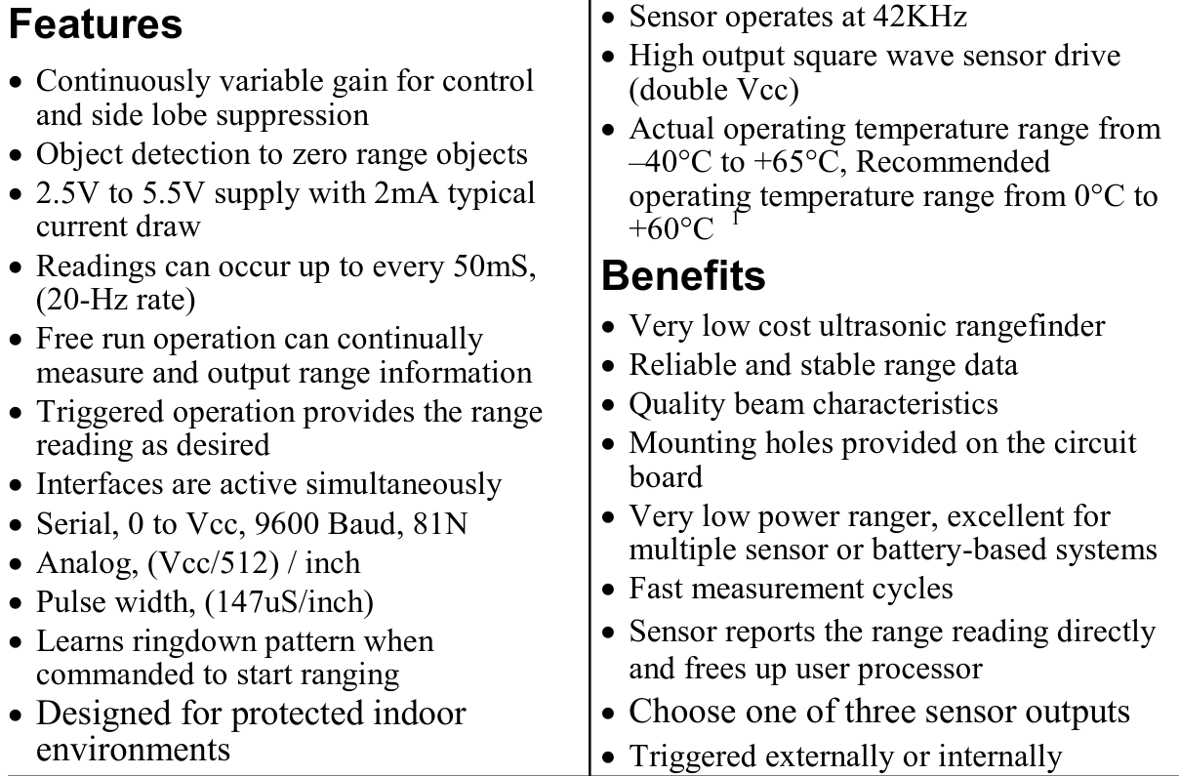

*Figure 30.1: Features of LV-HZ1 Ultrasonic Rangefinder [26]*



*Figure 30.2: LV-HZ1 Operating Current [26]*

We selected this component because it has low current draw and is within our supply voltage. We can use a regulator to ensure this component is within the correct supply and has the right current. For short range sonar, we will use the HCSR04 sensor from Sparkfun. The electrical parameters can be seen below from its datasheet:   
  
 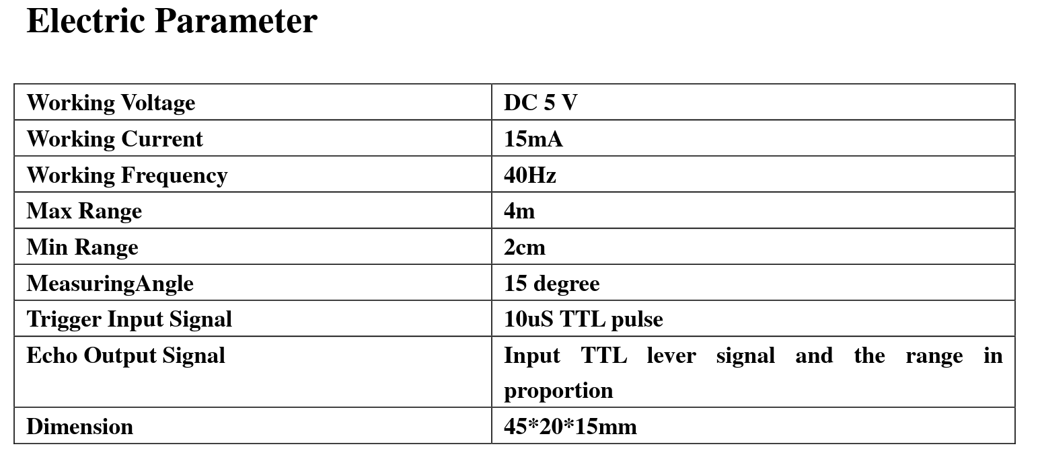  
 *Figure 31: HC-SR04 Electrical Characteristics [27]*

The HC-SR04 is able to accurately detect distances of 2cm-4m, and uses 5Vdc and typically draws 15mA when in use.

The next component to worry about is the optical sensors we will be using. The sensors we selected were AFBR-S50MV85G optical sensors from Broadcom Limited. The voltage for this sensor should be kept to 5V and operates well within the typical temperature the user will experience in the environment.

**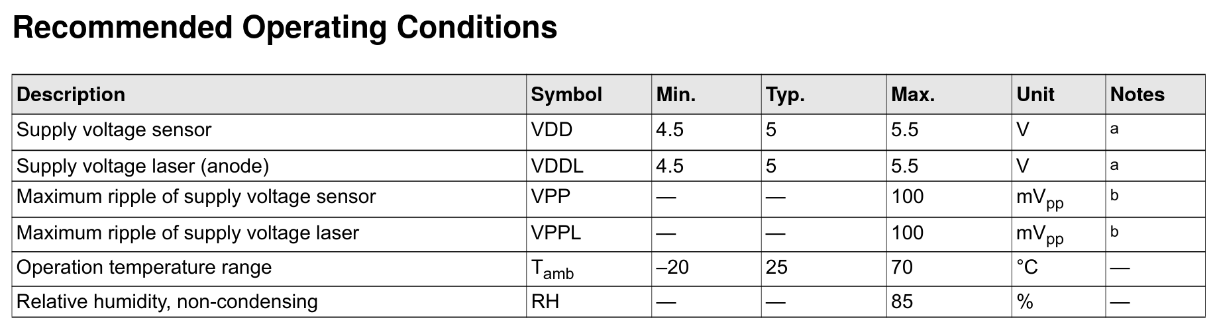***Figure 32: Operating Conditions for Optical Sensor[*28*]*

This optical sensor is highly attractive due to its standard 5V supply, and the maximum power dissipated should be less than 230mW[28]. Optical sensors will provide more accurate rangefinding as well as adding the capability for object detection when used with the Raspberry Pi Camera Module, which uses between 200-250mA and is plugged directly to the Raspberry Pi.

|  |  |  |  |
| --- | --- | --- | --- |
|  | **Voltage(V)** | **Current(mA)** | **Power(mW)** |
| **LV-EZ1** | **5** | **2-3** | **10-15** |
| **HC-SR04** | **5** | **15** | **75** |
| **AFBR-S50MV85G** | **5** | **<45** | **<230** |
| **RaspberryPi Camera Module v2** | **5** | **200-250** | **1000-1150** |
| **Vibrating Motors** | **2-5** | **40-100** | **80-500** |
| **MSP430G2553** | **3.3** | **0.42** |  |
| **Rasp. Pi 4** | **5** | **3000-4200** | **15000-21000** |

A rough estimate for the required current draw solely from peripherals is around 2 Amps. To accommodate for the possibility of the need for more current, plus the Raspberry Pi drawing 3A alone we should pick a power supply that supplies at least 6A.

# **5.1.1.2. Battery Design and Housing**

Considerations for the battery design and housing are highly appropriate, given the fact that our customer market is one who is visually impaired, and thus ease of use should be one of our highest priorities if this device will be used every day for navigating the world.

Due to this, we have decided to utilize a rechargeable battery system, as constantly purchasing and replacing battery packs is harder to do when you are visually impaired. Modern battery technology has allowed for smaller batteries with more capacity, this can be used to our advantage.

One of the most common batteries in the world is a lithium ion polymer (LiPo) battery, and is typically used as cell phone batteries. The advantage to using this as our source of power is they are lightweight, easily replaceable, and highly rechargeable. The housing for these batteries can therefore have a small profile and not be a hindrance to day to day tasks. **Batteries Technology**

There were several types of batteries to choose from. Among the most popular are the Nickel Cadmium (NiCAD), Nickel Metal Hybrid (NiMH), Lithium-Ion , and Lithium-Ion-Polymer (LiPO) Batteries. Each battery type has its pros and cons and we looked into each a bit further to make sure we are choosing the best fit for our needs and requirements for the project.

Looking over the Nickel Cadmium and Nickel Metal Hybrids first. The NiCAD is a type of rechargeable battery with a strong endurance in extreme environments. It has a longer life cycle than NiMH but does have charging issues. These issues sometimes arise when the battery is not charged up all the way and then used. When the battery is set to charge again, it may only go up to its last highest charge. This could lead to a notable decrease in the battery life cycle. The NiMH have a good energy capacity but are almost twice as heavy as NiCAD. Although they may not be extremely heavy, for our project this may be an issue for the user wearing the glasses if they weigh too much. The NiMH has a fair temperature range, ranging from -5 to 95 degrees fahrenheit. The NiMH also is better on the environment when disposed of correctly. It is at a net neutral rating when disposed of correctly, where it doesn't impact in a negative way but it also doesn't impact in a positive way.

Next we looked at Lithium-Ion and Lithium-Ion-Polymer batteries. The lithium-ions energy capacity is a lot greater than standard NiCAD and NiMH also allows for longer use before having to recharge. It is also lighter than both NiCAD and NiMH. We need to keep the overall weight of the project down so the user won't be hindered by an uncomfortable experience. Also, because the Lithium-ion battery is quite common, it is also one of the cheaper batteries to obtain. But, due to the nature of our project where the user will be wearing our project on their head, safety is paramount. We have to take extra precautions to avoid any unwanted situations that could hurt the user. For us, the Lithium-ion battery’s biggest concern was its volatility and potential to explode. This occurs when the battery is punctured or damaged. Because of the batteries high density, when punctured the gas will expel through high pressure and any spark may meet with the highly reactive lithium and catch fire. There is also the chance that if the battery were to reach an extremely high temperature that it could heat up to a thermal runaway. When this occurs, the pressure built up within the battery exerts and potentially creates an explosion. This is our biggest fear and must be avoided at all cost. We do not want any of our components to catch fire or explode on the users face. Thus we move onto the Lithium-Ion-Polymer battery. [39]

The lithium-ion-polymer seems to be best suited to meet all the requirements we have set for our project. The Lithium-ion-Polymer caught our eye initially because it is commonly used in cell phone batteries. The LiPO batteries are created using a polymer that allows for very thin battery design and also different shapes. Because of its polymer characteristics, this also allows for a more lightweight battery pack. But the lightweight and design flexibility does not take away from its high energy density or cost. The LiPO battery has great energy density and it also remains relatively cheap to manufacture. The polymer electrolyte is why this is a safer choice than a regular Lithium-Ion battery. The Lithium-Ion battery uses a liquid electrolyte which is affected by the outside environment easier than the polymer. This allows for the polymer to not explode or create fires as easily.

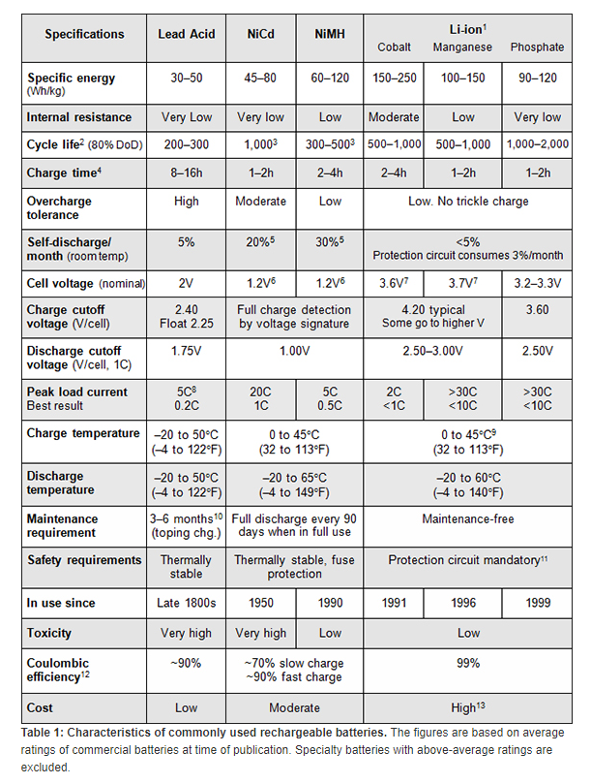

*Figure 33: Rechargeable Battery Datasheet [41]*

For our project, we have chosen the Panasonic NCR18650B battery cells from manufacturer Panasonic. This battery outputs 3.25Ah at a voltage of 3.6V, and is highly attractive due to its small profile, use of Li-ion technology, high current output, standard voltage level and rechargeability. The MSP430G2553 operates at a nominal voltage of 3.3V with a low current consumption around 420μA while the Raspberry Pi 4 uses 5V and can draw as much as 3A for connected components. Using three of these battery cells in parallel allows for up to 9.75Ah of current, and will surely satisfy our power consumption.

# **5.1.1.3 Voltage Regulator Design**

The various components and peripherals within this project require different voltage adjustments in order for the components to operate in safe conditions and have a long lifespan for a better user experience.

The voltages for the devices and peripherals used in this project are shown in the table in section 5.1.3.1. There are a variety of output voltages needed from our power supply, and the task of correctly regulating a constant DC voltage level should be handled by efficient voltage regulators with low ripple voltage with small footprints and costs also kept in mind. For the MSP430, which uses 3.3V at 0.42mA can be handled nicely by TI’s TLV1117-18CDRJR LDO linear voltage regulator since it outputs a set 3.3V and 800mA of current with 0.4% load regulation, while taking an input between 3.2-15V. The Raspberry Pi 4 uses 5V with 2.5-3A input, so our 5V regulator needs to be able to output sufficient current.

Using Texas Instruments’ Webench tool, both voltage regulators were designed and picked after selecting for low cost, footprint, part count, and high efficiency within our design parameters. Below is the 3.3V regulator design from the Webench resource.  
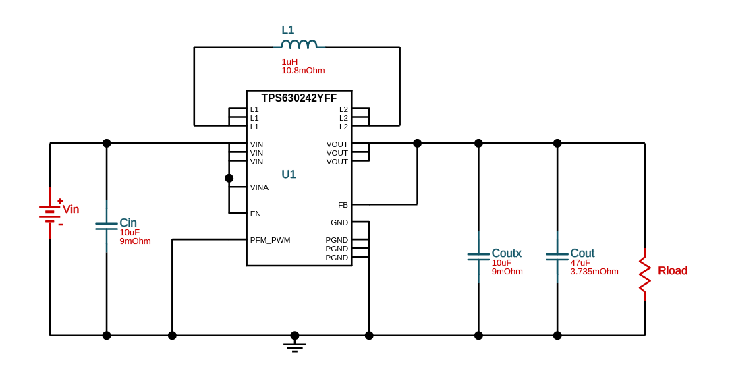  
 *Figure 34: 3.3V Regulator from Webench*

This design allows voltage inputs between 3.2-4.5V, which is within the range for our batteries when they have charge, and outputs a constant 3.3V at 1.5A to power our MSP430 as well as the peripherals connected to it. The TPS630242 IC from Texas Instruments is a combined Buck/Boost converter, since our desired output voltage is 3.3V and the battery voltage will change between 2.5V, when completely discharged, to as much as 4.35V when fully charged, so the voltage regulator needs to act in Boost mode when the voltage is below desired output of 3.3V and in Buck mode when the input voltage is higher than 3.3V.

The other voltage regulator needed was a 5V regulator. Using the same resource, a regulator was designed to accommodate the Raspberry Pi and related peripherals. The schematic for the regulator is shown below.

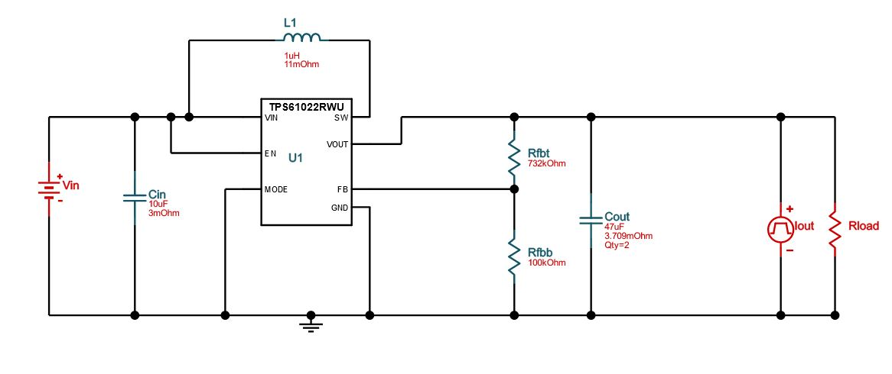  
*Figure 35: 5V Regulator from Webench*

This design accepts the same voltage input as the previous regulator since they will both be attached to the rechargeable batteries also attached to the PCB, but outputs a constant 5V at 3.5A because the Raspberry Pi requires much more current than the MSP430.

# **5.1.1.4 Battery Charging**

For this project, the design needs to allow the battery cells to recharge and not be disposable. To recharge the battery cells, our team went with the AAT3693 BatteryManager from Skyworks. This chip is useful because it has a fixed charge voltage (4.2V) and it’s output current can be adjusted for many Li-Ion battery types depending on the charging capacity. Our battery cells (NCR18650B) have the same charging voltage of 4.2V and require ~1.6A for charging current. The AAT3693 has a max current output of 1.66A and should be sufficient to charge the batteries. The circuit for the batteries and charging components is shown below. Each battery cell requires its own charging circuit and AAT3693 IC, and these BatteryManagers can be hooked up to a USB power cable to be turned on and power the circuit.

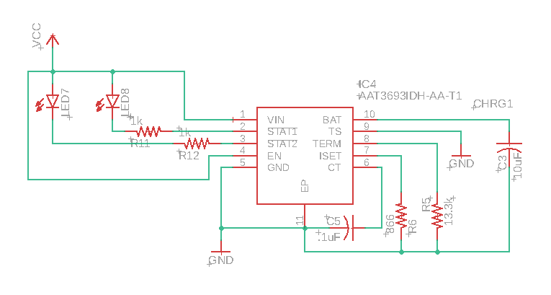  
*Figure 36: Recharging IC AAT3693*

This IC is needed multiple times, and each will be connected to its own respective battery. Care will be taken to ensure the charging IC does not damage their battery cell when operating under normal use. They have a rated charging current of up to 1.65A, and are determined by the ISET resistor. At 1.33k, the output current to the batteries will be 1.6A, and is sufficient to charge the cells when they are low on power. The connection between the recharging IC and the batteries are shown below, where CHRG(*N)* is the line to the battery to charge it.

*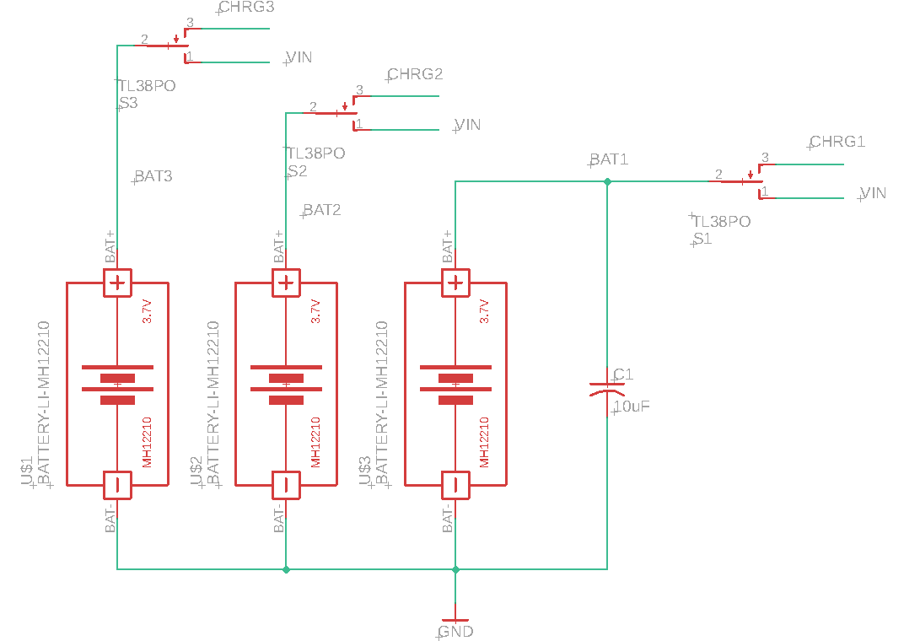  
Figure 37: 3 Battery Cells Connected to Rechargers and VIN*

In the design above, there is a switch to allow the user to choose between recharging the battery cells when they are low, or to turn on the input to the design (the net named “VIN”). There are green and red LEDs to accompany the AAT3693, showing the user when the batteries are charged or in standby mode. In order to power the circuit and recharge the batteries, there will be a USB port connected and is referred to as “VCC” in this schematic. The schematic of the USB is shown below.

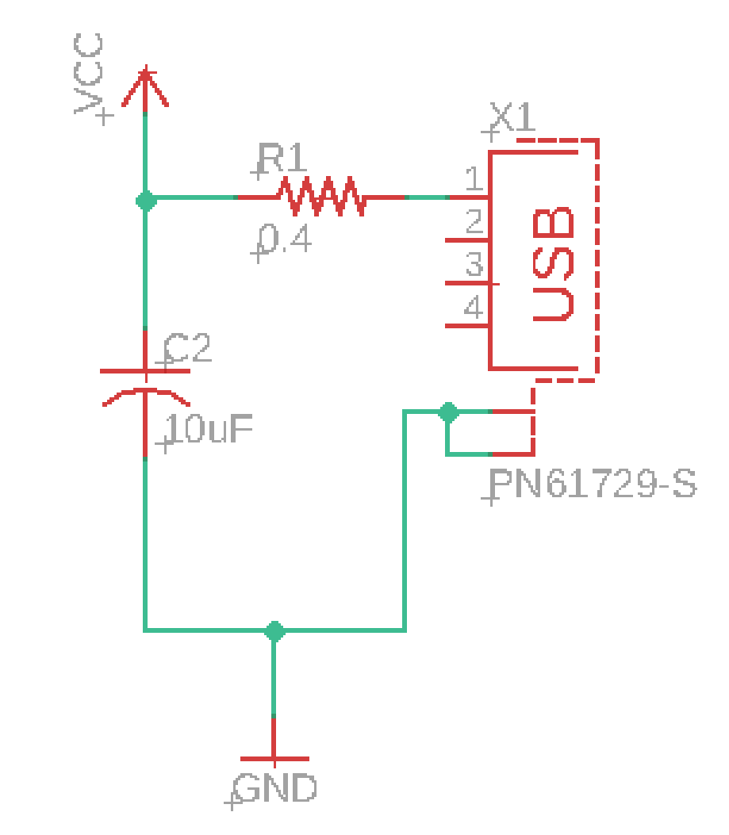  
*Figure 38: USB Charging Circuit Supplying TP4056 Recharger*

# **5.1.1.5 PCB Design**

Tying together the voltage regulators with the batteries and recharging circuit, we can develop the full schematic for the PCB. It will include the aforementioned components, as well as the MSP430 and several jumpers to communicate with the peripherals/MCU and test the board for errors. The MSP430G2553 has 2KB of flash memory which will hold our program, and an extra memory module was added to the PCB to accommodate for a program larger than 2KB. The module chosen was a 24CW1280T from Microchip Technologies. It has 128KB of space and operates via I2C and will be useful for our project if we need extra space.

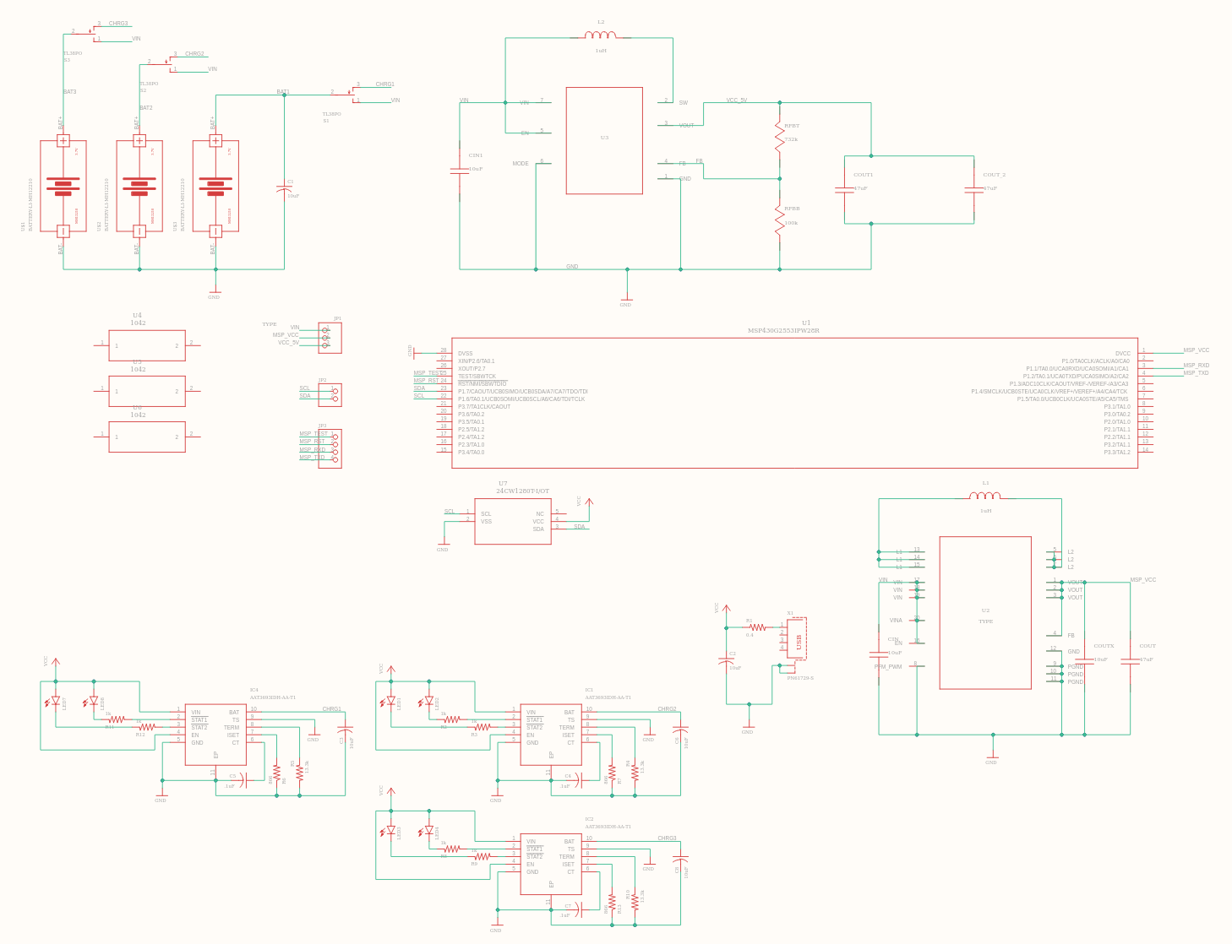  
*Figure 39: Eagle Schematic for PCB Design*

There are pin headers to test and connect the board to the outside world. The headers include connections to the MSP430’s SBWTCK and SBWTDIO pins to program the flash memory on the board from an external launchpad, connections to the SCL and SDA for I2C communication, and test pins for VIN(battery voltage), 3.3V regulator output and 5V regulator output.

The schematic file is linked to a board file, which must be laid out carefully to ensure proper connections, spacing, and other concerns for the manufacturer. In addition to the batteries, we also require the footprint for a battery cell holder to place the batteries on the board itself. Another consideration for the board is from the datasheet for the AAT3693 BatteryManager, which requires the capacitors and other components be placed close to the IC for proper operation. This is generally true for other components as well, so proper layout of the PCB is essential to good operation for our project. The board file is shown below in Fig. 40, and includes the necessary parts for powering our project.

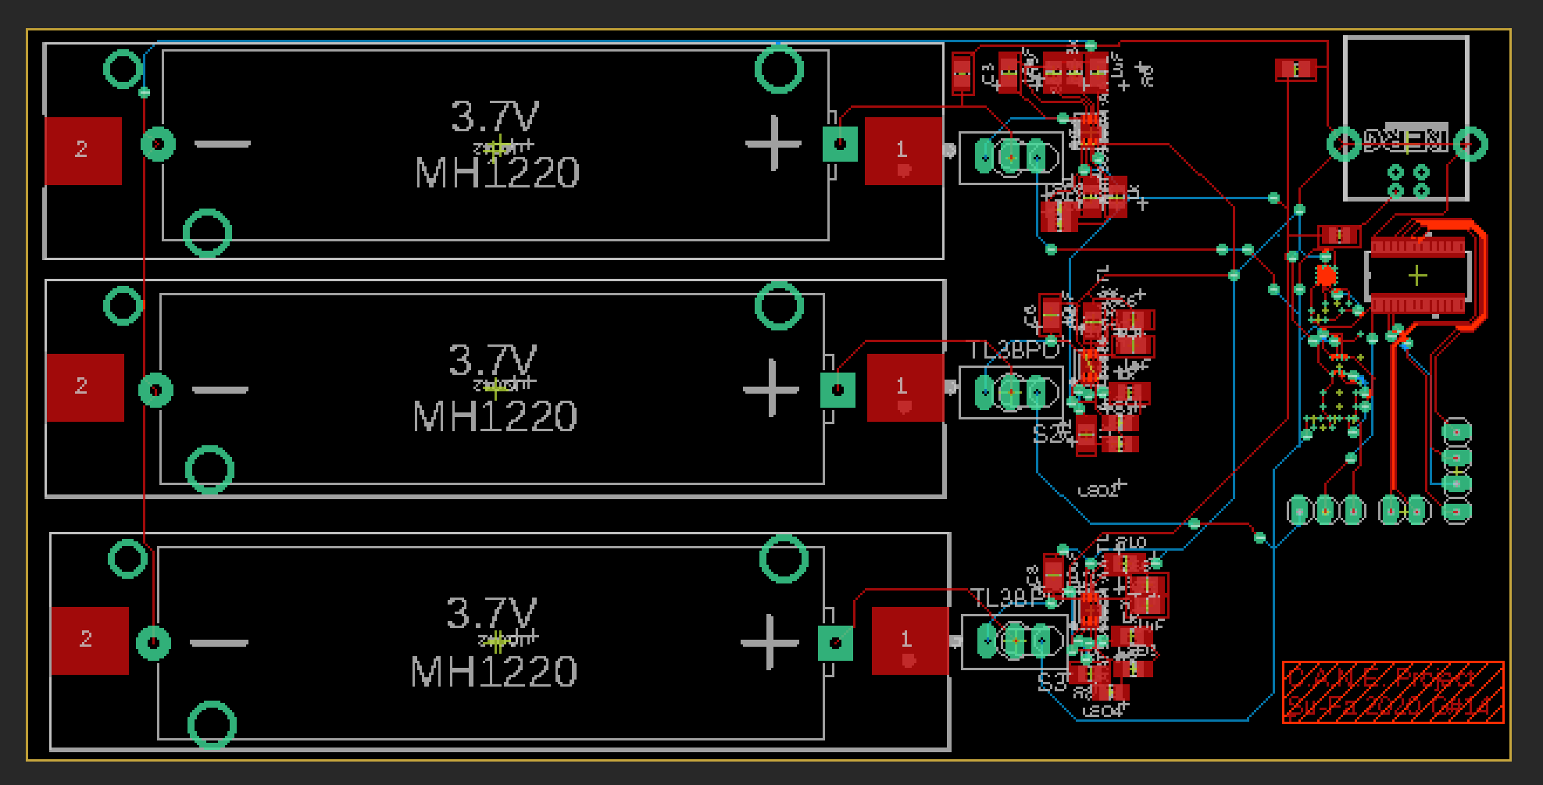  
*Figure 40: BRD File of the PCB Design*

# **5.1.2. MCU Design**

Here in this section we will review our Microcontroller Unit Design. We will go over specific characteristics and important powering information.

# **5.1.2.1. MSP430**

The MSP430G2553 is a low power embedded controller useful for repetitive tasks. This chip has 2KB of flash memory, and our PCB will add an additional 128KB of memory to our project. The MSP430 has USCI so it can accept UART, SPI and I2C. I2C is the popular choice because we will be using the Raspberry Pi in this project as well, and the ability to use both the MSP430 and the Raspberry Pi as “masters” is useful, in addition to the fact that the memory module communicates via I2C and will be accessible to both the MSP430 and Raspberry Pi. There are also pin headers to connect outside devices to the board via I2C.

The MSP430G2553 itself is a low-power component, but the other peripherals connected to it require quite a large amount of current, so special care will be taken with regards to the power draw.

# **5.1.2.2. Raspberry Pi**

The computer vision aspects of this project will be accomplished using the Raspberry Pi Single Board Computer. The Raspberry Pi 4 model with 2GB of RAM will be used in conjunction with the Raspberry Pi Camera Module.

In the process of selecting the technology to be used for camera vision, our team also considered Arduino as an option. After some research, it became clear that Raspberry Pi was the correct choice. With over 60,000 times the RAM and nearly 100 times the processing speed, the Raspberry Pi 4 is a significantly more powerful device than the Arduino Uno. When considering the tasks we will be requiring, the additional speed and power of the Raspberry Pi will be very important.

In addition, many of the optical algorithms that will be run for computer vision are slow - the Canny Algorithm alone has a runtime of O(mn log mn). Considering the limited amount of time our algorithm will have between the user ‘seeing’ and reaching the obstructions we will detect, it is highly unlikely the Arduino board would be fast enough to identify obstructions and notify the user in time. Additionally, the Raspberry Pi is a single board computer, meaning we are free to utilize any programming language and dependencies we choose, while the Arduino boards are limited to C++. Since our team has chosen Python and the open source *OpenCV* computer vision libraries, the Raspberry Pi is again the clear choice.

Our team did consider the use of the Raspberry Pi Zero W instead of the Raspberry Pi 4. Since we are attempting to choose the smallest components possible, the Zero W was very appealing, as its total dimensions are roughly that of a credit card [30]. However, the Zero W only has a 1 GHz clock and 512 MB of RAM, compared to the Pi 4’s 1.5 GHz clock and 2 GB of RAM [15]. For the same reason the Arduino Uno was disconsidered, we have eliminated the Zero W as an option because it simply does not have the processing power to handle the computer vision algorithms we will be running. The Zero W is infamous for lacking the power for computer vision. One account shows that the Zero W took over ten hours just to install OpenCV[29]; a feat that took just minutes on the Pi 4. While sufficient for other tasks, the Zero W is simply not equipped to handle the necessary requirements for the C.A.N.E. device; therefore the Raspberry Pi 4 is our final choice.

# **5.2 Software Design**

The software design will be vital to the success or failure of our project. Our planned software design and algorithms, including methodology and version control, are detailed in the subsections below.

# **5.2.1. Design Methodology**

Today’s clear choice in design methodology is the Agile method. The agile method is newer and far more efficient than the alternative waterfall method. Contrary to the waterfall method’s linear sequential life cycle model that often delivers late and outdated software, agile aims to adapt and change as needed in the process of development. The twelve principles of the agile manifesto are detailed in below.   
  
Agile Manifesto

1. Customer Satisfaction
2. Welcoming change, even late in development
3. Frequent delivery of working software
4. Engineers and business officials working together to create the best possible product
5. Trusting motivated individuals to get the job done
6. Face-to-face meetings
7. Working software as the best show of progress
8. Maintaining a constant pace
9. Good design and technical excellence
10. Simplicity
11. Self-organizing teams
12. Reflections on efficiency, and adjustments to make improvements

In summary, the agile framework is designed to adapt, communicate, and deliver the best possible product in the least possible amount of time[30]. Its ability to adapt and adjust is a huge part of why our team has selected this methodology in our project going forward.

# **5.2.2. Version Control**

As in nearly any project today that requires even the slightest use of software elements, the C.A.N.E. system will be utilizing version control. Version control has become a near necessity in today’s world. It has numerous benefits, including the ability to track changes over time. Utilizing version control is by far the easiest way for a group of developers to work on one project at the same time. Version control will allow us to track changes over time, providing information such as which user made the updates, what was changed, and a time stamp for the changes. It also allows the ability to revert to different versions of our software, which provides the ability to revert code if mistakes are made.

We plan to utilize Github for our version control purposes, since it is easily accessible, free, and common among developers today. This will allow us to keep safe records of different file versions, without the risk of a harddrive failure and loss of many weeks’ work.

# **5.2.3. Integrated Development Environment**

In order for the C.A.N.E. project to succeed in its functionality of being able to detect objects to assist its user the hardware such as the sensors and microcontrollers must interact with the software. A key tool that will be used to aid in this communication is an IDE (Integrated Development Environment). IDEs provide an environment so that a programmer can send certain instructions that the hardware can implement, whether interpreting results or to perform specific tasks.

The C.A.N.E. project will use a MSP430 launchpad which is manufactured by the company Texas Instruments. With that knowledge Texas Instruments has created an IDE that can be used for their own microcontroller named Code Composer Studio. This will be used when programming the microcontroller when connected to the devices such as the ultrasonic sensors and the vibration controllers. Code Composer Studio only has support for one language. So when programming the microcontroller all coding must be done in the high level programming language of C/C++.

# **5.2.4. Ultrasonic Sensor Algorithm**

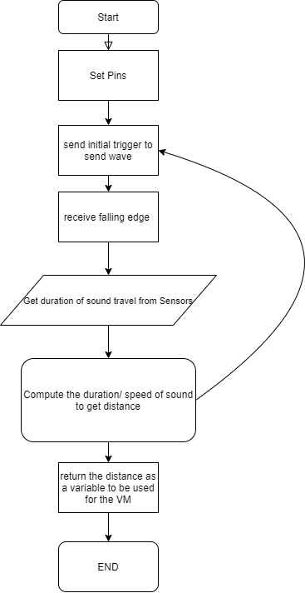

*Figure 41*

It can be seen when programming the ultrasonic sensors for this project that certain pins must be set to the microcontroller to state which pins will allow for the ultrasonic sensor to transmit the sound which will cause an internal timer to start. Then once the sound is received the signal to stop the timer will be raised. The timer will be set to the variable so that calculations can be performed on it. This will then perform the calculations for distance by taking the time that will be divided by 2 and then multiplying it by the known speed of sound. This will then set to a variable labeled distance. The distance will then be set as an output used for the vibrating motors. This process will then be on a continuous loop.

# **5.2.4.1. Overlap Ultrasonic Sensor Algorithm**

With the design for the placement of the ultrasonic sensors where there are two pairs of long range and short range sensors there would have to be an overlap of the sensors sensing range for them to be able to all the closest objects within the entire range. If this overlap were not to happen there would be a spot that would be outside the range of detection and would be devastating to the user of this device. If an object were to be in front of them it would be possible to within the overlap of the two sensors it should be possible to detect what is in front. The detection of the object by both sensors will return a value that should be close to the same distance and would return the same distance value. Which will alert that the object is in front. These can also be done for the left and right of the sensor overlap.

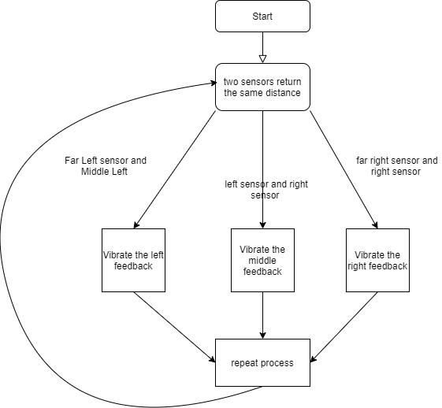

Figure 42

# **5.2.5. Optical Sensor Algorithm**

We plan to use slightly different variations of the optical algorithm we have created for each obstruction we are searching for. Each algorithm is detailed in a subsection below. Further testing will determine if any adjustments need to be made.

# **5.2.5.1. Sidewalk Detection Algorithm**

The sidewalk detection algorithm will be part of the computer vision section of this project. After analyzing the potential tools to aid in image processing and object detection, our team has created what we hope will be the most effective process. Figure (43) provides a flowchart of our planned methods.

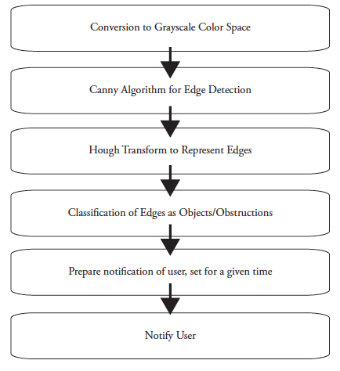  
*Figure 43: Sidewalk Detection Algorithm*

The Canny algorithm for edge detection will be used in conjunction with the Hough Transform method to describe the detected lines. This will make it possible to classify the contents of the image and positively identify any sidewalks present, as well as its location. We will then continue to monitor the sidewalk as well as the user’s position on the sidewalk to determine any haptic feedback that will be sent to the user.

# **5.2.5.2. Doorway Detection Algorithm**

The doorway detection algorithm will primarily rely on a CNN object classification network trained for doorways. Since there are an abundance of available resources and images available, we believe this will be both simpler and more effective to implement than the Canny/Hough method described above.

The CNN object detection process involves several steps to identify the object and its location in an image. This process is detailed in figure 44 below.

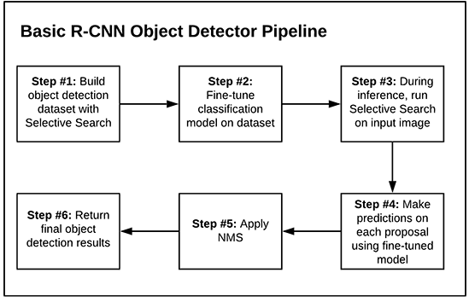  
*Figure 44: CNN Object Detection Process*

There are a few potential concerns regarding CNN object classification that must be considered. Firstly, an abundance of images are ready made and available online to be used for the purpose of CNN object classification. However, there is no guarantee that the C.A.N.E. device will be connected to the internet often, or even at all. Therefore, our algorithms cannot rely on any connection from the internet.

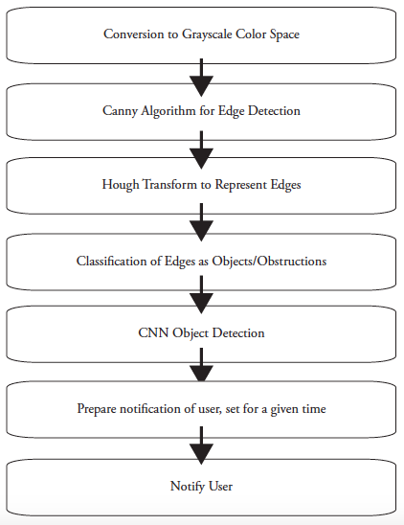  
*Figure 45: Doorway Detection Algorithm*

Since we cannot rely on an internet connection, all images that we will use in our neural network must be stored in house on the Raspberry Pi. This raises a number of additional concerns. Firstly, there is not much storage space built into the Raspberry Pi 4. There is a space for an optional SD card, which may need to be utilized to make this work. However, that adds to both the weight and the cost of the component. Additionally, the smaller the collection of images, the less accurate the neural network will become. A careful balance will have to be made between the size of the network and the decision to add or eschew the optional SD card.

# **5.2.5.3. Stairway Detection Algorithm**

As far as the tools and algorithm go, the beginning of the stairway detection algorithm will function exactly like the sidewalk plan detailed above. However, since stairways present more complications than the basic shapes of sidewalks and doorways. For the most accurate outcomes, our team plans to use two different methods of object detection and compare the results. First, the Canny algorithm for edge detection will be used with the Hough Transform method to classify detected lines (as described above). We will then run a CNN object detector trained for stairway detection and compare the results to the Canny/Hough algorithms above. If the results do not match, preference will be given to the CNN object detector’s results, as previous tests have shown that it has higher accuracy.

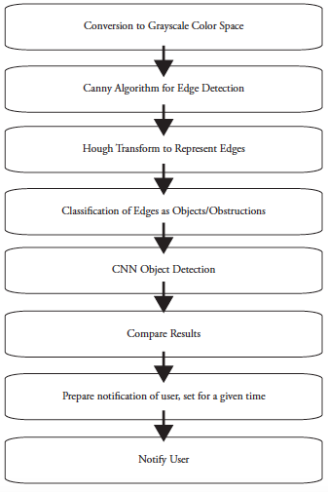  
*Figure 46: Stairway Detection Algorithm*

The same potential issues will apply to the stairway detection algorithm, since it will also be utilizing a trained CNN for object detection. We will take this into account in decisions regarding the potential use of an SD card.

# **5.2.6. Vibration Motor Controller**

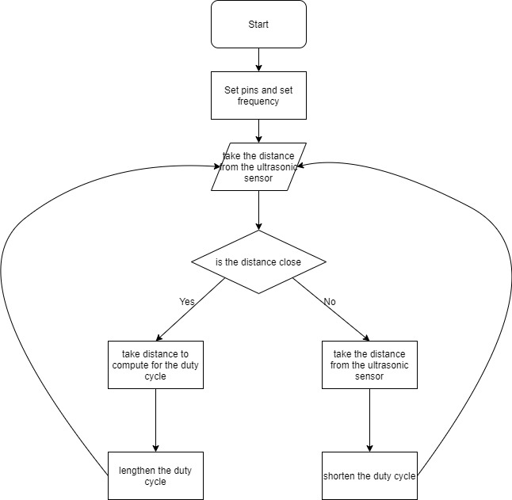

*Figure 47*

To make sure that the vibration motors are able to change in intensity pulse width modulation is used in the following algorithm. The above flow chart depicts simplistically how the algorithm is structured. The first thing that needs to be done is to set the pins of the vibration motors so the output will be known as where to send the signals. The next step will be creating a method so that will house the main function of changing the duty cycle. The next step will be to have that function take in an argument from the parameter. This argument will be coming from the ultrasonic sensor which contains the distance. The distance will be recomputed so that it can be used to change the duty cycle. By changing the duty cycle the average voltage supplied to the motor will allow it to be changed.

The challenge of controlling multiple motors at the same time can be addressed with the Adafruit 2327 16-Channel PWM/Servo HAT for the Raspberry Pi. This HAT will sit on top of the Raspberry Pi and provide control over the vibrating motors via a simple I2C connection, which can also be routed to other devices. This module will drive PWM signals to up to 16 motors individually. It receives 3.3V directly from the Raspberry Pi, and requires an additional 5V input to power each motor. Luckily, our motors are very small and have low current draw, around ~70mA each, so this should be easily taken care of with the 5V voltage regulator. This module includes ready-made python libraries which allow for fast and easy motor control out of the box. Examples of functions include the following list:

* Initialize object
  + pwm = PWM(0x40)
    - Where “pwm” is the object name and “PWM(0x40)” is the creation call. 0x40 is the default address for each 2327, but can be changed if you are using multiple for your project (we aren’t).
* Adjust PWM Frequency
  + setPWMFreq(freq)
    - Adjusts the PWM frequency, which changes how many pulses per second are generated. Argument “freq” must be between 40-1000 Hz.
    - *Ex*: pwm.setPWMFreq(500)
* Control Channel
  + setPWM(channel, on, off)
    - “Channel” is from 0 to 15, “on” is a number between 0 and 4095 and indicates when the pulse transitions from low to high, and “off” is also between 0 and 4095, indicating when the pulse transitions from high to low.
    - *Ex*: setPWM(4, 1023, 3071)
      * This sets channel 4 to go high on “tick” 1023 out of 4096 then turn off at tick 3071 out of 4096. Essentially 50% on, 50% off.

Using these functions, various buzz types can be realized, from soft and constant buzzing to fast, repetitive buzzing. This can be useful depending on the input received from the sensors. If an object is nearby a more urgent buzz may be necessary then something further away.

# **5.3. User Interface**

The user interface of a device describes all information that will be communicated to and from the user. This information is divided into two subsections, the information input by the user and the information output by our device.

# **5.3.1. User Input**

After careful consideration, our team has decided that the C.A.N.E. device will not accept any user input at this time. Further along in the development process, we may revisit this decision.

As mentioned in our goals section of this project, we would like to create an app or similar means of allowing the user to enter information. At this point in our research phase, we do not believe there will be time for this.

# **5.3.1. Product Output**

The C.A.N.E. device will communicate with our users in a few ways. The first will be vibration feedback to the user via two wristbands that will be worn. As the user gets closer to the object, the vibrations will become exponentially stronger, as shown in figure 48.

**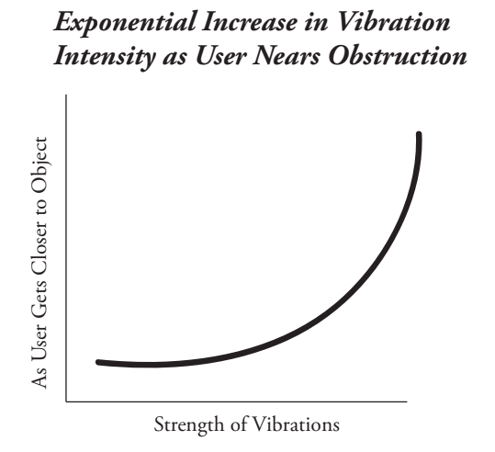***Figure 48: Vibration Feedback vs. Distance from Obstruction*

In addition to the haptic feedback described above, the C.A.N.E. device will also provide audio feedback to the user. Audio feedback will be reserved for cases in which obstructions are picked up by the computer vision systems. These obstructions are slightly more complicated than those picked up by the sensors, and potentially include staircases, doorways, and sidewalks. The audio feedback will inform the user that one of these obstructions is present, and provide an approximate distance away from the user. It will then guide the user through this obstruction via more voice commands or clearly explained transfer back to the haptic feedback systems.   
  
For these such obstacles, Our plan is that the vibration feedback will be used to guide users on sidewalks (vibrating if the user deviates from the center of the path) and doorways (vibrating in essentially the same way). We believe the stairs will require additional assistance, and plan to continue the use of audio feedback to inform users of information such as how many more steps are left and whether or not the staircase contains any landings or turns.

# **5.4. Placement of Ultrasonic Sensors**

When conceiving the idea for the C.A.N.E. project the key feature for the project had to implement some sort of wearable technology. Due to the ultrasonic sensors having a weight that is almost negligible to a hat or glasses it would be best for the sensors to fit on that so that they the user does not need to hold onto the object for it to operate. It is also best for the sensors to be placed on a hat because the brim of a hat is flat. This will be suitable to use for the placement of the sensors because all the sensors will be on the same plane. This allows for optimal detection of objects. The frame of glasses are also suitable due to the design of the frame that it is also flat. The C.A.N.E. project also states that the range of detection must also be wide so not only does the user have the ability to detect what is in front of them but also to the sides so for ease of use and maximum range the sensors should be placed where one is placed to be in the middle and two extra sensors will be placed on either side of them. This layout of the design can be seen in the figures below.

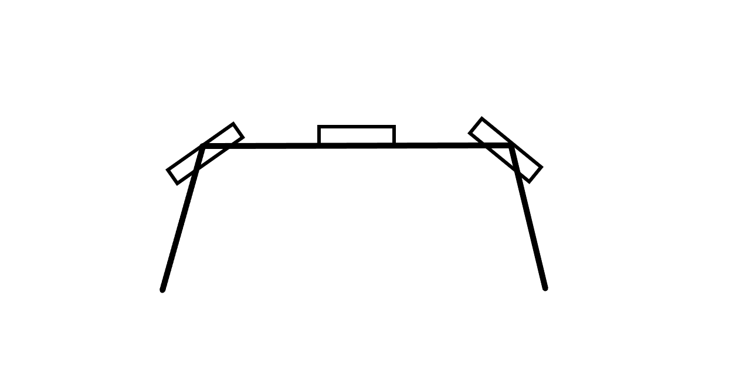

*Figure 49: Top View of the Placement of Sensors*

The picture above depicts the theoretical top view of the layout of the sensors. From here it can be seen that the sensors,which are the boxes, will be placed so that the user sides and front view will be able to detect objects that are within the sensing field providing coverage. These sensors are also angled so that no overlap of sound waves can be kept to minimum since the sound waves that are created will be spread out.

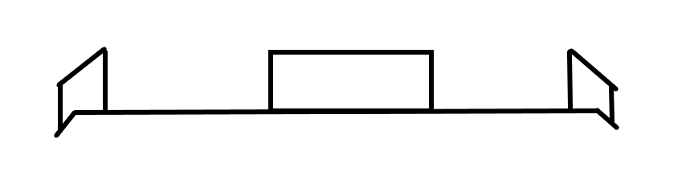

*Figure 50: Front View of the Placement of Sensors*

The above figure depicts the front view of the placement of the ultrasonic sensors on the frame of the frame of the glasses. This allows for the planar view to show how all the sensors will be placed on the same plane.

# **5.4.1. Secondary Placement**

A secondary placement of sensors might be used where there are two long range sensors and two close range sensors. Having the two will separate types of sensors will account for improved accuracy so that none fall out of range. The placement of these sensors will be placed to be on the frame of glasses or on the brim of the hat. It is best to keep these devices on these accessories strictly because they are at a higher ground. They will also be on a level plane so that they do not convey false results. One long range sensor and one short range sensor will be paired together and will be placed left and right of the center of the glasses, where for each pair of the long range and short range sensors the long range sensors will be placed closer to the center of the glasses. The following figure depicts the idea for the placement of the ultrasonic sensors.

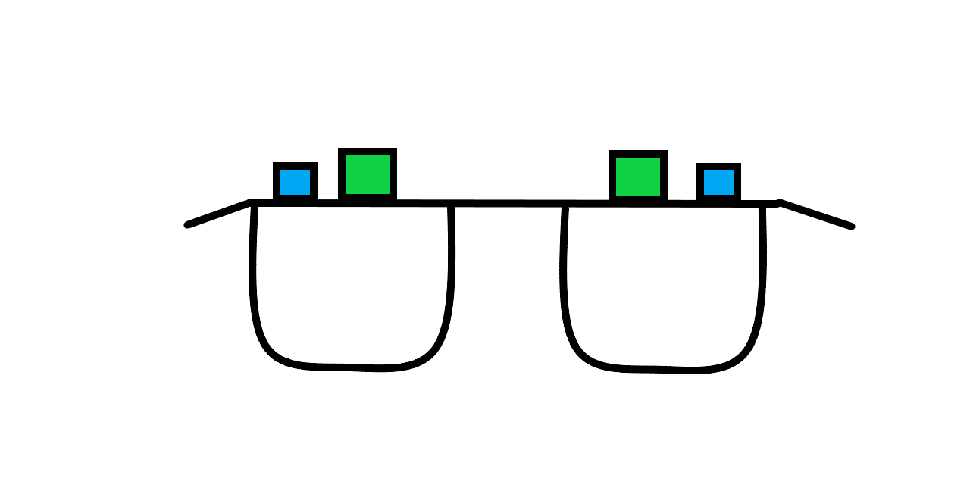  
Figure 51: Secondary Placement

# **5.5. Placement of Vibrating Motors**

As mentioned before the device that is being created for the C.A.N.E project is an idea that the tech that is being created will be a wearable device. This means that the user will be comfortable that the devices being implemented should be small enough to fit on the user such that it is not bothersome. Vibrating motors are reasonably small and do not weigh a lot which means that they may be placed anywhere on the body. Naturally when thinking of places and accessories that do not encumber the human body a bracelet is the first place that the team had thought of. This is the perfect place to have the vibration motors be around. This is also because there are devices that are worn around the wrist that also have vibration motors in them such as the basic smartwatch.

When placing the motors on the wristband each motor should represent general directions that a person would need in order to walk down a hallway and avoid obstacles such as walls and oncoming people walking to them. Because there are three ultrasonic sensors that are being used it would also make sense that the vibration motors also correspond to each sensor. The human wrist is rather sensitive to touch so determining where a vibration is coming from one wrist is possible. The vibration motor that will be detected in response to the front facing sensor will be placed on the top of the wrist. The vibration motor that will be detecting in response to the sensor that will be facing left will be placed on the left of the wrist.The vibration motor that will be detecting in response to the right facing sensor will be placed on the right of the wrist. The following layout will be seen as shown in figure 50 below

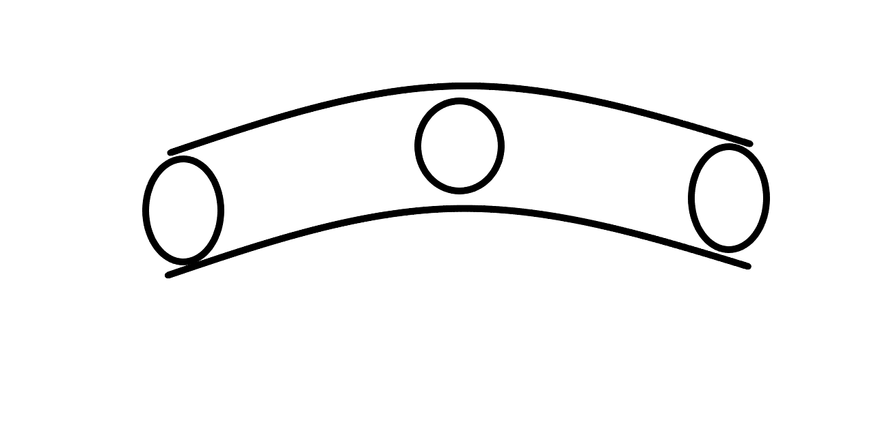

*Figure 52: Front View of the Placement of Vibrating Motors*

# **5.5.1. Shoulder Placement**

A secondary option that would be a great choice in providing a place for the vibration motors to be set are on both shoulders. This place would be the second best option because it will be easier to determine the orientation of direction. This is because on the human body is a left and right shoulder which will aid in distinguishing between left and right. The figure below depicts this idea.

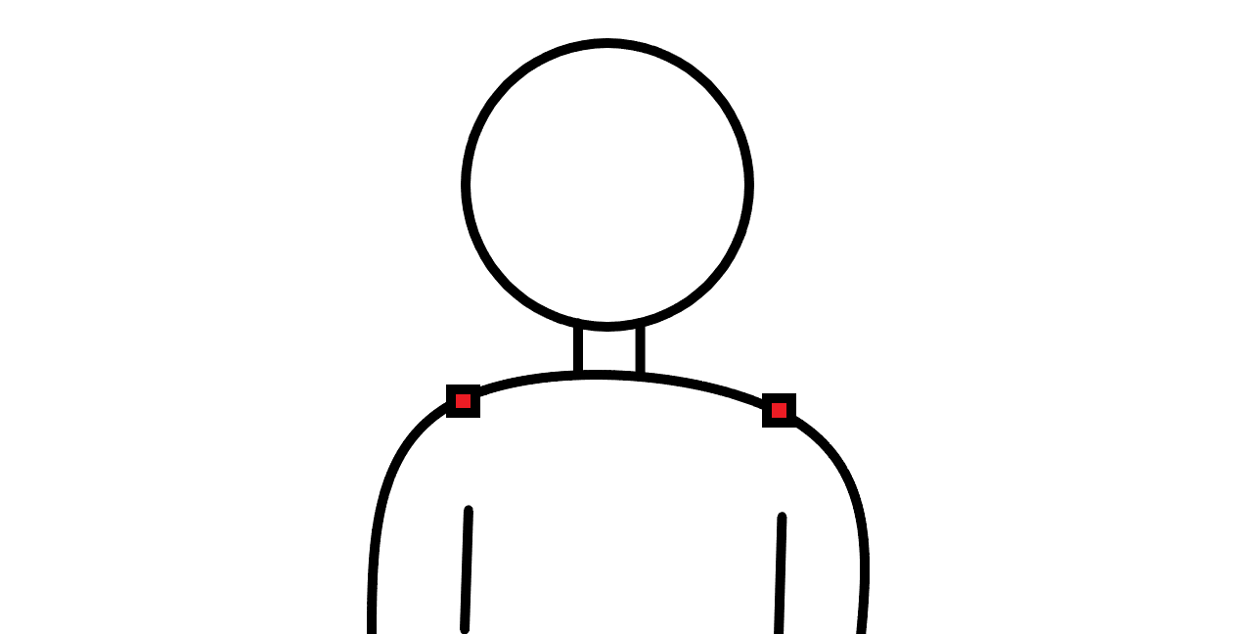  
  
Figure 53: Shoulder placement of vibrating motors

This is the best for determining between left and right. The issue with this option is trying to convey to the user that an object is in front of them. So when trying to show the user that an object is in front of them a pattern of vibrations might be used to give that sense that is different.

If there are surplus of funds from the budgeting for this project another idea would be to have a third vibration motor placed on the back of the user as well as the the other two placed on the shoulders this will be the motor that is strictly for the correlation of the sensor that detects objects that are in front. This eases the programming of the microcontroller by not having to make a pattern for knowing when something is in front while also letting the the left and right shoulder vibration be used for strictly being used for the feedback of the left and right sensors. Overall the placing them on the shoulders and back are best for laying down wire since these parts of the body do not typically move. So the wire will not become loose. And less wire will be used because the motors are closer in proximity to where the sensors and CPU are. The figure below shows the idea for this.

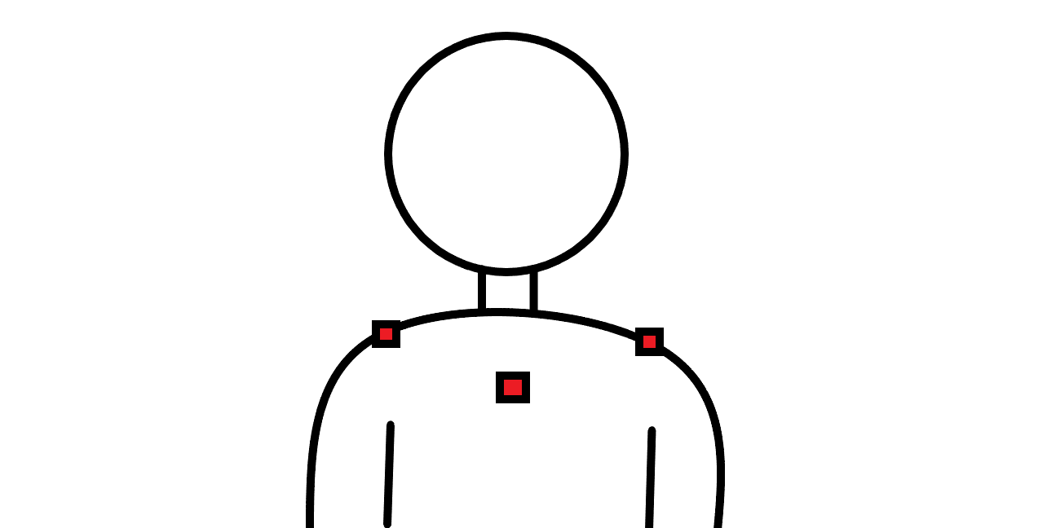  
Figure 54: Secondary shoulder placement for vibrating motors

# **5.5.2. Belt Placement**

The next option would be to place them around the waist. This is great option because they can be placed on existing wearable accessories such as belts. This will also allow for great recognition of feedback and determining from which direction the vibration is coming from. The vibration motor on the left will sense things on the left while the one on the right will correlate to the right sensor. There are two places that would be considered for placing the vibration motor that will correlate to the sensor in the front. Placing it in the front would be the best choice but if placed on the belt it would be hard to place a vibration motor on the buckle of the belt. The next best option to place it would be to have it placed on the back of the belt. The figure below shows this placement.

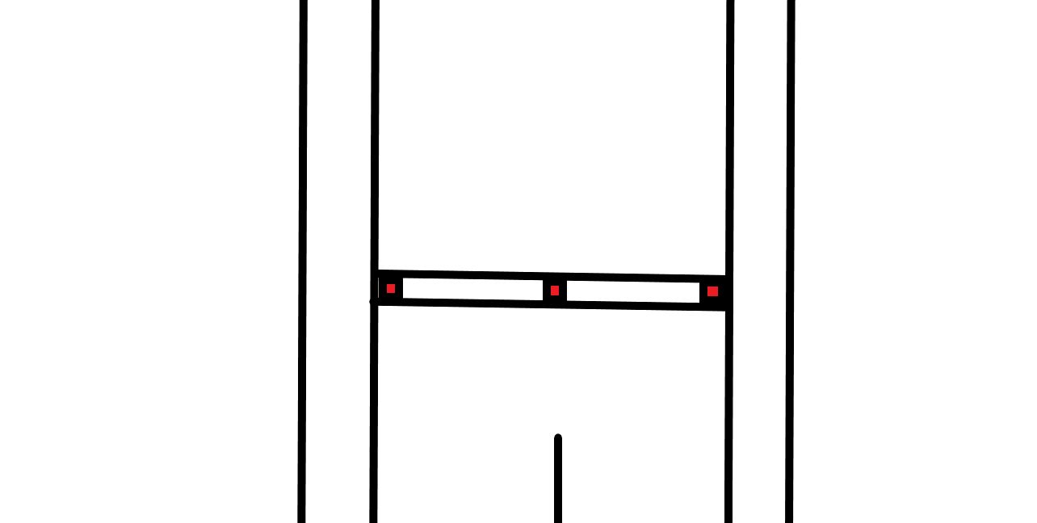  
  
Figure 55: Belt placement of vibrating motors

This option for the belt is the last option to use because it will qualify as the use of a wearable object. The key issue with this build is that the wiring would be long and would require a lot of slack. This is because if a person would twist their hips the wiring could be ripped out if not enough slack is used. Too much slack could also cause discomfort to the user of this object. So if the belt option would be used the wiring and belt would need to be fitted for the individual user.

**5.6. Placement of Computer Vision Camera**  
For optimal camera readings, the placement of the computer vision camera will need to be towards the center of the glasses or hat in the C.A.N.E. device. Since we only plan to use one camera, its location will need to be as central as possible to ensure the full field of vision possible. If for example the camera was placed to the right side of the glasses, there is a higher chance that it would miss a sidewalk that is located far to the user’s left. The planned placement of the camera is shown in figure 56.

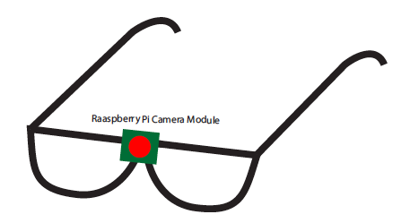  
*Figure 56: Placement of Raspberry Pi Camera Module*

# **5.7. Placement of Optical Sensors**

For our project to meet and exceed our set requirements, getting the placement and alignment of our sensors is crucial. We need to make sure that the sensors are set on the glasses to optimize their transmitter and receiver nodes. If we set the optical sensors incorrectly we could get wrong readings and throw off our accuracy because of this error. For our project we want to make sure that the optical sensors are reading objects in front of the user and are not being interrupted by the user themselves. If the optical sensors are misaligned they may be reading incorrect data due to the beam catching hanging wires, the users hair, or if pointed very incorrectly the sensors may be reading the distance from the user themselves.

We must have the optical sensors forward pointing with their line on sight clear from the user forward. If we place the sensors on the front part of the glasses frame we can be more readily able to avoid issues like hair and interruptions in line of sight. Having the optical sensors on the front of the glasses also give optimal readings for our user walking forward. The placement of these sensors on glasses also gives the team better readings due to height. We want the sensors to read objects that could interfere with our users walking path. Objects that may not have been easily detected would be those above the waist (below the waist, the physical cane aids users) and placing the sensors at eye level gives us clear readings of those obstacles.

Our initial talks included placing all components on one side of the frame to keep everything together and look sleek. But upon further research and finding which comoponets we will be using, it has come to our understanding that distributing the weight of our components over all the glasses frames would be a better fit. It may not look sleek like we had initially planned but the use will not be hindered if we relocate our components to different sections. It may not physically look how the team initially planned but we will get better and more accurate readings by applying our components in a balanced way. Balancing our sensors on each side of the fram will also aid in the users experience of the glasses. Too much weight on one side and the glasses may tip or the user would be very uncomfortable. The addition of rubber tacs on the nose of the glasses was an idea to help with discomfort from the glasses if the weight was bearing down on the user's nose. But balaxing our sensors as shown should relieve some of that stress and pressure.

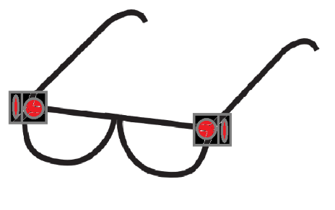

*Figure 57: Placement of Optical Sensors on Glasses*

# **6. Testing**

Testing is a very important part of any engineering project. In order to ensure that we present a working, usable device, our team will be sure to test each individual component, attachment, and code snippet thoroughly. Our plans for testing are presented in the subsections below.

# **6.1. Hardware Testing**

The subsections below describe in detail our plans to test each hardware component that will be used in the C.A.N.E. device.

# **6.1.1. Microcontroller**

We will be moving the program for the MSP430 from a Launchpad to the chip on the PCB via the SBWTCLk and SBWTDIO pins on the MSP430G2553. We can test the program is working by assessing how the microcontroller responds to our sensors’ stimuli. If the response of the microcontroller to a signal from our ultrasonic range finders is to buzz a corresponding vibrating motor, we will know that our program and microcontroller are working correctly.

We can also assess the input voltage to the MSP430 via a pin header on the PCB, and it should be around 3.3V from our regulator output. This will allow us to troubleshoot and diagnose any power related problems to our microcontroller. This is the same case for the Raspberry Pi, except it will not be on the PCB so we needed an additional pin header for the 5V output to our various sensors and Raspberry Pi.

# **6.1.2. Sensors**

In this section of our project we will be going over the testing of the sensors used for our project. Testing our sensors is imperative because they are a key component that we need to verify are reliable to our overall project. We will be discussing how we will test for accuracy and good reliable readings from our sensors.

# **6.1.2.1. Ultrasonic sensor**

The ultrasonic sensor is very important to the health and safety of this project so it is advised that thorough testing must be done to understand where the ultrasonic sensor will not be operable. This test is not to see whether or not it works but more to see if there are certain situations and/or locations that we the team might advise that the C.A.N.E device not be used.

To test for this several locations and objects will be used the following is a list where the test will take a place:

* A room with soundproof foam on the walls
* A room with curved walls
* Objects that are narrow such as poles and trees

The first step in the test will be the control variable. We will measure five distances from the target that is being detected. The ultrasonic sensors will then emit their noise from those five distances and will see if it happens to match the distance that was already measured. This control will take place in a rectangular room where the walls are flat.

The next step will then be to place the reuse the five measured distances in this case the targets will be the bulleted locations and objects that were mentioned above. The five sensed distances from the target using the ultrasonic sensor will then be compared to the measured distances.

The test will be considered a pass if all five of sensed distances are within five percent error of the measured distance. It will be considered a failure if one of the five sensed distances are not within the five percent error of the measured distances. This will then be labeled as a cautionary to not use this device in those rooms.

# **6.1.2.2. Optical Sensor**

Here in this section we will go over the testing of the optical sensor. We will be testing for reliability and accuracy of the sensor.

# **6.1.2.2.1. Care Prior to Testing**

To make sure we get the most accurate measurements for this project we want to make sure our instruments are clean and working and follow a strict protocol to maintain a “normal” from which we can draw our results. We want to make sure to remove any dust, gunk, stains, and impurities. We also need to be careful when removing debris and try to use only compressed air. This is to make sure that we do not permanently damage our sensors. The use of liquid cleaner or any solvents is strongly advised against. Wearing powder free latex gloves will help us make sure we do not add any dirt or extra unnecessary material. Also, wearing a mask during testing will help in maintaining a clean environment but also due to COVDI-19, when our team is testing our project we will need to maintain UCF’s new protocols in regards to social distancing. One of the new rules is to also wear a mask to help reduce the spread of COVID-19.

# **6.1.2.2.2. Testing Protocol**

The testing protocol for optical sensors will include:

* **Verify all equipment and sensors are clean**If not properly cleaned and checked reading accuracy could deteriorate.
* **Verify all systems are powered**It has been noted that most issues arise from simple user error. Making sure we power and turn on our equipment is simple but should not be overlooked.
* **Verify objects being detected are correct color, reflectivity, and size**We want to make sure we are reading the correct objects per our requirement specs. We want to detect objects that could interfere with our users walking path so objects the size of a watch may be negligible. Thus we do not need to necessarily check for objects below or above a certain size.
* **Verify testing platform apparatus are in good working order**  
    
  When using different apparatus to help us measure distance, we want to maintain a level of accuracy. If we use a system on a track, the height variance of the object could be maintained vs if we tried holding the object ourselves and walked toward or away. Maintaining a level of accuracy will be key to make sure we test our sensors correctly.
* **Record data as precisely and quickly as possible**  
  We want to make sure we take down our readings with high precision and as soon as we read them. We do not want to wait till after we finish testing to record our results. This could lead to incorrect readings or forgetting what the result was and having to re-do different testing aspects
* **Take notes during procedure that may help for future testing**  
  We want to also take notes during our testing that may not have been obvious from the beginning but that could help us in developing a stronger product. New ideas or observations should be recorded to help the team move forward and create an ideal project.

# **6.1.2.2.3. Testing Location**

The team is currently not one hundred percent sure as to where we will be doing the testing. This is in part due to the unknown nature of the current pandemic. The school has reached out and said there are procedures set in place to help bring back students to a safe environment but new regulations and rules have been set in place. For example, wearing masks is mandatory, blocking off certain seats in the classroom to abide by social distancing rules have been implemented. With the rising cases of COVID-19 though, returning back to school is not yet certain. Given this information, our team will either meet at school at the Senior Design Lab to create the settings in which the testing of our project will begin. If for whatever reason we cannot or do not have access to the lab on campus, we will have to meet at one of our homes.

This creates certain variables that we are not yet sure how to handle but have taken precautions to help. The school has sent the team an oscilloscope to help with readings. We have a soldering kit that will be used.We have power outlets as well.

# **6.1.2.2.4. Testing Techniques**

1. **Measuring Optical Sensor initial distance measurement accuracy.**
   1. We will use a large piece of paper or cardboard that we will place in front of the optical sensor and record multiple readings to get an accurate measurement recording.
   2. We will initially set the optical sensor on a flat stable service.
   3. 2 feet in front of the placed optical sensor we will stand the large piece of paper or cardboard. We will make sure this piece is stable. We need this to be stable so the optical sensors reading will be of the actual distance and will not take into account any swaying the paper or cardboard may create.
   4. Once the optical sensor and paper/cardboard is set, we will begin taking measurements
   5. We must make sure to take multiple measurements using the Optical Sensor so we can take an average and verify a standard. We agreed that our sensor may have a max of 5% error in measurement readings. Ensure all data and measurements are recorded.
   6. After we record these measurements, we will move the paper/cardboard to 5 feet away from the optical sensor and repeat steps d & e.
   7. We will repeat this process one final time. This time the paper/cardboard will be set at 10 feet in front of the optical sensor. We then will repeat steps d & e again.
   8. We will then take these values and measurements and use them as a standard to continue further testing.
   9. The optical sensor will pass our initial test if it is able to record correct distances within the 5% error rate and also correctly measure the 3 initial distances; 2ft, 5ft, & 10ft.
   10. If the sensor does not measure within 5% error rate or is not able to measure the correct distance at 2ft, 5ft, & 10ft, then we will consider this a failure and the component will have to be reevaluated for the project.
2. **Measuring OS accuracy on different materials of different colors from varying locations/distances.**
   1. We will use a large piece of paper with 7 different colors; Red, Orange, Yellow, Green, Blue, Black, & White.
   2. We will place our optical sensor on a steady surface facing the colored paper.
   3. The distance between the optical sensor and paper will be measured using a tape measure.
   4. We will then use one color at a time and go through steps e - h from the previous subsection.
   5. After completing these measurements we will record and compare to our initial data that we recorded in step a.
   6. The test will be considered a success if the optical sensor is able to record the distance of the colored paper/cardboard at all three distances and within 5% error rate.
3. **Measuring Optical Sensor against on different materials of different reflectivity from varying locations/distances.**
   1. We will be using an empty glass, a glass of water, and a mirror to test reflectivity
4. **Measuring Optical Sensor accuracy of different size objects from varying location/distance.**
   1. We will use 4 different sized objects. A marble, a golf ball, a softball, a basketball, backpack
   2. We will start with the golf ball and place it on a steady surface and place the Optical sensor facing the object 1 foot away.
   3. We will record the initial distance between the two objects using a measuring tape.
   4. We will then begin recording the distance using the optical sensor.
   5. Once the distance has been measured at one foot, we will increase the distance by a foot and record the results.
   6. We will then increase the distance by a foot again, and repeat this process until we reach our limit (10m) or until the optical sensor is not able to read our object.

# **6.1.3. Power Systems**

The power system for this project is 3 parallel 18650 Li-Ion rechargeable battery cells. This power network is in parallel, so voltage is the same but current is combined. We can test the output of this system with a pin header on the PCB that is connected to the battery systems’ positive terminals by using a multimeter and recording the voltage and current. The main concern for this project is current supply, so this is much more important than higher voltage rating from a series combination. By testing the output current, we can be sure our system is supplied with enough power to run effectively and without brown-outs. The test we will carry out is detailed below.

1. **Ensure batteries are connected to the PCB correctly**  
     
   If not properly connected, damage could be done to the sensitive Li-Ion battery cells and would render our project unusable. Following proper safety protocols given by the battery’s datasheet is of utmost importance in consideration for this project.
2. **Disconnect other connections to the batteries’ inputs**  
     
   If there are outside connections to the batteries, there could be an incorrect reading on the multimeter when assessing the current and voltage. It is best to test a system with as little load as possible so ensuring no connections to the batteries will allow for good data to be collected.
3. **Connect the positive terminal of the battery to a 1k Ohm resistor**  
     
   If a battery is short-circuited it could stop discharging, or even damage the cell. By attaching a resistor, we still have an open circuit but we will not cause a short-circuit and can properly measure the current and voltage without damaging the battery cells.
4. **Connect the resistor to the positive terminal of the multimeter**  
   Special care should be taken when connecting the terminals of the battery, so connecting the positive lead of the multimeter to the resistor will give a positive voltage and current reading, and will not confuse the polarity.
5. **Connect the GND of the battery to the GND terminal of the multimeter**  
   Similarly, the battery should be grounded to the negative terminal of the multimeter to give a proper reading with the correct polarity.
6. **Test and record the voltage output by the battery system**  
     
   After turning on the multimeter, the reading for Volts must be selected. Then, recording the voltage for further use and comparison to datasheets and expectations will be undertaken.
7. **Test and record the current output by the battery system**  
     
   Switching the multimeter reading to Amps will allow us to read the current output by the parallel battery system. Similarly, we will record the output current by the battery system and compare with the datasheet.
8. **Ensure voltage and current are within acceptable limits and reconnect the system to the board**  
     
   A final comparison will be done to make certain the batteries are operating correctly and safely before reconnecting the system to the board. This will ensure our project receives enough power.

If the battery system is working correctly, we will move on to test the charging circuit for each battery. We will follow a similar procedure to the one above, except we will read the charge current from the charging IC (AAT3693) to the battery while a USB cable is plugged in, so it receives the necessary power to turn the IC on.  
  
Finally, we will test the output voltage and currents of the 3.3V and 5V regulators, and compare the data with the expected output from the Webench resource used to build them. This should be accomplished while the system is powered and batteries are plugged in, as that is how the system will be operating under normal use.

# **6.1.4. Computer Vision Subsystem**

The computer vision hardware components for the C.A.N.E. system include the Raspberry Pi 4 single board computer and the associated Raspberry Pi Camera Module 2.

Prior to its use in the C.A.N.E. device, the Raspberry Pi 4 and camera module will be vetted to ensure they are working properly. This will be accomplished in an enclosed environment prior to installation on our device. The video feed from the camera module can be displayed on a computer monitor, which will allow us to identify and correct any issues in both the hardware and the software design before moving forward.

# **6.1.5. Audio Output Testing**

For our C.A.N.E. system we will have to verify we have good audio output coming from our headphones so that the user receives a clear audio signal. We will be using a 3.5mm TRS audio plug for our headphones. TRS describes the plug type, Tip, Ring, and Sleeve. We have old headphones laying around that are most likely a TRS or TRRS variant (Tip, Ring, Ring, Sleeve) the main difference between the two is that the TRRS is microphone compatible.[33] But for our project we do not need audio input from our user so we would be fine using a TRS headphone. Plugging in a TRRS headphone into our system wont mess it up or alter it, it will just not be able to use its mic.

To test our headphones and verify we have audio output, we can test them in two ways. One Is using a multimeter and the other is using a potato. [34] We will first use the multimeter method and check for continuity at the headphones plug. We will be testing both sides of the headphone’s speakers.

To Test the left speaker on our headphones unit, we will place the negative lead from the multimeter on the “sleeve “ of the plug and place the positive lead on the “ tip “ of the plug. We should get a reading of somewhere near 32 ohms. [35] Next, we will want to verify we also have audio output from the right speaker on our headphones. We will place the negative lead onto the “sleeve “ and positive lead on the “ ring “ of the plug. We are also looking for a reading in the 32-ohm range. If we get “zero “ as a reading, it could be an indication that there is a short circuit in our headphones and we would have to replace them. Also, reading “inf” (infinite) from our multimeter would be an indication that there is an open, its an indication of a broken circuit. We can also do another testing method using a potato that will test audio output in a different manner.

For the headphone test using a potato, we will need to use a copper penny and a galvanized nail. We place the copper penny into the potato with half the penny visible. We push the nail into the potato relatively close to the penny. We will then use the plug and listen for feedback. As we did before, we will test the left speaker by placing the “tip “onto the penny and laying the “sleeve “ on the galvanized nail. This creates a very small current that can be heard as static or noise in the speaker. We test the right speaker the same way by placing the “ring “onto the penny and laying the “sleeve “ on the galvanized nail. Again, we will listen for noise coming from the speaker to verify audio output.

If we do not get the correct continuity reading or if we do not hear anything coming out of the headphone speakers we will reevaluate our headphone choice and attempt a different type. Audio output is essential in our system and we need to make sure we have good audio output for the user to use our product efficiently and safely.

# **6.2. Software Testing**

Testing the functionality of our software will be vital to the success of our project. Without working software, the C.A.N.E. device simply will not work. Therefore, a very thorough and comprehensive set of software tests is of the utmost importance. Our team’s plans to ensure the success of our software are detailed in the subsections below.

# **6.2.1. Software Test Environment**

Each group member will be testing software on their respective computers. Since our testing will not be dependent upon the operating system or which individual debugging software is used, we do not foresee any issues with this method.

# **6.2.2. Ultrasonic with Air Temperature Testing**

As it is known ultrasonic sensors sound waves can have their speeds be altered in many ways. One of these ways in which that can be affected is the temperature. This holds the highest precedence due to the fact that for the CANE project object detection is a high priority for the safety of the user and it can be used at all times of the day and year, so it should also be operable within those times and also be accurate. A test must be conducted so that it can be guaranteed that this device can be functional in almost all temperature conditions. The test will follow as stated below by steps

1. The first step in this test will be to have a control value for the test so that the team will be able to use these results as a benchmark. The most controlled environment to serve as a benchmark is an airconditioned room where the temperature will be constant. The temperature will then be recorded.
2. The person wearing the device will be placed just outside of the sensing range. This distance will be known by the team because the data sheet from the specific model of the sensor is given and will show the range. This distance will then be recorded and will be shown that there was no feedback from the vibration motors.
3. The next step will be to have the user walk forward closer and closer to the object. Once the notices a change in intensity of the vibration motors on the device the user will then be stopped and a tape measure will be used to record their distance from the user to the certain object.
4. Step 3 will then continue with those results until the user is within arms reach of the object that was being sensed.
5. The results of this experiment will be compared to the algorithm that was used in determining at what distance the vibration motors should be increasing in intensity. The test will be considered to be a pass if the users detects the increasing in intensity at the predetermined distance.
6. The previous steps one through five will then be recreated in two different environments the first will be a place where there is an increase in temperature. The best place to do this is outdoors in Florida in specific due to the state being very close to the equator where it is the hottest and due to it being where most of the development of the project will be done. To make sure the temperature is constant throughout the test for the conditions it will be made sure that the sky will be clear from all obstructions. This will make sure that no shadows are created so that will not cause a change in temperature. The wind is also a factor that will be considered as a cause for skewing the results. In order to avoid this a secondary member of the testing process to warn about the wind and the test will be stopped.
7. Steps one through five will be repeated again for these steps but in this case a new testing environment will be used so that the testing can be done in the cold. The best setting to use for this would be for a walk-in refrigerator. This would be great to use strictly for its ability to be held at a constant temperature.

# **6.2.5. PWM Testing**

The CANE project is rather serious in terms of health and safety for those that will use this device. So testing must be done on the pulse width modulation to make sure all results are accurate and precise.

When testing the pulse width modulation there are two aspects that need to be considered when testing. These two aspects are hardware and the software. In the aspect of software the modifying the pulse width modulation is done by programming the microcontroller. To test whether the software is complete to be able to use the program will be run through a debugging process to make sure that all code that the code is correct in the programming language that will be used. The steps for this are as follows.

The first step in this process is to first upload the code into an Integrated Development Environment(IDE). The certain IDE that will be used for this test is Code Composer Studio due it being in relation with Texas Instruments and the microcontroller that is being used is created by Texas Instruments. Once the code is uploaded the next step in the process is to run the code to check for errors that will cause the program to crash. This will be done by running the code through Code Composer Studios debugging program which checks for these certain errors and will not allow for the program to be uploaded to the microcontroller.

From the previous step that was stated in the paragraph prior to this one it will be seen that the test will be considered a pass if the uploaded code into the debugging program will allow for the program to be successful. The test will be considered a failure if the debugging program does not allow for the program to be uploaded to the microcontroller. This process will then be repeated until the test is of the passing variety.

The second test that will be used for testing the pulse width modulation is to make sure that the average voltage value is the value that is required. To test this the following steps will be followed to make sure that the pulse width modulation code is operable.

The first step in this testing process is to first hand calculate values of the duty cycle where the high voltage value is equal to 5 volts. The duty cycle will then be varied from zero to one-hundred percent where each percentage for each step is increased by 25%. Those values will serve as a control.

The next step will be to upload the pulse width modulation code to the microcontroller and setting the V high to 5v. An oscilloscope will then be used next to measure the voltage coming from the pins that will take in the signal used. The duty cycle will be displayed to the screen of the oscilloscope. By using the cursors on the oscilloscope you can see how long the voltage is at high and how long it is as low. Using the time that knowledge the percentage can be made to show the ratio of how long it is at the high voltage versus at the low voltage. The high voltage will also be measured. These then give the values all needed to calculate the output voltage. The output voltage will then be recorded and will be repeated as many times as the hand calculations from the step above.

The results will then be compared to the hand calculations. The test will be considered a pass if the measured output voltage for all five repetitions match with the estimated results and are within a ten percent error. The test will be considered a failure if one of the five repetitions of the measured output voltage are not within the ten percent error of the expected output voltage.

# **6.2.6. Computer Vision Testing**

Our computer vision algorithms will need to be tested thoroughly both before and after its installation on the C.A.N.E. device.

Prior to installing the Raspberry Pi hardware and camera module on our device, the computer vision systems can be tested by displaying the camera module’s video feed to a computer monitor, and running our algorithms to see the process (and any fallacies) in our software design. We will utilize both bounding boxes and a percentage of probability that the object in question is located in the bounding box. An example of this is shown in figure 53 below [31].

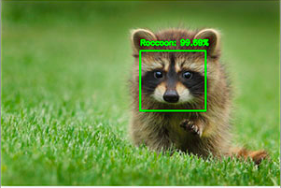  
*Figure 59: CNN Object Detector Output*

This visual will be incredibly valuable in the initial testing stages of the computer vision algorithms. It will allow us to see what is picked up by the object detector, what is missed, the location of said object, and the probability that it is actually there. This information will be unavailable as soon as the Raspberry Pi is connected to the C.A.N.E. device, as we don’t plan on having a screen aboard.

In addition to this visual information that will be provided in the initial testing stage, we plan to also begin our audio feedback testing at this stage. This will be necessary since in later stages of testing, we will not have the visual to confirm that the audio output is accurate. The audio will need to be checked at this stage as we will not have this visual information to compare it with for very much longer. Therefore, this pre-assembly testing of the computer vision algorithms will be both very informative and incredibly helpful for debugging the software.

Additionally, this same test can be run without the use of the Raspberry Pi and camera module at all. An initial test of the software can be run using still images of the objects we are attempting to locate. Once we eliminate bugs from these tests, we can begin to use the built in webcams on our computers with actual video feed. As mentioned before, we will utilize NumPy to store snapshots of our video to make it easier to process images and eliminate the need to store video footage, but this will still be a necessary additional step to test. Running our software on the live stream from our webcams will again allow us to see exactly what our object detectors are seeing, and provide the added bonus of acting as a control variable in our test for the actual Raspberry Pi and camera module hardware. We will choose several instances of each obstruction (sidewalk, doorway, staircases) that will be kept consistent throughout each version of this test. With this test run first and used as a basis, we will be able to compare the Raspberry Pi’s systems to that of our laptops to determine if the Raspberry Pi and camera module are functioning correctly.

Once we have established that both the actual code and the Raspberry Pi systems are functioning properly, we will connect the Pi and camera module to our C.A.N.E. device and begin a new series of tests. This stage of testing will focus on the real-time applications of our code. We will once again test the locations of the obstructions from before to ensure that our responses are still consistent. Once this test passes, we will begin testing with other instances of the obstructions we are searching for.

From this stage onward, testing for the computer vision will be of the stress test variety. We will do our best to find scenarios in which the software does not work or does not detect the obstructions, then fix the bugs. Essentially breaking the software as much as possible in order to improve it in the long run.

Validation criteria for the computer vision testing will be consistent throughout our testing stages. We will begin with a minimum of 70% prediction accuracy to consider an obstruction to be present. Testing will determine if this value needs to be adjusted in either direction. Validation criteria regarding audio output will be as simple as the audio matches the displayed result or it does not.

As with the sensor software, further testing will be used to determine the most optimal time to inform users of the upcoming obstruction. This will likely be measured in distance from the object in question, in feet. We plan to begin testing by informing the user when they are approximately 6 feet away from the obstruction and adjust depending on our test results.

# **6.2.7 Blind Spot Testing**

The goal of our design is that there will not be any blind spots due to the amount of sensors we plan to have. Our goal is a full 180 degree view in front of the user. However, we will need to perform some testing to determine if this goal has been accomplished. We plan to stress test this theory thoroughly utilizing the following criteria.

Blind spot testing will be performed at a park or a similar location where there will be an open clearing free from obstructions. The first step in the process will be to have the user wear the complete set up of the C.A.N.E. device. A secondary team member will be placed just outside of the sensing range of the sensors. The team member that is out in the field will then head into the sensing range. Once they are detec they will be asked to then walk in an arc. The will once they walk the arc the user will be asked to see if the haptic feedback has stopped vibrating. If it has stopped the team member out in the open field will be asked to stop and the direction and distance from the user to the team member will be recorded. Once the team member in the open field has walked the arc they will be asked to step forward and repeat the process. This process will then be repeated until the team member in the field has become within arms length of the user.

This test will be considered a pass if there are less than one blind spot within the whole test. And the test will be considered a failure if there are more than one blind spots.

# **6.2.8 Vibrators**

The goal in the project is to provide the sense of detection by comprising three directions. This will be done by using the vibrators. It is important that the vibrating motors be able to operate as intended by increasing and decreasing in intensity. To test the viability of the vibrating motors the following steps will be carefully followed.

The first step in this test is to program the microcontroller with the pulse width modulation code in order to change the intensity of the vibrating motor. In this step the pins will also be set so that the signal can be directed to the vibrating motors.

To perform the control variable for this test the code for the pulse width modulation will not be used. Instead it will be given a direct voltage at 5V. This will not only allow the vibrator to continuously be on but it will also allow for the intensity of the vibration to be the strongest. A member of the team will hold the vibration motor and will feel the intensity of the vibration.

The next step is to run the pulse width modulation program on the microcontroller with the vibration motors attached. While the team member holds the vibration motor in their hand another team member will change the duty cycle of the pulse width to be ninety-five percent. The team member will be asked to see if they felt any decrease in intensity from the vibration motors. This will be repeated until the and the duty cycle will decrease by five percent after each repetition. This will be stopped when the duty cycle is at five percent.

The test will be considered a pass if the vibration motors successfully decreased in intensity. The test will be considered a failure at any point if the tester did not sense a decrease in intensity.

# **6.2.9. Overall Desired Testing Results**

Our team has agreed upon an acceptable margin of error of no more than 5 percent. Each of the tests detailed in the section above must return results with 95 percent accuracy in order to be accepted as completed. In the case that any tests fail, our team must analyze the failed test to determine if the failure was the fault of software or hardware issues. Once any failures are traced back to their cause, adjustments will be made. There are several software adjustments that can be made to increase or decrease the range of detection. Our team does anticipate adjusting these values slightly. As far as any potential hardware failures, the team will need to determine whether the issue occurred due to a failure with our hardware (eg. one of our components is broken in some way) or if a completely different component needs to be selected. As it stands, our team has room in our budget for both the case in which a component is broken and a new one needs to be purchased and the case in which an entirely new component will be purchased to determine if it produces better results.

A summary of all our intended tests and their desired results is below.

|  |  |  |  |
| --- | --- | --- | --- |
| **Classification** | **Test Performed** | **Perfect Result** | **Accepted Result** |
| Software - Computer Vision | Using static images, test computer vision algorithms for detected objects. Will be tested for sidewalk, stairway, and doorway detection. | All sidewalks, staircases, and doorways are detected. | 95% of all sidewalks, staircases, and doorways are detected. |
| Using a built-in laptop camera, test computer vision algorithms for detected objects. Will be tested for sidewalk, stairway, and doorway detection. | All sidewalks, staircases, and doorways are detected. | 95% of all sidewalks, staircases, and doorways are detected. |
| Using the Raspberry Pi Camera Module, test computer vision algorithms for detected objects. Will be tested for sidewalk, stairway, and doorway detection. | All sidewalks, staircases, and doorways are detected. | 95% of all sidewalks, staircases, and doorways are detected. |
| Final computer vision testing. Bring Raspberry Pi and camera module to different, untested locations to ensure sufficient accuracy in unknown environments. | All sidewalks, staircases, and doorways are detected. | 95% of all sidewalks, staircases, and doorways are detected. |
| Software - User Feedback | Vibration feedback is present when object is detected | Vibration feedback occurs in every instance that an obstruction is detected. | Vibration feedback occurs for 95% of detected obstructions. |
| Vibration feedback is present on the same side as the obstruction | Vibration occurs on the side of the user that the obstruction is on in all cases. | Vibration occurs on the side of the user that the obstruction is on 95% of the time. |
| Vibration feedback is stronger for closer objects and weaker for objects that are further away. | Vibrations are stronger for closer objects 100% of the time. | Vibrations are stronger for closer objects 95% of the time. |
| Audio feedback informs the user that they are approaching a staircase, doorway, or sidewalk. | In every case in which the computer vision algorithms detect an obstruction, the user is informed of it. | 95% of the time in which the computer vision algorithms detect an obstruction, the user is informed of it. |
| Audio feedback informs users of how they will be guided through the staircase, doorway, or sidewalk. | In every case, after the user is informed of the obstruction they will receive additional information regarding how to get through it. This may involve further audio feedback or a transition to vibrations. | In 95% of cases, after the user is informed of the obstruction they will receive additional information regarding how to get through it. This may involve further audio feedback or a transition to vibrations. |
| Hardware - Optical Sensors | Sensors transmit signal to MCU about nearby object | Sensors correctly transmit a signal to the MCU without error every time. | 95% of the time the sensor transmits a signal, it will arrive at the MCU. |
| Detects medium-long range objects with high precision | Sensors are correct about an obstruction/ interference to the ultrasonic wave every time. | 95% of the time the sensor detects an object, the object will be at that location within a margin of error |
| Hardware - Ultrasonic Sensors | Sensors transmit signal to MCU about nearby object | Sensors correctly transmit a signal to the MCU without error every time. | 95% of the time the sensor transmits a signal, it will arrive at the MCU. |
| Detects short-medium range objects with high precision | Sensors are correct about an obstruction/ interference to the ultrasonic wave every time. | 95% of the time the sensor detects an object, the object will be at that location within a margin of error |
| Hardware - Initial Component Checks | Raspberry Pi Camera Module - distortion checks, run Brown-Conrady method with printed checkerboard | Size of boxes is found to be 1 inch, distance between boxes is also 1 inch | Acceptable ranges of 0.95-1.05 inches for each test |

# **7. Administrative**

This section will detail our team’s plans to ensure that our project is delivered on time and remains under budget. Our proposed budget includes details about part descriptions, manufacturers, price, and quantities. This is subject to change as testing continues. Our project milestone stable details every submission and research deadline from start to end of our project.

# **7.1. Budget**

The projected budget for this project is below. Further research will allow us to narrow down the budget and select specific manufacturers and parts to use. The budget is subject to change as we begin to receive parts and test for our needs.

|  |  |  |  |  |
| --- | --- | --- | --- | --- |
| **Part Description** | **Quantity** | **Price per Unit** | **Manufacturer** | **Part No.** |
| Raspberry Pi 4 | 1 | $35.00 | Raspberry Pi |  |
| RPi Camera Module v2 | 1 | $8.77 | Raspberry Pi |  |
| Ultrasonic Sensors | 2 | $26.25 | MaxBotix Inc. | MB1010 |
| Ultrasonic Sensors | 2 | $4.95-7.99 | SainSmart | HC-SR04 |
| Optical sensors | 2 | $60.06 | Broadcom Ltd. | AFBR-S50MV85G |
| Glasses | 1 | $5.00 - $15.00 | Unknown |  |
| Wrist/ankle bands | 4 | $0.01 - $5.00 | Unknown |  |
| Headphones/ Earbuds | 1 | $5.00 - $20.00 | Unknown |  |
| Vibrating Motors | 5-7 | $1.95 | Adafruit | 1201 |
| Micro-Controller | 1 | $0-$1.84 | Texas Instr. | MSP430G2553 |
| Recharging IC | 3 | $0.476 | Skyworks | AAT3693 |
| Li-Ion Battery | 3 | $4.99 | Panasonic | NCR18650B |
| Li-Ion Battery Holder | 3 | $2.97 | Keystone Electronics | 36-1043-ND |
| PCB | 1 | $212.00 |  |  |
| 16ch PWM/Servo Controller for RPi | 1 | $17.50 | Adafruit | 2327 |
| 5V Voltage Reg. | 1 | $2.47 | Texas Instr. | TPS61230 |
| 3.3V Voltage Reg. | 1 | $2.60 | Texas Instr. | TPS630242YFF |
| **Total** |  |  |  |  |

*Figure 60: Budget Analysis*

# **7.2. Milestones**

Below is a comprehensive list of our project milestones, both past and upcoming. Days until due will be updated periodically.  
  
By following the milestones outlined above, our group can and will address tasks on schedule and with enough spare time to address problems that are sure to arise when designing this project. At the time of this submission, we are ready to order components and begin prototyping and testing our design.

|  |  |  |  |  |  |  |
| --- | --- | --- | --- | --- | --- | --- |
| **DESCRIPTION** | **SEMESTER** | **START** | **END** | **DURATION** | **DAYS UNTIL DUE** | **%**  **COMPLETE** |
| **BRAINSTORM SENIOR DESIGN IDEAS** | **SD1** | **5/14/2020** | **5/14/2020** | **1 day** | **Past date** | **100** |
| **CONFIRM PROJECT IDEA** | **SD1** | **5/15/2020** | **5/15/2020** | **1 day** | **Past date** | **100** |
| **GOALS AND OBJECTIVES FOR PROJECT** | **SD1** | **5/15/2020** | **5/15/2020** |  | **Past** | **100** |
| **INITIAL PROJECT DOCUMENTATION** | **SD1** | **5/18/2020** | **5/29/2020** | **2 weeks** | **Past** | **100** |
| **MEETING WITH PROFESSOR** | **SD1** | **6/2/2020** | **6/2/2020** | **30 mins** | **Past** | **100** |
| **RESEARCH SENSOR TECHNOLOGY** | **SD1** | **6/1/2020** | **6/8/2020** | **1 week** | **Past** | **100** |
| **RESEARCH SENSOR COMMUNICATION PROTOCOLS** | **SD1** | **6/1/2020** | **6/8/20201** | **1 week** | **Past** | **100** |
| **60 PAGES DOCUMENTATION DRAFT** | **SD1** | **6/1/2020** | **7/3/2020** | **5 weeks** | **Past** | **100** |
| **100 PAGE DOCUMENTATION SUBMISSION** | **SD1** | **6/1/2020** | **7/17/2020** | **7 weeks** | **Past** | **100** |
| **FINAL DOCUMENTATION DUE** | **SD1** | **6/1/2020** | **7/28/2020** | **9 weeks** | **Past** | **100** |
| **FINALIZE COMPONENTS** | **SD1** | **6/1/2020** | **7/28/20** | **9 weeks** | **Past** | **100** |
| **PCB LAYOUT** | **SD1** | **6/1/2020** | **7/28/20** | **9 weeks** | **Past** | **100** |
| **RESEARCH CODING LANGUAGES** | **SD1** | **6/1/2020** | **7/28/20** | **9 weeks** | **Past** | **100** |
| **ASSIGN PROGRAMMING TASKS** | **SD1** | **6/1/2020** | **7/28/20** | **9 weeks** | **Past** | **100** |
| **ORDER COMPONENTS** | **BREAK** | **7/28/20** | **9/1/20** | **5 weeks** | **Past** | **100** |
| **INITIAL TESTING** | **SD2** | **10/1/20** | **12/10/20** | **2 months** | **Past** |  |
| **BUILD PROTOTYPE** | **SD2** | **11/29/20** | **12/10/20** | **2 weeks** | **4 days** | **75** |
| **TEST & DEBUG PROTOTYPE** | **SD2** | **11/29/20** | **12/10/20** | **2 weeks** | **4 days** | **75** |
| **FINAL DOCUMENTATION DUE** | **SD2** | **12/8/20** | **12/8/20** | **1 day** | **Past** | **100** |
| **PEER PRESENTATION** | **SD2** | **12/2/20** | **12/2/20** | **1 day** | **Past** | **100** |
| **FINALIZE PROJECT** | **SD2** | **11/29/20** | **12/10/20** | **2 weeks** | **4 days** | **75** |
| **FINAL PRESENTATION** | **SD2** | **TBD** | **12/2/20** | **12/2/20** | **Past** | **100** |

*Figure 61: Project Milestones*

**Appendix A References**

[1] P. Strong, “The History of the White Cane”, *ACB*, 11-Jan-2009. [Online]. Available: http://www.acb.org/tennessee/white_cane_history.html. [Accessed: 29-Jun-2020].

[2] “Awake Time Per Day in the United Kingdom (UK) 2014, by Age and Gender”, *Statista Research Department*, 06-Aug-2014. [Online]. Available: https://www.statista.com/statistics/326907/awake-time-per-day-uk-by-age-and-gender. [Accessed: 01-Jul-2020].

[3] “Mixed Signal Microcontroller, SLAS735J”, *Texas Instruments*, May-2013. [Online]. Available: https://www.ti.com/lit/ds/symlink/msp430g2553.pdf. [Accessed: 02-Jul-2020].

[4] “Power Supply Safety Standards, Agencies, and Marks”, *CUI Inc.,* 22*-*Jun-2018. [Online]. Available: https://www.cui.com/catalog/resource/power-supply-safety-standards-agencies-and-marks. [Accessed: 30-Jun-2020].

[5] “1625-2008 - IEEE Standard for Rechargeable Batteries for Multi-Cell

Mobile Computing Devices”, (n.d.). [Online]. Available: https://standards.ieee.org/standard/1625-2008.html. [Accessed: 22-Jun-2020].

[6] “About IPC”. *IPC, 2020*. [Online]. Available: https://www.ipc.org/ContentPage.aspx?pageid=About-IPC. [Accessed: 01-Jul-2020].

[7] “”STD-8739.4, *NASA*, 30-Jun-2016. [Online]. Available: https://standards.nasa.gov/standard/nasa/nasa-std-87394. [Accessed: 01-Jul-2020].

[8] “Electronic eyewear for the visually impaired”, *eSight Corp.,* 21-Jun-2020. [Online]. Available: https://esighteyewear.com/. [Accessed: 02-Jul-2020].

[9] “Microsoft Soundscape”, *Microsoft Research,* 28-Feb-2020. [Online] Available: https://www.microsoft.com/en-us/research/product/soundscape/. [Accessed: 02-Jul-2020].

[10] “I2C Info – I2C Bus, Interface and Protocol”, [Online]. Available: https://i2c.info/. [Accessed: 03-Jul-2020].

[11] Brain, M. “How Microcontrollers Work”, *HowStuffWorks*, 01-Apr-2000. [Online]. Available: https://electronics.howstuffworks.com/microcontroller1.htm. [Accessed: 04-Jul-2020].

[12] “Raspberry Pi Camera Module V2”, *ThePiHut,* [Online]. Available: https://thepihut.com/products/raspberry-pi-camera-module/. [Accessed: 05-Jul-2020].

[13] “Raspberry Pi Camera Module v2”, *Digikey,* [Online]. Available: https://www.digikey.com/catalog/en/partgroup/raspberry-pi-camera-module-v2/63181/. [Accessed: 05-Jul-2020].

[14] “MSP430G2553 Datasheet”, *Texas Instruments,* Apr-2011. [Online]. Available: https://www.ti.com/product/MSP430G2553. [Accessed: 05-Jul-2020].

[15] “Raspberry Pi 4 Model B”, *Raspberry Pi Ltd.,* Jun-2019. [Online]. Available: https://www.raspberrypi.org/documentation/hardware/raspberrypi/bcm2711/rpi_DATA_2711_1p0_preliminary.pdf. [Accessed: 06-Jul-2020].

[16] PDF, D. “Understanding How a Voltage Regulator Works”, *Analog*, 2009. [Online]. Available: https://www.analog.com/en/technical-articles/how-voltage-regulator-works.html. [Accessed 06-Jul-2020].

[17] “Advantages vs Disadvantages in Comparison with Linear Regulator: Basic Knowledge”, *Techweb*, 12-Nov-2015. [Online] Available: https://techweb.rohm.com/knowledge/dcdc/s-dcdc/02-s-dcdc/88. [Accessed 06-Jul-2020].

[18] “Introduction to OpenCV-Python Tutorials”, *OpenCV*, [Online]. Available: https://docs.opencv.org/master/d0/de3/tutorial_py_intro.html. [Accessed 09-Jul-2020].

[19] “What is NumPy?”, *SciPY Community,* 29-Jun-2020*.*[Online]. Available: https://numpy.org/doc/stable/user/whatisnumpy.html. [Accessed 09-Jul-2020].

[20] “Camera calibration With OpenCV”, *OpenCV*, 31-Dec-2019. Available: https://docs.opencv.org/2.4/doc/tutorials/calib3d/camera_calibration/camera_calibration.html. [Accessed 10-Jul-2020].

[21] “What is Machine Learning? A definition”, *ExperSystem*, 29-May-2020. [Online]. Available: https://expertsystem.com/machine-learning-definition/. [Accessed 11-Jul-2020].

[22] Hardesty, L. “Explained: Neural networks”, *MIT News Office*, 14-Apr-2017. [Online]. Available: http://news.mit.edu/2017/explained-neural-networks-deep-learning-0414. [Accessed 11-Jul-2020].

[23] “Google's DeepMind AI Just Taught Itself To Walk”, *Tech Insider*, 12-Jul-2017. Available: https://www.youtube.com/watch?v=gn4nRCC9TwQ. [Accessed: 11-Jul-2020].

[24] Bonner, A. “The Complete Beginner's Guide to Deep Learning: Convolutional Neural Networks”, *TowardsDataScience*, 01-Jun-2019. [Online]. Available: https://towardsdatascience.com/wtf-is-image-classification-8e78a8235acb. [Accessed 11-Jul-2020].

[25] Gandhi, R. “R-CNN, Fast R-CNN, Faster R-CNN, YOLO - Object Detection Algorithms”, *TowardsDataScience*, 09-Jul-2018. [Online]. Available: https://towardsdatascience.com/r-cnn-fast-r-cnn-faster-r-cnn-yolo-object-detection-algorithms-36d53571365e. [Accessed 13-Jul-2020].

[26] “LV-MaxSonar-EZ Series High Performance Sonar Range Finder”, *MaxBotix Inc.,* 2013. [Online]. Available: https://www.maxbotix.com/documents/LV-MaxSonar-EZ_Datasheet.pdf. [Accessed: 16-Jul-2020].

[27] “Ultrasonic Ranging Module HC-SR04”, *ElecFreaks,* [Online].Available: https://cdn.sparkfun.com/datasheets/Sensors/Proximity/HCSR04.pdf. [Accessed: 16-Jul-2020].

[28] “AFBR-S50MV85G Time-of-Flight Sensor Module for Distance and Motion Measurement”, *Broadcom Ltd.,* 30-Oct-2019. [Online]. Available: https://docs.broadcom.com/doc/AFBR-S50MV85G-DS. [Accessed: 17-Jul-2020].

[29] Sol, Rosebrock, A., Jacob, Marek, Balamaci, S., Fattah, S., . . . Amantay, N. “Installing OpenCV on your Raspberry Pi Zero”, 18-Apr-2020. [Online]. Available: https://www.pyimagesearch.com/2015/12/14/installing-opencv-on-your-raspberry-pi-zero/. [Accessed 17-Jul-2020].

[30] Klosowski, T. “The Raspberry Pi Zero W Adds Wi-Fi and Bluetooth to the Zero, Costs $10”, *LifeHacker*, 02-Mar-2017. [Online]. Available: https://lifehacker.com/the-raspberry-pi-zero-wireless-adds-wi-fi-and-bluetooth-1792789503. [Accessed 18-Jul-2020].

[30] “12 Principles Behind the Agile Manifesto”, *Agile Alliance,* 06-Oct-2019. [Online]. Available: https://www.agilealliance.org/agile101/12-principles-behind-the-agile-manifesto/. [Accessed: 18-Jul-2020].

[31] “R-CNN object detection with Keras, TensorFlow, and Deep Learning”, *PyImageSearch*, 11-Jul-2020. [Online]. Available: https://www.pyimagesearch.com/2020/07/13/r-cnn-object-detection-with-keras-tensorflow-and-deep-learning/. [Accessed 21-Jul-2020].

[32] “About Us”, *ASTM*, 2020. [Online]. Available: https://www.astm.org/ABOUT/overview.html/. [Accessed 23-Jul-2020].

[33] “Understanding TRRS and Audio Jacks”, *Cable Chick*, 13-Feb-2014. [Online]. Available: www.cablechick.com.au/blog/understanding-trrs-and-audio-jacks/. [Accessed 25-Jul-2020].

[34] “Earbud/headphones repair + diagnosis EXPLAINED. #22” *MySimpleFix*, 24-Jul-2020. [Online]. Available: https://www.youtube.com/watch?v=2pwFYRGfgyo/. [Accessed 25-Jul-2020]

[35] *“Geometrical Product Specifications (GPS) — Acceptance And Reverification Tests For Coordinate Measuring Systems (CMS)”, ISO,* 2020. [Online]. Available: https://www.iso.org/obp/ui/#iso:std:iso:10360:-8:ed-1:v1:en/. [Accessed 16-Jul-2020].

[36] “Overview Of Photoelectric Sensors | OMRON Industrial Automation”, Omron, *Omron, 2020.* [Online]. Available: http://www.ia.omron.com/support/guide/43/introduction.html/. [Accessed 27 June 2020].

[37] Hughs, M., “How Do Time of Flight Sensors (ToF) Work? A Look at ToF 3D Cameras - Technical Articles.” *All About Circuits*, 8-May-2019. [Online]. Available: www.allaboutcircuits.com/technical-articles/how-do-time-of-flight-sensors-work-pmdtechnologies-tof-3D-camera/. [Accessed 20-Jun-2020].

[38] “Photoelectric Sensors”, *Panasonic, [Online]* www3.panasonic.biz/ac/na/service/tech_support/fasys/tech_guide/data/photoelectric_e.pdf. [Accessed 7 June 2020].

[39] Energy, Benzo. “Which Type of Battery for Smartphone Is Better: Li-Ion or LiPo ?” *Benzoenergy.com*, 20 Aug. 2019, [Online] www.benzoenergy.com/blog/post/better-battery-for-smartphone.html. [Accessed 27 June 2020].

[40] Ross, Benjamin. *Battery Power Online*, 19 Sept. 2019, [Online] www.batterypoweronline.com/news/thermal-runaway-understanding-the-fundamentals-to-ensure-safer-batteries/. [Accessed 27 June 2020].

[41] “BU-107: Comparison Table of Secondary Batteries.” *Secondary (Rechargeable) Batteries – Battery University*, [Online] batteryuniversity.com/learn/article/secondary_batteries. [Accessed 28 June 2020].

[42] *Characteristics of Rechargeable Batteries* . [Online] www.ti.com/lit/an/snva533/snva533.pdf?ts=1593378052519&ref_url=https%253A%252F%252Fwww.google.com%252F. [Accessed 25 June 2020].

[43] “Raspberry Pi Camera Module v2.” [Online]www.digikey.com/catalog/en/partgroup/raspberry-pi-camera-module-v2/63181?utm_adgroup=Programmers%2BDev&utm_source=google&utm_medium=cpc&utm_campaign=Dynamic%2BSearch&utm_term=&utm_content=Programmers%2BDev&gclid=CjwKCAjwltH3BRB6EiwAhj0IUJXIbGsGl7DYC7bzqSyxpyLEvCeYHVCxpwa6iTb7NwdCzOYCLoBs_RoCwf0QAvD_BwE. [Accessed 25 June 2020].  
  
[44] “Raspberry Pi Camera Module v2.” [Online] www.digikey.com/catalog/en/partgroup/raspberry-pi-camera-module-v2/63181?utm_adgroup=Programmers%2BDev&utm_source=google&utm_medium=cpc&utm_campaign=Dynamic%2BSearch&utm_term=&utm_content=Programmers%2BDev&gclid=CjwKCAjwltH3BRB6EiwAhj0IUJXIbGsGl7DYC7bzqSyxpyLEvCeYHVCxpwa6iTb7NwdCzOYCLoBs_RoCwf0QAvD_BwE. [Accessed 25 June 2020]

[45] “Raspberry Pi Camera Module V2.” [Online]thepihut.com/products/raspberry-pi-camera-module. [Accessed 25 June 2020]

[46] “Time Complexity of Canny Edge Detector”. [Online] https://stackoverflow.com/questions/17458237/time-complexity-of-canny-edge-detector. [Accessed 23 June 2020].

[47] Rosebrock, Adrian. “Zero-Parameter, Automatic Canny Edge Detection with Python and OpenCV.”. *PyImageSearch.* [Online] www.pyimagesearch.com/2015/04/06/zero-parameter-automatic-canny-edge-detection-with-python-and-opencv/. [Accessed 24 June 2020].

[48] Rosebrock, A., 2014. *Practical Python And Opencv: An Introductory, Example Driven Guide To Image Processing And Computer Vision*. 1st ed. PyImageSearch. [Accessed 12 June 2020].

[49] Fourier.eng.hmc.edu. 2020. *Canny Edge Detection*. [Online] http://fourier.eng.hmc.edu/e161/lectures/canny/node1.html [Accessed 23 June 2020].  
  
[50] Homepages.inf.ed.ac.uk. 2020. [Online] http://homepages.inf.ed.ac.uk/rbf/CVonline/LOCAL_COPIES/MARBLE/low/edges/canny.htm [Accessed 1 July 2020].

[51] Homepages.inf.ed.ac.uk. 2020. *Image Transforms - Hough Transform*. [Online] http://homepages.inf.ed.ac.uk/rbf/HIPR2/hough.htm [Accessed 1 July 2020].

[52] Uio.no. 2020. [Online] https://www.uio.no/studier/emner/matnat/ifi/INF4300/h09/undervisningsmateriale/hough09.pdf. [Accessed 1 July 2020].

[53] Sinha, U., 2020. *The Hough Transform: The Basics - AI Shack*. [Online] Aishack.in. https://aishack.in/tutorials/hough-transform-basics/. [Accessed 2 July 2020].

[54] Sinha, U., 2020. *The Hough Transform: The Normal Form - AI Shack*. [Online] Aishack.in. https://aishack.in/tutorials/hough-transform-normal/. [Accessed 27 July 2020].

[55] Mansurov, N., 2020. *What Is Lens Distortion?*. [Online] Photography Life. https://photographylife.com/what-is-distortion#pincushion-distortion> [Accessed 14 July 2020].

[56] Lifewire. 2020. *How To Fix Lens Barrel Distortion In The Camera*. [Online] https://www.lifewire.com/what-is-barrel-lens-distortion-493725. [Accessed 27 July 2020].

[57] Calibrator, C. and Calibrator, S., 2020. *What Is Camera Calibration?- MATLAB & Simulink- Mathworks Deutschland*. [Online] De.mathworks.com. https://de.mathworks.com/help/vision/ug/camera-calibration.html [Accessed 15 July 2020].

[58] Compphysics.github.io. 2020. *Convolutional Neural Networks*. [Online] https://compphysics.github.io/MachineLearning/doc/pub/cnn/html/._cnn-bs001.html. [Accessed 16 July 2020].

[59] Nepp.nasa.gov. 2020. [Online] https://nepp.nasa.gov/docuploads/06AA01BA-FC7E-4094-AE829CE371A7B05D/NASA-STD-8739.3.pdf. [Accessed 21 July 2020].

[60] CUI Inc. 2020. *Power Supply Safety Standards, Agencies, And Marks | CUI Inc*. [Online] https://www.cui.com/catalog/resource/power-supply-safety-standards-agencies-and-marks.pdf. [Accessed 16 July 2020].

[61]Linear Resonant Actuators – LRAs 2020 . *Precision Microdrives*, Precision Microdrives, [Online]www.precisionmicrodrives.com/vibration-motors/linear-resonant-actuators-lras/. [Accessed 20 June 2020 ]

[62]“Vibration Motors – ERMs and LRAs.” 2020 *Precision Microdrives*, Precision Microdrives, [Online] www.precisionmicrodrives.com/vibration-motors/vibration-motors-erms-and-lras/. [Accessed 20 June 2020]

Eccentric Rotating Mass

[63] “Application Notes.” *Recision Microdrives*, www.precisionmicrodrives.com/content/ab-012-driving-vibration-motors-with-pulse-width-modulation/.

[64]“Google's DeepMind AI Just Taught Itself To Walk”, *Tech Insider*, 12-Jul-2017. Available: https://www.youtube.com/watch?v=gn4nRCC9TwQ. [Accessed: 11-Jul-2020].

[65] Gandhi, Rohith. “R-CNN, Fast R-CNN, Faster R-CNN, YOLO - Object Detection Algorithms.” *Medium*, Towards Data Science, 9 July 2018, towardsdatascience.com/r-cnn-fast-r-cnn-faster-r-cnn-yolo-object-detection-algorithms-36d53571365e.

[66] “API Documentation : TensorFlow Core v2.2.0.” [Online] *TensorFlow*, www.tensorflow.org/api_docs. [Accessed 17 July 2020].

[67] Ipc.org. 2020. *IPC*. [Online] https://www.ipc.org/. [Accessed 17 July 2020].

[68] Analog.com. 2020. *Understanding How A Voltage Regulator Works | Analog Devices*. [Online] https://www.analog.com/en/technical-articles/how-voltage-regulator-works.html#:~:text=A%20voltage%20regulator%20generates%20a,input%20voltage%20or%20load%20conditions.&text=It%20compares%20the%20output%20voltage,maintain%20a%20constant%20output%20voltage. [Accessed 17 July 2020].

[69] “Advantages vs Disadvantages in Comparison with Linear Regulator: Basic Knowledge.” *ROHM TECH WEB: Technical Information Site of Power Supply Design*. [Online] techweb.rohm.com/knowledge/dcdc/s-dcdc/02-s-dcdc/88. [Accessed 17 July 2020]

[70] “Different Types of Optical Sensors and Applications.” [Online] *ElProCus*, 22 Nov. 2019, www.elprocus.com/optical-sensors-types-basics-and-applications/. [Accessed 25 June 2020]

[71] “ColdLasers.Org.” [Online] *ColdLasers*, www.coldlasers.org/therapy/laser-vs-led/. [Accessed 25 June 2020]

**Appendix B Author Communications**

















